# Reflection

# WHOLE COURSE CHALLENGE

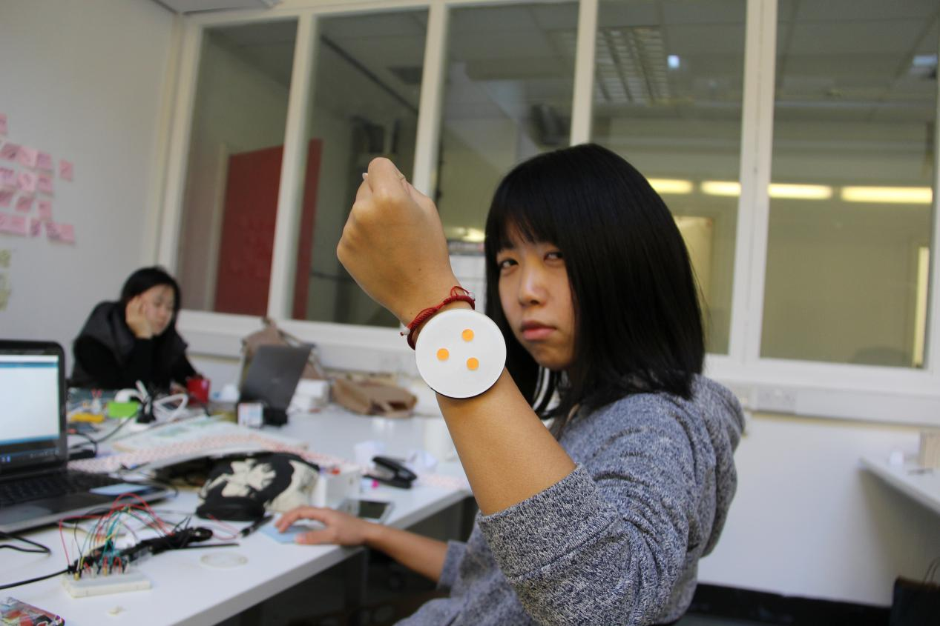

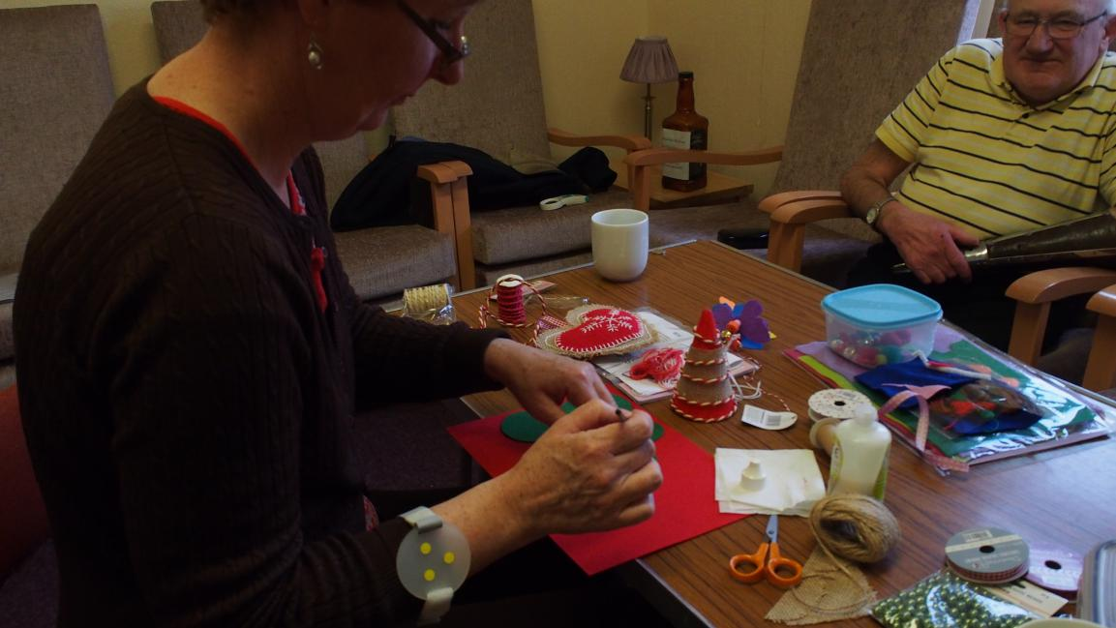

In these intensive four weeks, I repeated going forward and looking back. I felt that it was a tough course for me. But now, I feel the time flies very fast, especially after I acquire new skills and knowledge as well as experiences. I always desire more time to complete and develop my project.

From Exercise Reminder to **WEMOVE** attachment, my idea changed a few times. But the main core is still sharing daily data during the whole process. The idea came from my friends who don’t have much time to do exercise. In addition, there are so many people have not moved enough in this world. So I decided to make something to help them have motivation to do sport or exercise.

At first, we had some lectures about the things connected home to expend the definition of **HOME.** I learned the different ways of thinking by discussion with classmates and tutors, watching videos of examples, making scenarios and so on. I realized that the problem usually is more important so we suppose to focus more on problem rather than concerning on solution immediately. During the period when I was looking for better problem for project I was impacted by my friends who gave me significant inspirations. That helped me to set up vivid scenario to think about the story - how does it work. But usually when I have got strong ideas abruptly like brain storm they will be not well-organized. So the next step would be making them in order and finding the core of the concept since sometimes it is easy to make concept too complicated.

Another major part of this course is technology - Arduino. I regard the technology as a tool to support the concept. Because sometimes the function can just be achieved by some small and simple parts like Arduino. I cannot deny what Arduino is very useful for product design. And it is helpful for beginners. We can operate some basic parts on Arduino only in one week. However, when we want to approach some goals which need particular effect then it will be challenge to us. For example, I need some kind of sensor to track the balance for my product. So I was thinking the devices in mobile phone. But considering the time limitation, I used tilt switches in stead, which was much easier to obtain.

We share the videos and codes on Github while learning from each other. We also bothered Ali a lot to learn how to connect wires and other parts on Arduino board. Sharing and learning with classmates is an efficient and healthy way to achieve our purpose. It was awesome to study with interactive surrounding. It is also one of the places where inspiration come from.

In addition, as designer I should have the eyes which are good at observing details. The theme of the project is Connected Home thus every detail and data can be the resource of the whole project.