Orso’s World

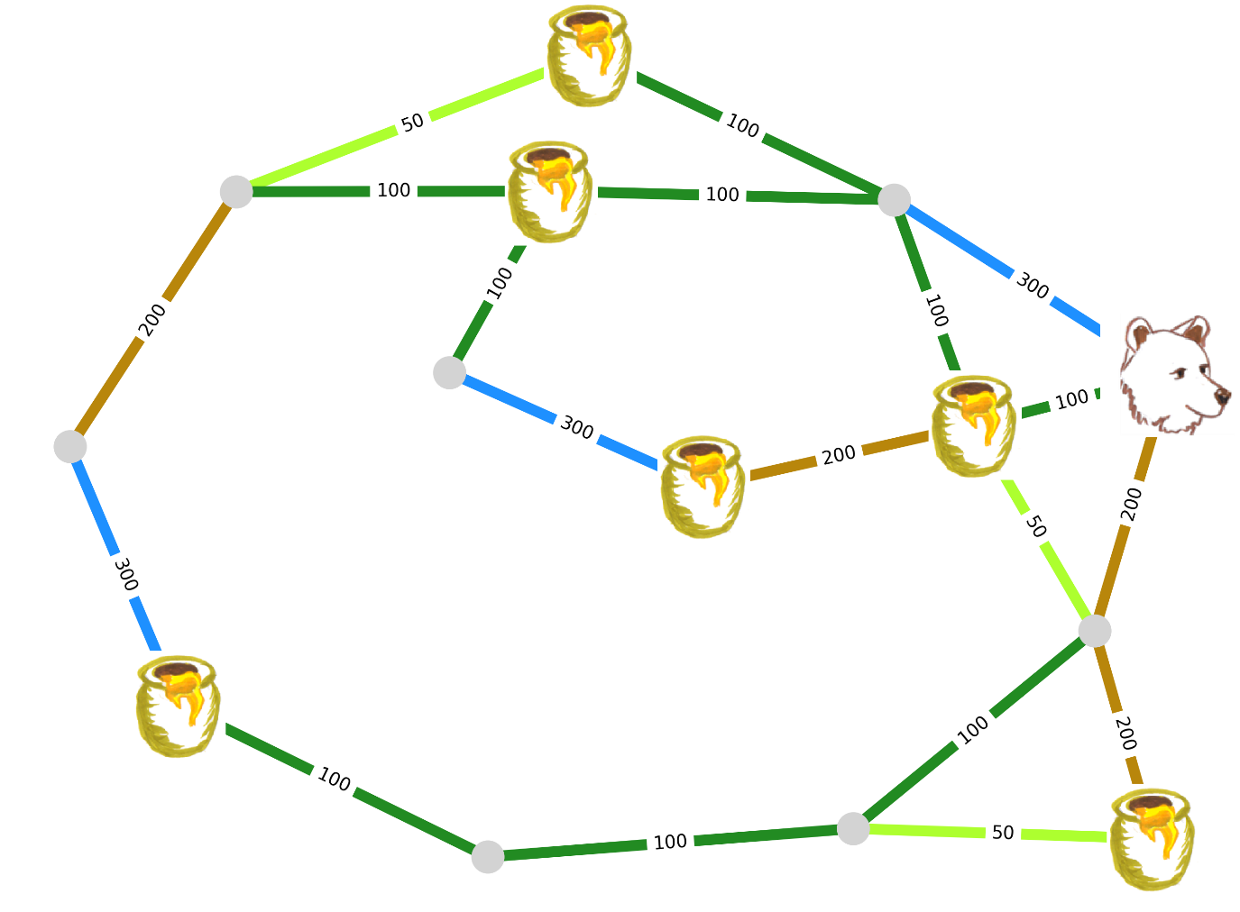

Modelling as a Reinforcement Learning problem

Be as specific as possible

|  |  |  |  |  |
| --- | --- | --- | --- | --- |
| **Objective**  What are we trying to achieve? | **Environment**  How would you model the Bear’s world? | **Rewards**  Enumerate the events giving a reward and how much | **Observation**  What can the Bear see? | **Actions**  Enumerate the actions the Bear can perform |
|  |  |  |  |  |