Orso’s World

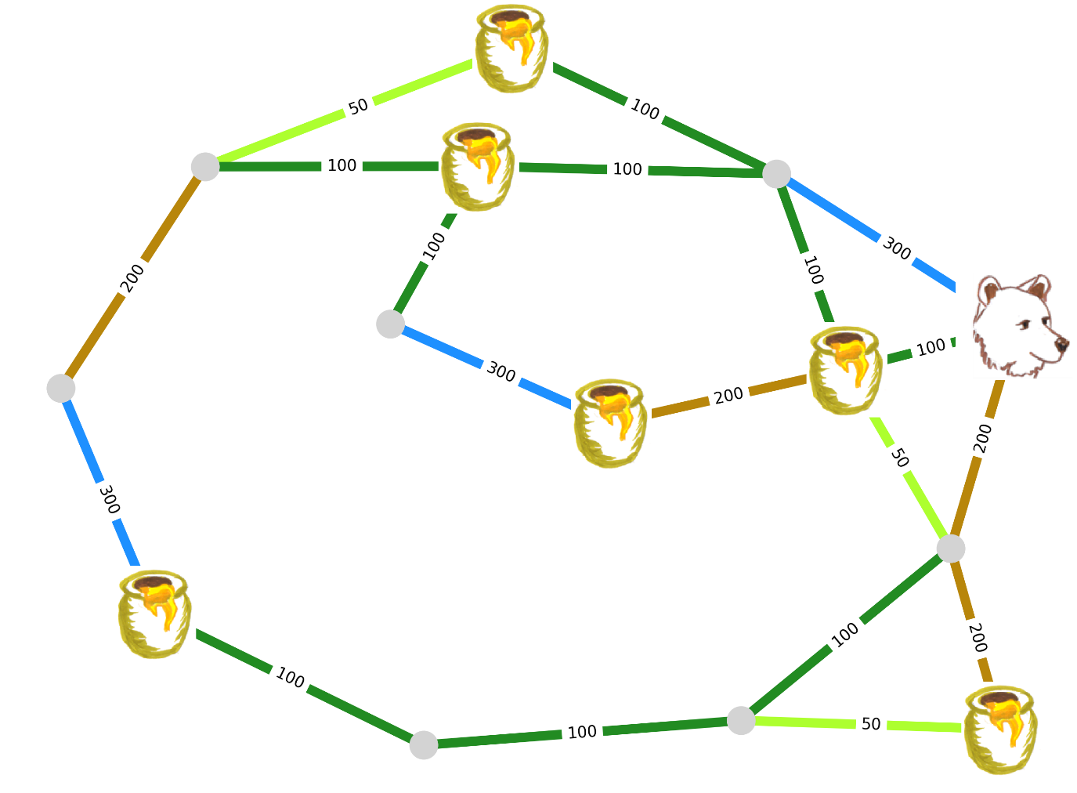

Modelling as a Reinforcement Learning problem

|  |  |  |  |
| --- | --- | --- | --- |
| **Environment** | **Rewards** | **Observation** | **Actions** |
|  |  |  |  |