Experiment #1: Training

Experiment #2: Data Cleaning

Experiment #3: Evaluation

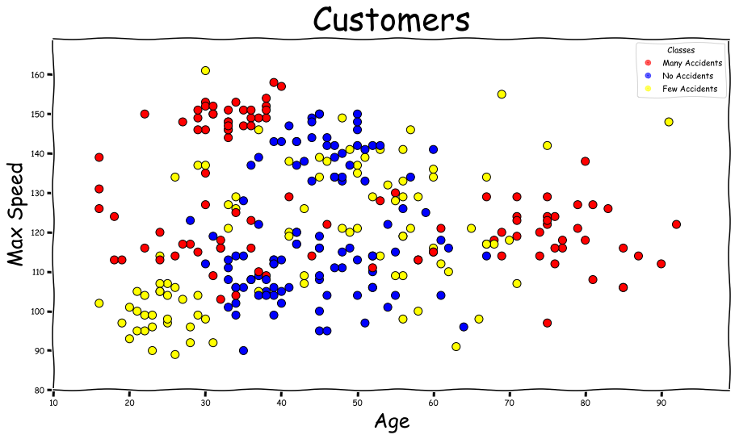

Experiment #4: Clustering

