Experiment #1: Classify Customers

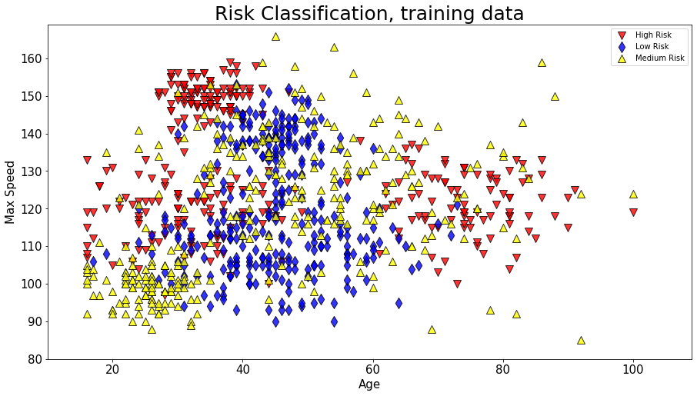

Experiment #3: Clustering

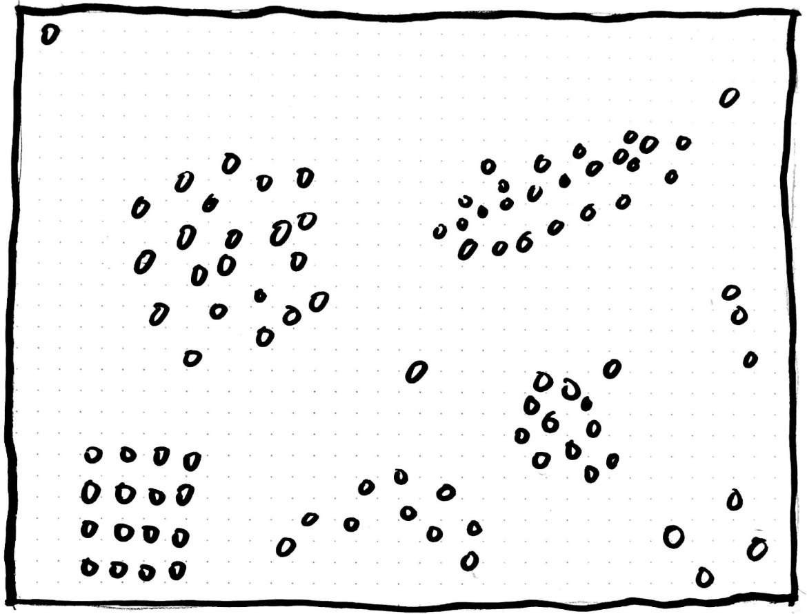

Experiment #2: Evaluation

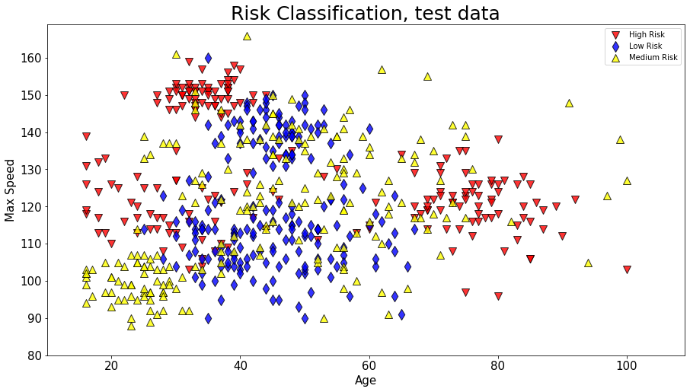

Experiment #4: Finding Applications

**Choose from those applications and decide which ML approach to take or do this for your own project**

1. **_______________________________**
2. **Detecting tuberculosis from X-Rays**
3. **Teaching a robot to pick up objects**
4. **Which two football players are similar to each other?**
5. **Optimize Chemical reactions**
6. **Deciding risk class of potential customers for loans**
7. **Learn how to control traffic lights**
8. **Detecting credit card fraud**
9. **News Recommendation**
10. **The AI finds out when a machine needs maintenance**