Experiment #1: Training

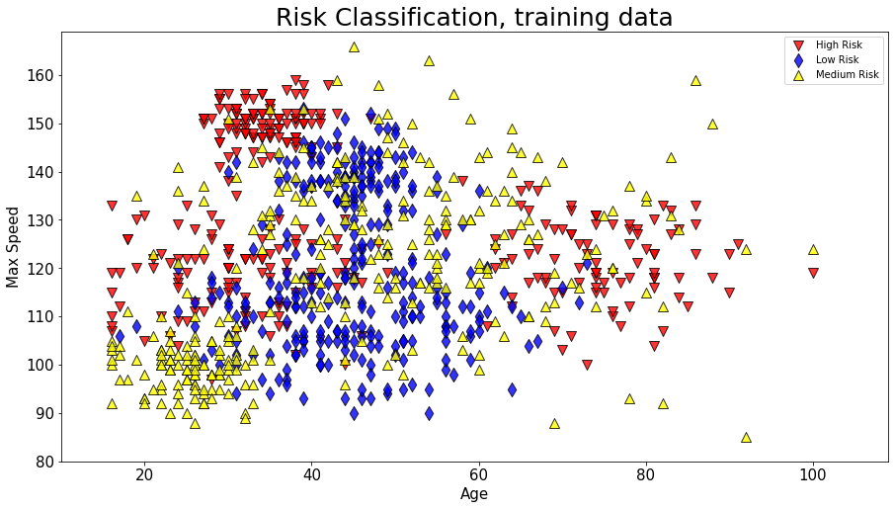

Experiment #2: Data Cleaning

Experiment #3: Evaluation

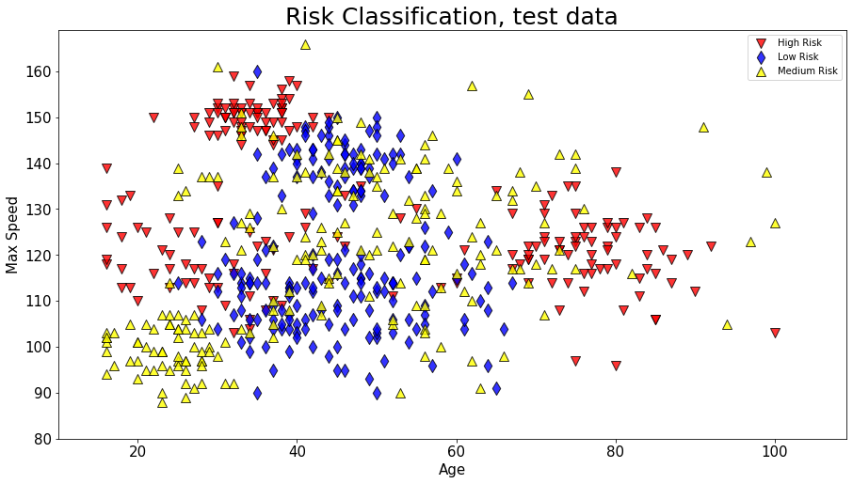

Experiment #4: Interpretation

