Kinematic Analysis of Mechanism Mobility, Joint Constraints, and Parallel Manipulators
Abstract— This paper covers mechanism mobility and degrees of freedom (DOF). Using Grübler's formula and Kutzbach's criterion, methods for analyzing 2D and 3D systems are outlined. Standard joints, including revolute, prismatic, universal, and spherical pairs, are evaluated with their motion constraints. The report then analyzes the 6-UPS Stewart-Gough platform, deriving its 6-DOF spatial mobility and reviewing its high stiffness, payload capacity, and typical industrial uses.
Keywords—Degrees of freedom, Grübler's formula, Kutzbach criterion, kinematic pairs, parallel mechanisms, Stewart platform.

I. Introduction and Structural Topology

A. Rigid Bodies and Kinematic Links
In kinematic synthesis, machine components are modeled as rigid bodies where external loads induce negligible strain. The relative spatial displacement between any two arbitrary coordinates remains constant:
||r_{a}(t) - r_{b}(t)|| = constant
A kinematic link is a rigid body with nodes designed to attach to mating links. Links are grouped by connectivity:
- Binary Link: 2 attachment nodes.
- Ternary Link: 3 distinct joint nodes.
- Quaternary Link: 4 nodal connection axes.

B. Kinematic Pairs, Chains, and Mechanisms
A kinematic pair (joint) connects two mating links, permitting defined relative motion while constraining remaining degrees of freedom.
An assembly of links and joints forms a kinematic chain. When the chain forms one or more closed loops, it is termed a closed chain; otherwise, it is an open chain. Grounding at least one reference link transforms the kinematic chain into a mechanism (if mobility M ≥ 1) or a structure/truss (if mobility M ≤ 0).

II. Degrees of Freedom (Mobility Analysis)

A. Unconstrained Operational Space
Mobility (M) defines the minimum count of independent coordinates necessary to specify the precise instantaneous configuration of all links relative to ground:
- Planar Space (2D): Unconstrained rigid bodies possess 3 DOFs (T_{x}, T_{y}, R_{z}).
- Spatial Space (3D): Unconstrained rigid bodies possess 6 DOFs (T_{x}, T_{y}, T_{z}, R_{x}, R_{y}, R_{z}).

B. Spatial and Planar Kutzbach Formulations
For an assembly of n links constrained by j joints, grounding one reference frame leaves (n - 1) active links. The spatial Kutzbach equation evaluates as:
M = 6(n - 1) - ∑ (6 - f_{i})
M = 6(n - 1) - 5j₁ - 4j₂ - 3j₃ - 2j₄ - j₅
For mechanisms confined strictly to a single 2D plane:
M = 3(n - 1) - 2j₁ - j₂
Where j₁ represents 1-DOF lower pairs and j₂ denotes 2-DOF higher pairs.

C. Grubler's Criterion
Franz Grubler's simplification targets single-degree-of-freedom planar linkages (M = 1) constructed purely from 1-DOF joints (j₂ = 0):
3(n - 1) - 2j₁ = 1 => 3n - 2j₁ - 4 = 0
j₁ = (3n - 4) / 2
For j₁ to evaluate to an integer, the link count n must always be an even integer (4, 6, 8, ...). Planar single-DOF lower-pair mechanisms cannot be assembled with an odd link count.

III. Classification of Kinematic Joints
Joints are categorized into lower pairs (surface contact) and higher pairs (point or line contact). The number of constraints c imposed by a pair satisfies:
c = D - f
Where D is the dimension of the space (D = 3 for planar, D = 6 for spatial) and f is the joint's permitted degrees of freedom.
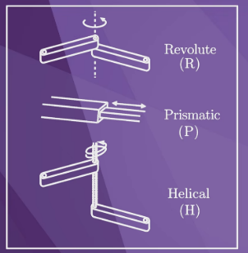
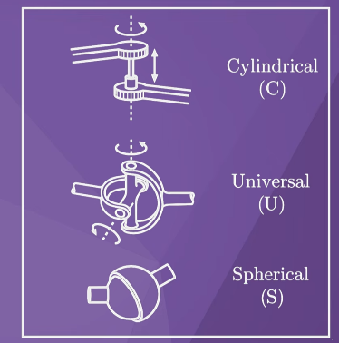
Fig. 1. Fundamental lower kinematic pairs: (a) 1-DOF pairs (R, P, H); (b) multi-DOF pairs (C, U, S).

TABLE I: KINEMATIC JOINT CONSTRAINT MATRIX
Joint Name | DOF (f) | Constraints (c) 2D Planar | Constraints (c) 3D Spatial
Revolute (R) | 1 | 2 | 5
Prismatic (P) | 1 | 2 | 5
Helical (H) | 1 | N/A | 5
Cylindrical (C) | 2 | N/A | 4
Universal (U) | 2 | N/A | 4
Spherical (S) | 3 | N/A | 3

IV. The Stewart-Gough Platform

A. Definition and Overview
A Stewart Platform (or hexapod) is a 6-degree-of-freedom (6-DOF) parallel manipulator. It consists of a fixed base plate connected to a mobile top platform via six independent, extendable linear legs (struts) acting simultaneously in parallel.

B. Mobility Derivation
The platform achieves 6 spatial DOFs: 3 translations (Surge X, Sway Y, Heave Z) and 3 rotations (Roll R_{x}, Pitch R_{y}, Yaw R_{z}). Evaluating mobility via the spatial Kutzbach criterion:
M = 6(n - 1) - ∑ (6 - f_{i})
- Link Count: n = 14 (1 Base + 1 Top Platform + 12 Leg cylinders/rods).
- Joint Constraints: 6 Universal pairs (6 x 4 = 24), 6 Prismatic actuators (6 x 5 = 30), and 6 Spherical pairs (6 x 3 = 18). Total constraints = 72.
M = 6(14 - 1) - 72 = 78 - 72 = 6

C. Working Principle
The mobile stage moves through synchronized length adjustments of all six linear struts. No single motor controls a solitary axis. Uniform stroke extension results in pure vertical translation (heave), while differential stroke adjustments create tilt, roll, and yaw angles.

D. Advantages and Disadvantages
Advantages: High payload capacity (loads are distributed across 6 compressive/tensile struts), high structural rigidity, and averaged joint fabrication clearances.
Disadvantages: Highly restricted workspace envelope, complex forward kinematics requiring numerical root solvers, and risk of mechanical strut interference at sharp tilt limits.

E. Practical Applications
Standard deployments include Level-D commercial aviation flight simulators, stabilized optical and satellite dishes, micron-precision surgical robotics, and high-stiffness hexapod CNC machine centers.

V. Conclusion
Kinematic mobility analysis provides the analytical foundation for both open- and closed-chain mechanisms. The Kutzbach and Grubler criteria offer systematic methods for determining system degrees of freedom, while practical design requires verifying passive motions and geometric over-constraints. The 6-UPS Stewart-Gough platform demonstrates how closed-loop parallel kinematics can achieve 6-DOF spatial positioning with high stiffness and load-carrying performance.

References
[1] J. J. Uicker, G. R. Pennock, and J. E. Shigley, Theory of Machines and Mechanisms, 5th ed. Oxford Univ. Press, 2017.
[2] D. Stewart, "A platform with six degrees of freedom," Proc. Inst. Mech. Eng., vol. 180, no. 1, pp. 371-386, 1965.
[3] J.-P. Merlet, Parallel Robots, 2nd ed. Springer, 2006.
[4] L.-W. Tsai, Robot Analysis: The Mechanics of Serial and Parallel Manipulators. John Wiley & Sons, 1999.

