Task 5: Electronics Task

Part 1: Logic Gates (Switch Logic)

1. AND Gate
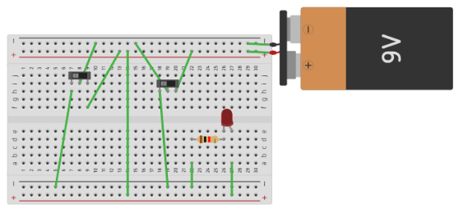https://www.tinkercad.com/things/3nbLPPHvDdm-and?sharecode=isPySqiRduzSUEm5l0uUPi6SlwcAlwQSg-6QYYkjPTo
2. OR Gate
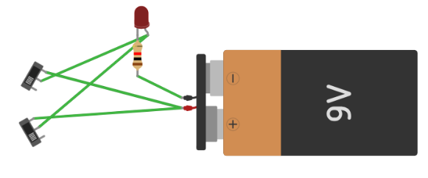https://www.tinkercad.com/things/ceNIOeEjxpY-or?sharecode=vbPZcyOGjIwNDPTRxjFz-ihyp4p8AdgA7wTKqpQZmb4

3. NOT Gate
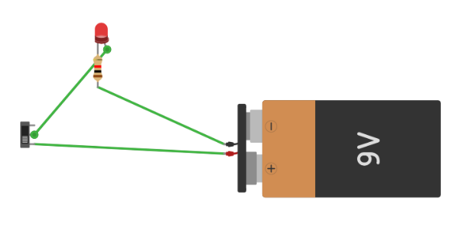https://www.tinkercad.com/things/aXgn2xuCUYq-not?sharecode=Fs7dQZbvJ-2i5sd_mkNM8Crtg4pKWYvH_IsUrah7Ezo

4. XOR Gate
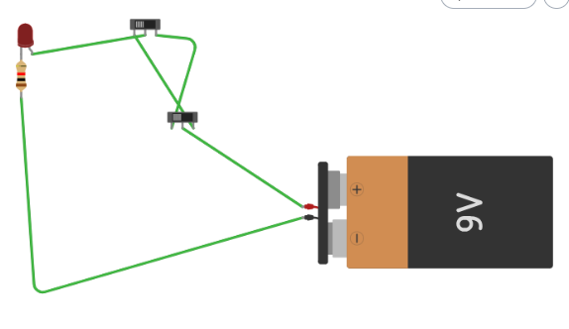
https://www.tinkercad.com/things/1UxhjRwS31M-xor?sharecode=fEh2L2mLbHSFDqeu3Cw4T35ahEQYHyVvhqFRKcxnbMs

5. XNOR Gate
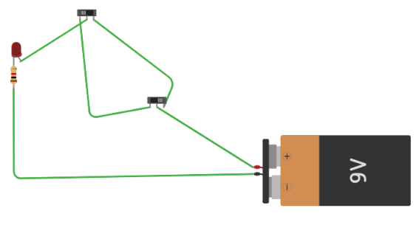https://www.tinkercad.com/things/ekqcIgoshO8-xnor?sharecode=sFfCrpdRRUv5queqMX9_DsaJ-P2TG3ssbRx3rdpE6IY

Part 2: Logic Gates (Diode Logic)

1. AND Gate (Diodes)
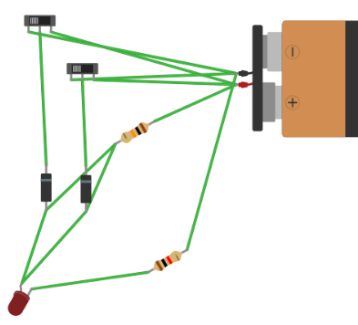
https://www.tinkercad.com/things/lAsxnMHrbaS-and-with-diodes?sharecode=Jij03Z1e_C_j9n3tb80mYVtu94Yq_la2CaQnKP0qzsg

2. OR Gate (Diodes)
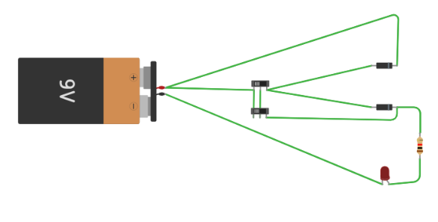
https://www.tinkercad.com/things/jV2Z0lStFLV-or-with-diodes?sharecode=AHLTQ8uve8I-mocjV051XU_GYbHlwKN1130LdciKjBg

3. NOT Gate (Diode)

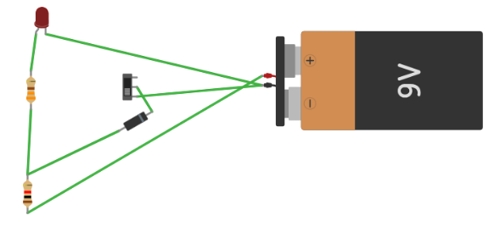

https://www.tinkercad.com/things/kA4kHpsbNO8-not-with-diode?sharecode=XekguZNIbN7NoCbb2LHQaPP4IDgonAF7aTOTRl3j7ao

Part 3: Arduino Sensor Systems

1. Ultrasonic Sensor 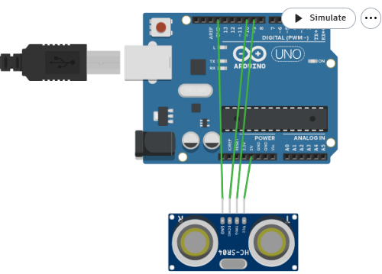
https://www.tinkercad.com/things/ex5nZvg7lGK-ultrasonic?sharecode=1UqXMm42fvFYwgUN_bBCsg0Z04S7aACjvKjIyblBp_g

2. Traffic Light System

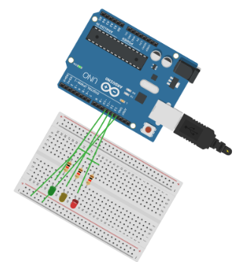
https://www.tinkercad.com/things/lFWvC802xe4-traffic-light?sharecode=-FPOtpCP_sS5SRkKWR28jqeedTjDhRtp8ETsHTty_r4

3. LDR Sensor (Photoresistor)
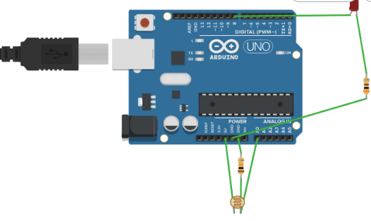
https://www.tinkercad.com/things/d4nMfH1rtJ2-ldr?sharecode=sInBF9Rol0aW4cMYG_hkwU-OOyCtGbQr0VkzoABDvyU

Part 4: Bonus Tasks

1. Speed Control using Ultrasonic Sensor & DC Motor
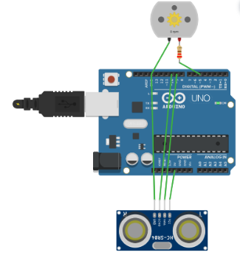
https://www.tinkercad.com/things/b0bndGpk94S-speed-control?sharecode=30aIWEL1_rbHbfRrdV1XqAqQ5eqeTFDTDrB2BC4Lb-U

2. Security Alarm System (PIR Motion Sensor + Buzzer)
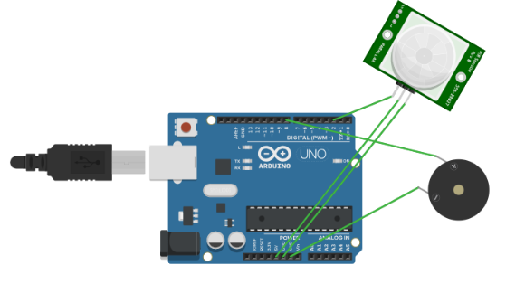
https://www.tinkercad.com/things/606B1sL1Dqy-security-alarm-system?sharecode=bIrmqqHsMZ7KCBbkcm3HyLeDxkkiCxE9_6l_itPc8V0

