|  |  |  |  |  |  |
| --- | --- | --- | --- | --- | --- |
| CКлюч | Имя | Тип | IS NULL | Default | Описание |
| **tBill** | | | | | |
| PK | BillCode | INT | NOT NULL |  |  |
|  | ClientCode | INT | NOT NULL |  |  |
|  | PaymentDate | Date | NOT NULL |  |  |
|  | PaymentType | INT | NOT NULL |  |  |
|  | PaymentStatus | INT | NOT NULL |  |  |
| **tCart** | | | | | |
| PK | CartCode | INT | NOT NULL |  |  |
| FK | BillCode | INT | NOT NULL |  |  |
|  | ProductCode | INT | NOT NULL |  |  |
|  | Unit | Nvarchar(20) | NOT NULL |  |  |
| **tCategory** | | | | | |
| PK | CategoryCode | INT | NOT NULL |  |  |
|  | CatDescription | Nvarchar(100) | NOT NULL |  |  |
| **tClient** | | | | | |
| PK | ClientCode | INT | NOT NULL | IDENTITY |  |
|  | Name | Nvarchar(10) | NOT NULL |  |  |
|  | Mail | Nvarchar(30) | NOT NULL |  |  |
|  | Phone | Varchar(15) | NOT NULL |  |  |
|  | BornDate | Date | NOT NULL |  |  |
|  | Status | INT | NOT NULL | 0 |  |
| **tDrinks** | | | | | |
| PK | DrinkCode | INT | NOT NULL |  |  |
|  | CategoryCode | INT | NOT NULL |  |  |
|  | Name | Nvarchar(15) | NOT NULL |  |  |
|  | Price | Money | NOT NULL |  |  |
| **tEmployer** | | | | | |
| PK | EmplCode | INT | NOT NULL |  |  |
|  | ClientCode | INT | NOT NULL |  |  |
|  | BillCode | INT | NOT NULL |  |  |
|  | Name | Nvarcahr(20) | NOT NULL |  |  |
|  | Phone | Nvarchar(15) | NOT NULL |  |  |
|  | Mail | Nvarchar(25) | NOT NULL |  |  |
|  | Salary | Money | NOT NULL |  |  |
| **tSnack** | | | | | |
| PK | SnackCode | INT | NOT NULL |  |  |
|  | CategoryCode | INT | NOT NULL |  |  |
|  | Price | Money | NOT NULL |  |  |

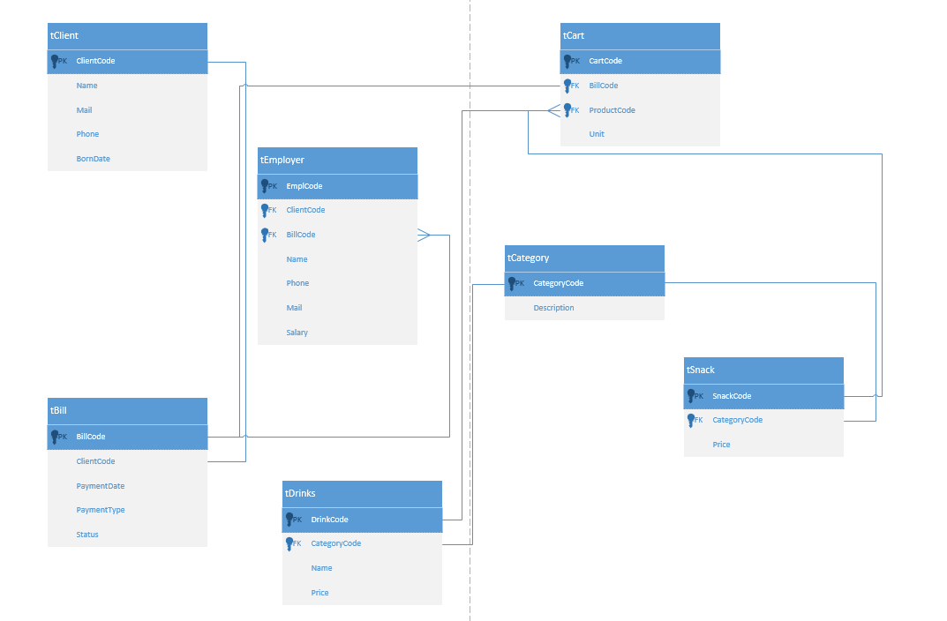Триггеры:

* При добавлении клиента, проверяется возраст. Если возраст <18, статус ставится 0. Если возраст >18, статус ставится 1.

Пользователи:

* Работник