

**A Research Presented to the faculty of**

**Manaoag National High School**

**Manaoag, Pangasinan**

**Academic Requirement for Practical Resarch 2**

**THE GREEN CRUNCH:**  
 **CRUNCH IT LOVE IT SWEET POTATO  
LEAVES**

**Submitted by:**

**Adriatico, Gabrielle Ann  
Cabales, Stephanie  
Estrada, Janelle  
Garcia, Ronnie S.  
Lorenzo, Althea Eurice  
Reganit, Shine Micheal  
Zarate,Regina**

**September 2024**

CHAPTER I EXECUTIVE SUMMARY 6

A. Name of the Business 6

B. Title of the Study 6

C.Store Location 6

D.Description of the Logo 7

E. Brief Description of the Project 8

F.General Objectives of the Business 8

G. Research and Methodology 8

G1. Survey 9

G2. Sloven's Formula 9

G3. Sampling Techniques 9

G4. Survey Questionnaire 10

G5. Interview 10

G6. Research 10

G7. Mapping 11

G8. Search of Internet, Books, and Libraries 11

H. Project Summary 12

H.1. Market Summary 12

H.2. Technical Summary 12

H3. Management Summary 13

H4. Financial Summary 13

I. Operational Terms 13

J. Scope and Limitation 14

CHAPTER II MARKET STUDY 15

Objectives 15

A.1 Past demand 16

A. 1.1. For the Industry 16

A.1.2. for Every Product 16

A.2. Market Segmention 16

A.2.2 Demographic 17

A.2.3. Psychographic 17

B. Supply 17

B.3 Competitors Analysis 17

C. Demand Supply Gap Analysis 18

E. 1. Product Strategies 18

E.2 PLACE STRATEGIES 18

E. 3 PRICING STRATEGIES 19

E.4. Promotion 19

E.4.1. Poster 19

E.4.2. Website 19

E.4.3. Flyers 20

E.4.4 Gift Certificate 20

F. Swot Analysis 20

**INTRODUCTION**

The lowly “talbos ng kamote” or “sweet potato leaves” is a kind of plant (scientifically called Ipomoea Batatas) that we always see growing in vacant lots and on the roadside anywhere we go in the Philippines. It grows all year round and doesn’t need that much maintenance because it grows wild most of the time (Library health news, 2018).

According to a study of the Louisiana State Agricultural Center (2018), sweet potato leaves or “talbos ng kamote” provide ascorbic acid (Vitamin C) and Vitamin B to the body. But it also offers other vital nutrients like Vitamin A, Vitamin K, B-Carotene, B6, Thiamine, Niacin, Zinc, Riboflavin, Iron, Folic Acid, Calcium, and Protein. It is a all-season vegetable with so much more to offer.

Furthermore, the goal of this study is to provide more nutritious food that is accessible to all age groups, particularly those who have trouble consuming greens



**THE GREEN CRUNCH  
CRUNCH IT LOVE IT SWEET POTATO   
LEAVES**

# 

# CHAPTER I EXECUTIVE SUMMARY

## A. Name of the Business Kamote Leaves Chips

The business proponents came up with the Kamote Leaves Chips as the name of our business product. "Talbos (dahon) ng kamote, as the tagalog term of " Kamote leaves" that we are represent the kind of vegetable leaves we making that we mainly served to our customers.

B. Title of the Study**:**  Creating kamote leaves Chips goody’s texture, flavor, and health benefits

## C.Store Location

* Manaoag National High School, Beside the building A, Bautista St. Manaoag Pangasinan

* Location is one of the major factors to be considered in starting up a business. It must be assured that it is accessible to the target market. If location is later found to be incompatible to the situation as to give consideration to its target market, it may lead the company to failure. Right choice of location means reaching your target customers and you respond correctly to market needs.

* Based on our survey, majority of the respondents choose mall as a place to locate our business. We've decided to put our business at Manaoag NHS, beside the building A because we believed it would be very accessible to our target customers are students. Beside the Building A is located infront of the other canteens at MNHS.

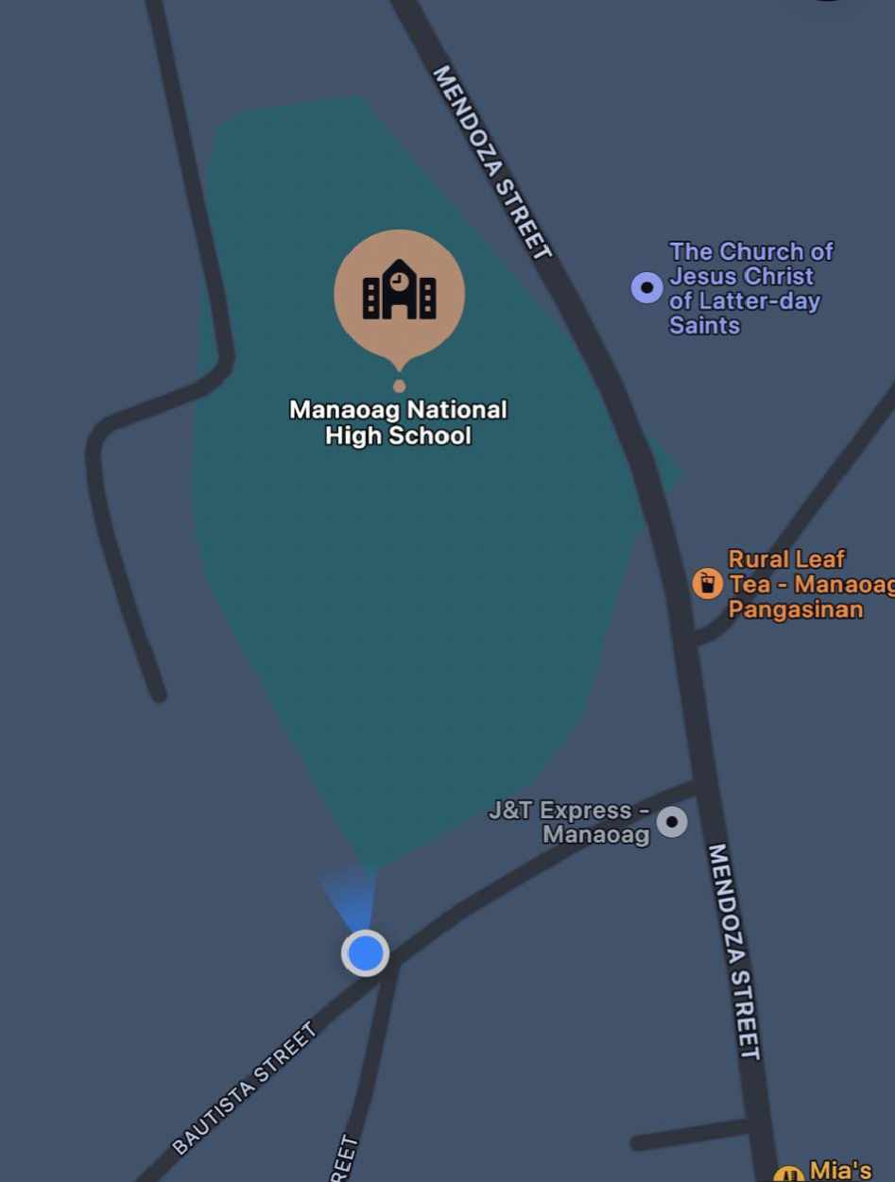

## D.Description of the Logo



Our logo features a vibrant purple color, symbolizing creativity, luxury. This choice of color can help the brand stand out in a competitive market, especially as purple is less commonly used in branding compared to other colors like blue or red. Our logo is simple and visually appealing. The use of the plant in the center of our logo is a clever way to represent the main product's ingredient, kamote leaves chips. The text "CRUNCH IT LOVE IT" is a catchy slogan that is likely to appeal to consumers. Overall, the logo effectively communicates the brand's identity by combining the allure of purple with the wholesome nature of kamote leaves crackers, creating a memorable and meaningful visual representation.

## 

## E. Brief Description of the Project

Kamote leaves, used in Various dishes such as salads and it can also be eaten when steamed. These leaves has many uses and benefits. Kamote Leaves is reach in vitamins A, C, and B-complex, as well as minerals like calcium, iron, and potassium. They are also high in dietary fiber and antioxidants. and since they have a high antioxidant properties this can help combat oxidative stress and inflammation. The leaves supports the eye, immune system and also helps in digestion. Kamote leaves can also be eaten. It can be sauted, steamed and its even added on salads. sometimes, it is also used as a herbal medicine which aids on anti-inflammatory and diuretics. So, we come up with these product not only because kamote leaves is seen everywhere but it is also have the benefits that can make a Chips healthier.

## F.General Objectives of the Business

a) By promoting Kamote Leaves Chips as a unique, healthy alternative to traditional snacks.  
 b) Investigating the nutritional benefits of Kamote Chips compared to other snack options.   
 c) Assess the feasibility of Kamote Chips in terms of production, cost, and profitability.  
 d) To offer an affordable and healthy option of snacks

**G. Research and Methodology**  The proponents used different techniques in gathering information to support the study.

### G1. Survey The proponents conducted survey among 100 respondents to get their opinion regarding the Kamote Chips that they will produced. These 100 respondents were come from Manaoag. the proponents used the sloven’s formula. The survey was distributed among all ages. It was used so that the proponents would be able to know the respondents perception and preference regarding to their proposed business.

**G2. Sloven's Formula** The group used the Sloven's Formula to determine the needed number of respondents.  
Formula: n = N 1+ Ne²

Where:   
N = the number of people who qualify in the area of study  
e = margin of error which is 5%  
n=number of needed respondents

Solution:  
N= 1737÷ 1+ (1737) (.3)² = 11.04

**G3. Sampling Techniques**

To gauge student interest in our new line of Kamote Leaves Chips, we'll employ a random sampling technique, targeting senior high school students at Manaoag National High School Senior High. We'll offer free samples of our different flavors and provide a short survey for participants to fill out. By analyzing the survey results, we'll gain valuable insights into the most popular flavors, overall demand, price points, and student preferences based on factors like grade level and gender. This data will inform our decisions about which flavors to prioritize, how to price our product, and how to effectively market our kamote leaves chips to this target audience.

### 

### G4. Survey Questionnaire

In order to have an access on the pertinent information and gather important data about consumer preferences and perceptions regarding Kamote Leaves Chips, the researcher agreed to use Questionnaires. In this process, we find it very easy and reliable. Questions are made by the researchers to helps us evaluate the market potential and improve the product's quality. By these questions we will be able to determine the demand of the product. The group provided 5 survey questions which are all in english language.

### G5. Interview

The proponents interviewed relevant persons to gain more insights, supplementing the data gathered through a survey questionnaire. We interviewed school administrators and canteen managers at all ABM students of Manaoag National High School to assess the potential costs of selling space, logistical requirements, and the best arrangement for the selling area. This helped us comprehend the school's policy on vendor placement and operations.

### G6. Research

The proponents used information from social media platforms as a source for their research. This included various online resources, social media posts, and internet searches. This allowed them to gather comprehensive information about the business, the location of the mall, and other relevant data to support their study.

### 

### G7. Mapping

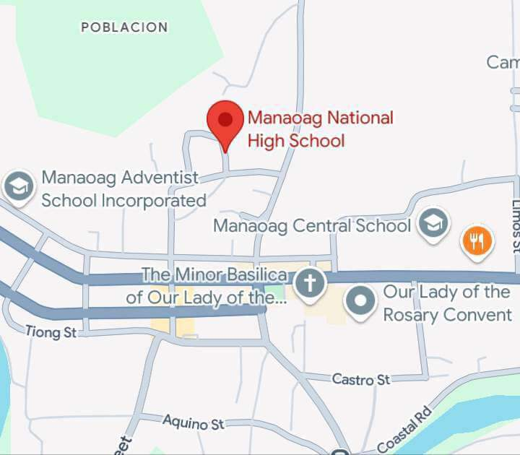

The study covered the place of Manaoag National Highschool as the target of the study as shown. The Community of Manaoag subdivided into (26) baranggay, Bautista Street, Manaoag, Pangasinan where the establishment of the Manaoag National Highschool is located.

### G8. Search of Internet, Books, and Libraries

The search results provide a comprehensive overview of Kamote Leaves Chips, focusing on their nutritional value, consumer feedback, and potential market applications.

Customers generally appreciate the taste and health benefits of Kamote Leaves Chips.

They describe them as delicious, slightly sweet, and a suitable snack paired with vegetables. However, some reviews indicate that the product may be perceived as overpriced, particularly concerning portion sizes. Research highlights that crackers made from sweet potato leaves are rich in essential nutrients, including vitamins and minerals.

A study on Malaysian purple sweet potato crackers found high fiber content and beneficial compounds like anthocyanins, indicating that similar products could offer significant health advantages. The nutritional profile suggests these crackers could be a healthy snack option for consumers.

The growing trend towards healthy snacking positions Kamote Leaves Crackers favorably in the market. Their unique flavor and health benefits cater to a health-conscious demographic, suggesting potential for increased acceptance and demand. Studies indicate that incorporating sweet potato leaves into snack foods can enhance their nutritional value, making them appealing to consumers seeking nutritious alternatives.

## H. Project Summary

### 

### H.1. Market Summary

The market for Kamote Leaves Chips is characterized by a growing interest in healthy snacks that leverage the nutritional benefits of sweet potato leaves. These Chips are gaining traction due to their appeal as a gluten-free, nutritious alternative to traditional snacks. Customers appreciate the taste, health benefits, and quality of Kamote Leaves Chips. They often highlight the unique flavor and slight sweetness, making them suitable for various pairings, such as with vegetables. However, some consumers express concerns about the pricing, indicating that the Chips can be perceived as overpriced relative to portion sizes. Kamote Leaves are rich in vitamins and minerals, including Vitamin A, Vitamin C, and calcium, which enhances the health appeal of the crackers. This aligns with the increasing consumer trend towards health-conscious eating, as more people seek snacks that contribute positively to their diets. The demand for healthy snack options is on the rise, particularly among consumers looking for convenient, nutritious products. This trend positions Kamote Leaves Chips favorably in the market, especially as they cater to health-conscious demographics and those interested in unique flavor profiles.

### H.2. Technical Summary

The products that we are going to offer is Chips with high demand and nutritious for our customers. Our main product will be Kamote Leaves Chips, a delicious and healthy snack. Machineries and equipment were enumerated as well as other supplies with their corresponding cost.

### H3. Management Summary

Kamote Leaves Chips is a partnership form of business ownership which will handle the management of the business. There is a store manager who will is over all in charged for the day-to-day operation of the business. At the present, the business has the total of 6 employees and as the business grows new employees will be hired for the minor business operation through an organized organizational structure, there will be a smooth operation of the business and also based on the technical know how of the managers, therefore this business is feasible in this aspect.

### H4. Financial Summary

The initial investment of Kamote Chips is P100,000 which came from the partnerships contribution to establish this business. There are no sources of capital aside from our contribution.

**I. Operational Terms**

-Kamote Leaves: fresh kamote leaves.

- Steamer: Used to cook food with steam, likely the kamote.

- Bowl: For mixing ingredients like rice flour.

- Strainer: To drain water or separate ingredients.

- Utensils: Tools for stirring, mixing, cutting, etc.

- Pan: For frying the crackers.

- Oil: Used to fry the crackers.

- Seasonings: To add flavor to the crackers.

- Packaging: To store and distribute the finished crackers

## J. Scope and Limitation

The study will tackle the feasibility of kamote leaves crackers business that is located at the MNHS Senior High, also the acceptance of the present and potential customers, on how well they will respond to this food served as a snacks that are usually found in the nearest store.

The respondent are those only who belong to the age bracket 16-50 years old, teenager, adults, female and male who are studying and working at Manaoag National High School Senior High. The competitors that the firm will consider are those crackers which can be found at store within the vicinity of Manaoag, Pangasinan

# CHAPTER II MARKET STUDY

Marketing is a system of business activities designed to plan, price, promote and distribute want-satisfying goods and services to present and potential customers. It is considered as the lifeblood of every business transaction because it is a strategic way on how to cope up with the needs and wants of the customers, finding opportunities regarding it, introducing and marketing the product, and achieving customer loyalty and patronage. This aspect includes the following topics: demands, supply, demand and supply gap analysis, marketing programs and the projected sales. The objective of the proposed project is to delight the customers, not just by meeting their expectation but rather exceeding and going the extra mile. Moreover, it's about the profit Marketing aspect serves as the basis of the financial section through the projected demand. There can be no discussion of profitability or of the other aspects of the study; if in the first place, there is no demand or market. Every business is practically aspiring for productivity but practically in order to last in the business world the first thing to take into consideration is the target market. The customers will be the key factor to achieve the objectives of the organization. Finding opportunities and spotting the right market are both important in establishing a business. Knowing customer's demand and supplying the right products at reasonable prices.

## Objectives

a. to analyze the market demand and supply of the business.  
b. to define the target customers of the business through segmentation.  
c. to determine the marketing strategies to be applied in the business.  
d. to determine the feasibility of the business.  
e. to determine the range of the business.  
f. to analyze and understand the complexities of the product business.

## A.1 Past demand

Past demand for industry or the whole Kamote Leaves Chips is computed by getting the target market share population times the frequency of agreement. It increases annually based on the annual growth of population of Manaoag by 2.40%

### A. 1.1. For the Industry

Since there is no statistical data recorded in NSO and DTI regarding the demand for streetfoods, past demand is computed by getting the target population in Manaoag for the year 2006 - 2010 multiplied by market acceptability which is obtained by getting the percentage of respondents who are willing to eat kamote Chips with 83.46% and multiplied to the frequency of agreement or the times the customers avail the products annually. It increases annually based on the annual growth of population of Manaoag by 2.94% and based on the percentage of every products on the survey, we distributed the annual past demand to get the past demand for every products.

### A.1.2. for Every Product

Since we determined already the computation for the industry, past demand for every Kamote Chips that the respondents usually eat are computed to the percentage of each products answered by the respondents multiplied to the annual past demand of industry.

A.2. Market Segmention A.2.1. Geographic

• Location : MNHS Canteen

• Climate : Wet and Dry

• Barangay : Poblacion

• Region : Region I

• Density of the Area : Rural

### A.2.2 Demographic

Age : 10-50

Gender : Male & Female

### A.2.3. Psychographic

• Personality : Curious

• Lifestyle : Diet- Conscious

## B. Supply

Based on the percentage of the population who already availed Kamote Chips from our survey questionnaire, we determined our past supply.

## B.3 Competitors Analysis

The following are the competitors of the business:

Marty's Cracklin'(1)- is a crunchy, tasty, and highly addictive snack from the Philippines.

Prawn Crackers (1)- They are made with real prawns, offering a distinct taste compared to other varieties in Southeast Asia.

Mang Juan(1)- Their product line includes snacks like Krispy Liempo and various chicharrón flavors, aiming to capture the essence of traditional Filipino cuisine.

Kangkong Chips(1)- The leaves are coated in an egg and flour batter, then deep-fried until crispy.

## C. Demand Supply Gap Analysis

This is necessary to determine our product market share. The gap or the unsatisfied market is obtained by subtracting the projected demand to the projected supply which shows the available market for street foods. It also shows the number of persons whom we need to supply to answer their demand for Chips food. We now show the gap for every product using the data from projected demand and projected supply. Table 10 will show the demand, supply and gap of the product as well as the overall total.

## E. 1. Product Strategies

Youth of today are fond of eating snack foods. This will serve as the competitive advantage of our business to penetrate the market. The product is : Kamote Leaves Chips (23.30%). The product will be cooked in its traditional way in order to maintain the original taste of this food. But, presentation will be something different. We want to emphasize the Importance of aesthetics, appearance and food preparation to attract customers as well as to achieve customers delight through safe and quality products.

## E.2 PLACE STRATEGIES

Kamote Leaves Chips will be distribute in Manaoag NHS is considered to be a strategic location for a business because it lies in the intersection of Manaoag NHS students. Through our scope is within Manaoag NHS students there’s a possibility that the teacher’s of Manaoag NHS can also be our customers. Different highschool levels such as grade 7 & grade 8 , 9, 10, 11, 12 are all in Manaoag NHS. The location of the business will be accessible enough to meet the needs pf our target customers. Moreover, the place is also near Manaoag Church and super 8 market where we can have easy access regarding the raw materials that we will be needed in regular operations and even on emergency operation.

## E. 3 PRICING STRATEGIES

We used cost plus strategy in order to set the price if our products. The computation would be: Purchase cost + Operating cost + Mark - up = Selling cost

## E.4. Promotion

Based on the responses on the survey, posters (32.58%), website (31.08%) and flyers (25.31%) are the top three advertising tools that our customers want us to use enable to reach them.

### E.4.1. Poster

Posters will be placed in our store. The design of the poster is able to catch the attention of the customers because of the information provided as well as its aesthetic. Chosen colors are pleasing to the eye and will surely boost the interest of the customers to eat at our restaurant. Two (2) posters will be produced which are good for three (3) months.

The computation would be:

No. of pcs X Unit Price X No. of times per month 2 X 200 X 2­­ Php. 800.00

### E.4.2. Website

We are now living in the modern world and surfing to the internet is one of the easiest ways to have quick access. The proponents will be using free website in order to reach wider range of possible customers. This will be a great help for them to know the concept behind Kamote Chips. It will also provide good communication relationship in ways that, we will be giving information and they will be giving comments and suggestions for product improvements and other concerns.

### E.4.3. Flyers

Flyers can convey wide range of possible buyers for it can be brought to other places. The store will produce 200 flyers per day. These flyers will be distributed twice a week or eight times in a month. Flyers will be given in the first three (3) months of the business until it will get its loyal customers

The computation would be:

No. of Pcs. X Unit Price X No. of times per month 200 × 8 × 8 = Php 15,000

### E.4.4 Gift Certificate

Our store will be giving gift certificates worth thirty pesos (30.00. on the first day of operation of our business. The recipients of these certificate will be the first 50 customers of our store.

## F. Swot Analysis

Strengths: Kamote leaves are rich in vitamins A and C, fiber, and antioxidants, appealing to health-conscious consumers.

Offers a novel alternative to traditional snacks, tapping into the growing demand for healthy snacks.

Weaknesses: Consumers may be unfamiliar with kamote leaves, requiring education and marketing efforts.  
Sourcing fresh kamote leaves consistently can be difficult, impacting supply.

Opportunities: Increasing consumer interest in plant-based and nutritious snacks presents growth potential.

Potential to expand product line with various flavors or related products like dips.

Threats: Established snack brands may dominate the market, making entry challenging.

Food safety regulations could complicate production and distribution processes.

Dddfghjk

**CHAPTER III**

**TECNICAL STUDY**

**OBJECTIVES**

**Objectives**

**a. to analyze the commercial viability of producing Kamote leaves chips, including cost analysis and consumer demand studies.**

**b. to establish a unique product in the snack market, appealing to health-conscious consumers while reducing food waste.**

**c. to raise awareness about the health benefits of sweet potato leaves and encourage healthier snacking choices among consumers.**

**d. to educate consumers about the nutritional benefits of sweet potato leaves and encourage healthier snacking habits.**

**e. to explore various processing techniques to create appealing and nutritious snack options, fostering creativity in food preparation.**

**f. to assess the nutritional content of Kamote leaves to establish their health benefits, focusing on vitamins, minerals, and antioxidants.**

**g. to investigate efficient processing methods for turning Kamote leaves into chips while maintaining quality and taste.**

**h. to evaluate the nutritional benefits of sweet potato leaves, emphasizing their vitamins, minerals, and antioxidant properties to promote health.**

**A. PRODUCT DESCRIPTION**

Kamote Leaves Chips bring the authentic taste of Filipino street food to your table, made with the highest standards of safety and cleanliness. We take the traditional favorite – kamote leaves – and transform them into a crispy, flavorful snack that's both delicious and nutritious. Our commitment to quality ensures that our chips are free from harmful contaminants, while still capturing the true taste of the Philippines. Enjoy the taste of tradition, made safe and delicious.

**A.1. Product Pricing**

**A.2. Product Preparation Guide**

**A.2.1. Product Pricing**

**Product Preparation Guide**

**-Water**

**-Oil**

**-Kamote**

**-Seasonings**

**-Garlic**

**-Pepper**

**Cooking procedure**

**1.**Wash the Kamote leaves at least three times and then if you are done to wash put the Kamote on the blender

**2.**

**3.**

**A.3. Time Motion Study**

**A.3. Time Motion Study**

**\* ﻿﻿Customer will go to the store, choose a flavor and fall in line with the counter (50 sec)**

**\* ﻿﻿Counter will take the order(24 sec)**

**\* ﻿﻿Call the order, receive payment, and give change if any(25 sec) Product preparation (5 min)**

**\* ﻿﻿Assemble the order (1 min)**

**B. Business**

The Green Crunch food store will be open during mall hours from 10:00 am in the morning to 9:00 pm in the evening. The personnel and assigned service crews for the opening must be at the store one (1) hour before the service crew is about getting the customer's orders to prepare the products being sold on that time. Then there is a set process for every order on the menu. The customers will fall in line to the counter to give orders then the service crew will take the orders.

**C. Business Location**

**D.1. Vicinity Map**

**D. FLOOR Plan**

**D.Machineries And Equipment**

|  |  |  |  |  |
| --- | --- | --- | --- | --- |
| **Description** | **Function** | **Quantity** | **Unit Cost** | **Total**  **Cost** |
| POS System | Used to input sales and keep the money safe | 1 | 16,200 | 16,200 |
| Computer Set | Used to store and record data | 1 | 15,500 | 15,500 |
| Vault | A secure space where money, val uables, records, and documents can be stored | 1 | 2,699.00 | 2,699.00 |
| Telephone | For communication  and business  transaction purposes | 1 | 500 | 500 |
| Freezer | Stores perishable goods and use for cooling purposes | 1 | 10,245 | 10,245 |
| Refrigerator | A [cooling](http://en.wikipedia.org/wiki/Cooling) apparatus use to  reduce the rate of spoilage of foodstuffs | 1 | 12,652 | 12,652 |
| Grill | Used to grill barbeque, isaw, adidas etc**.** | 1 | 1,250 | 1,250 |
| Weighing scale | A [measuring instrument](http://en.wikipedia.org/wiki/Measuring_instrument)  for determining the [weight](http://en.wikipedia.org/wiki/Weight)  or [mass](http://en.wikipedia.org/wiki/Mass) of an object | 1 | 249.00 | 249.00 |
| microwave oven | A kitchen appliance used for baking, broiling, roasting and heating food | 1 | 2,261.00 | 2,261.00 |
|  | An apparatus used in mixing flour and other ingredients | 1 | 758.00 | 758.00 |

**E. Utensils**

|  |  |  |  |  |
| --- | --- | --- | --- | --- |
| Colander | A bowl- shaped kitchen utensil with holes in it use for draining. | 2 | 260.00 | 520.00 |
| Measuring Cup | Used primarily to measure the volume of liquid or bulk solid cooking ingredients such as flour and sugar | 2 | 54.00 | 108.00 |
| Grater | Used to grate foods into fine strips or crumbs | 1 | 39.00 | 39.00 |

**F. Furniture and Fixtures**

|  |  |  |  |  |
| --- | --- | --- | --- | --- |
| Office chair | Generally comfortable and adjustable  type of [chair](http://en.wikipedia.org/wiki/Chair) that is designed for use at a desk in an office | 1 | 300.00 | 600.00 |
| Fluorescent Light | For better ambiance | 3 | **325.00** | **975.00** |

**G.Suppllies**

**G.1. Office Supplies**

|  |  |  |  |  |
| --- | --- | --- | --- | --- |
| Ballpen | Used in writing important details or documents | 3 | 5.00 | 15.00 |

|  |  |  |  |  |
| --- | --- | --- | --- | --- |
| Calculator | Used for computation | 2 | 50.00 | 100.00 |
| Logbook | Used for recording and reference purposes | 1 | 45.50 | 45.50 |
| Stapler | Used to compile  files | 1 | 29.75 | 29.75 |

**G.2. Sanitary Supplies**

|  |  |  |  |  |
| --- | --- | --- | --- | --- |
| Thermal paper | Used to provide receipt to the customers | 5 | 32.00 | 160.00 |
| Bond paper | Used for documentation purposes | 1ream | 232.00 | 232.00 |
| Pot Holder | A piece of textile used to hold hot kitchen equipment like pots and pans | 5 | 10.00 | 50.00 |
| Cleaning towel | Used to dry hands and for sanitation purposes | 5 | 10.00 | 50.00 |

**H. Store Uniforms**

**I. Utilities Requirements**

**I.1. Electricity**

**It is among the most important necessities for a store. This will be crucial for Kamote Leaves Crackers to run efficiently and correctly as well as to implement their unique features, such the air conditioner. This will also create the right lighting and ambience in the restaurant.**

**I.2. Water Supply**

**I.3. Telecommunication**

**I.4 LPG**

**This is very essential to our business because our product require LPG for efficient production. This will be available in various dealers in Manaoag.\\**

**J. Waste Disposal Method**

**K. Direct Labor Requirements**

**This section outlines the direct labor and resource requirements for the production of Kamote leaves chips. The process involves several stages, from harvesting and cleaning to frying and packaging. The following table details the necessary resources for an estimated production of Specify Production Volume, 100 kg of chips per day.**

**Manager 1**

**Service Crew 3**

**Kitchen 5**

**Packaging 5**

**Total Number 14**

**Note: This table reflects the minimum staffing requirements for efficient operation under normal conditions.**

**K.1. Work Schedule**

**\* Store Hours: 9:30AM to 9:00PM**

**\* Hours of Operation: 12 hours of operation**

**\* 15 Employees are needed in daily operation**

**Legend:**

**\* DO = Day Off**

**\* OP = Opening (8AM - 4PM)**

**\* CL = Closing (4PM - 10PM)**

**\* OT = Overtime**

**CHAPTER IV**

**MANAGEMENT STUDY**

**Objective**

**A. Form of Ownership**

**B. Vision, Mission, Core Values**

**B.1. Vision**

**B.2. Missioon**

**B.3. Core Values**

**C. Capitalization**

**D. Organization Chart**

**E. Manpower Requirements**

**F. Employment Process**

**G. Legal Requirements**

**G.1. Municipality of Parañaque**

** Business Permit**

** Barangay Business Clearance**

** Lease Contract**

** Locational Clearance**

** Picture of Establishment**

** Fire Clearance**

** Sanitary Permit**

**G.2. BIR**

** 1901 Form**

** 0605 Form**

** 2551 Form**

** 1701 Form**

**G.3. SSS**

** R-5**

** R-1**

** R-1A**

**G.4. DTI**

** Application for Partnership**

** Business Name Registration Form**

**G.5. SEC**

** Articles of Partnership**

** Registration Data Sheet**

**G.6. FDA**

** Petition to open a food establishment**

** RA 3720**

** Checklist for food establishmen**

**H.Organization Policies and procedures**

**H.1. Employment**

**H.1.1. Employment Requirements**

**H.2. Classiffication of Employees  
 G.2.1. According to Rank**

**G.2.2. According to Status**

**H.4. Personnel Record**

**H.5. Contracts of Employment**

**H.6. Work schedule**

**H.7. Tune Keeping**

**H.8. Attendance and Punctuality**

**H.8.1. Attendance**

**H.8.2. Punctuality**

**H.9. Personnel Movement and Performance Evaluation**

**H.10.2. Temination**

**H.11. Compensation and Benefits   
 H.11.1 Salaries and wages**

**H.11.2 Overtime Pay**

**H.11.3. Cancelled Day-off/Holiday Pay**

**Every employee shall be provided with a rest period of twenty-four (24) hours**

**after every six (6) consecutive normal working days.**

**The following shall be considered regular holidays:**

** New Year’s Day - January 01**

** Maundy Thursday - movable date**

** Good Friday - movable date**

** Araw ng Kagitingan - April 09**

** Labor Day - May 01**

** Independence Day - June 12**

** National Heroes Day - last Sunday of August**

** Ramadan - movable date**

** Bonifacio Day - November 3**

**H.11.4 13th Month Pay**

**H.11.5 Paternity and Maternity Leave**

**H.11.6. SSS/PHIC/HDNF Benefits**

**H.11.7. Hospitalization plan**

**H.11.8. Accident insurance**

**H.11.9. Retirement Benefits**

**H.11.10. Bereavement Assistance**

**H.11.11.Other Incentives and Awards**

**I. Code of Ethics**

**I.1 Hygiene and Sanitaion**

**I.2.Arrival and Departure of Employees**

**I.3. Procedure of Notices/Bulletin Boards**

**I.4. Notice of Disciplinary Action**

**I.5.1. Kinds of Penalties**

**H. Project schedule Gantt Chart**