POSTGRESQL LINUX COMMAND

***Connect to postgres database:***

sudo -i -u postgres

psql

# Schema

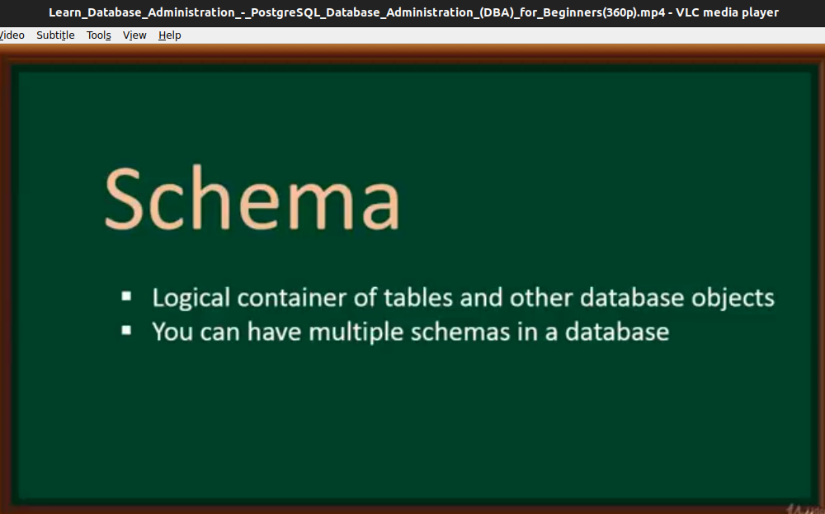**Fig 1: Schema definitions**

With schema we can create custom schema by setting some access permission data: how can access data in the schema. We can also create a separated schema for a particular class group of user.

# 2. Tablespace

Tablespace is a logical storage where data that are underling objects are kept. A Tablespace basically provide a layer of abstraction between the logical ant the physical data.

Tables in database ( PostgreSQL ) are saved in a tablespace. PostgreSQL basically provide two tablespaces (pg_default and pg_global) for every new PostgreSQL server.

* **pg_default:** pg_default is used to save user related data.
* **pg_global:** pg_global is used to system related data.

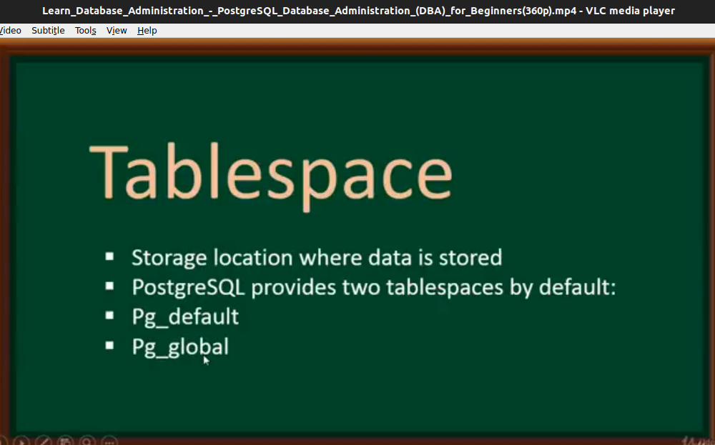**Fig 2: tablespace**

# 3. Views

Views are basically virtual tables used to simplify complex queries. Also, views are used to protect records securely. We can use view to hide information or protect setting path of the table from others to see.

Views support the same queries as table. Below is a screenshot of an select query on a view and it’s result.

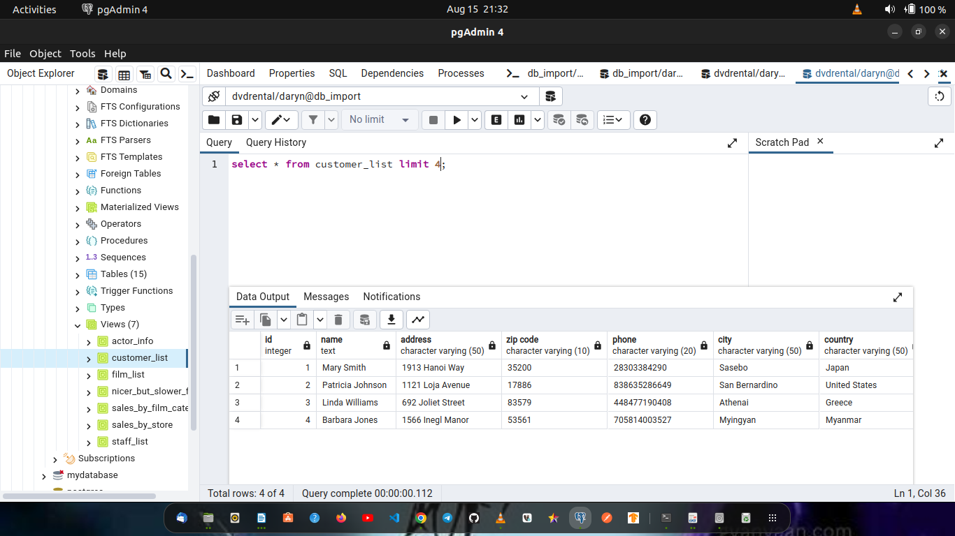**Fig 3: views**

# 4. Functions

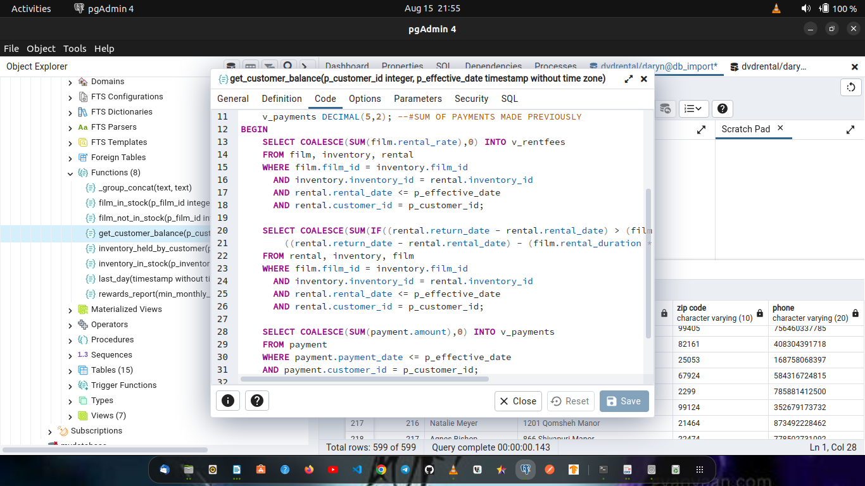**Fig 5: functions**

Above is an example of function.

Functions are blocks of reusable SQL code that can be use in other SQL query. Functions a created in the schema. Functions are useful for accomplish repetitive calculation.

Video watching: 01:50:31