P.O. BOX 63 Buea, South West Region CAMEROON Tel: (237) 3332 21 34/3332 26 90 Fax: (237) 3332 22 72

**PEACE-WORK-FATHERLAND**

**MINISTRY OF HIHGER EDUCATION**

**UNIVERSITY OF BUEA**



**FACULTY OF ENGINEERING AND TECHNOLOGY**

**DEPARTMENT OF COMPUTER ENGINEERING**

**MODELING A FEEDBACK SYSTEM FOR AN AUTOMATIC GATE CONTROL SYSTEM**

A School based Project proposed by members of group 18 and 19 for assessment in the course **EEF460: Feedback System Lab**

**GROUP 18 & 19**

|  |  |
| --- | --- |
| **AMGINYUWEPNJE CLINTON M** | **FE20A010** |
| **ENEMBE VERINE** | **FE20A033** |
| **AYAMBA OJONG** | **FE20A019** |
| **NGI KELVIN AYUK** | **FE20A076** |
| **NGANKEP FANDIO ORDY** | **FE20A075** |
| **DJOUKENG YANNICK IVAN** | **FE20A030** |
| **LEKEAKA DELAND** | **FE20A56** |
| **DJIOTSA DJOUKE CHRISTIAN** | **FE20A029** |

**Supervisor:**

**Engr. BOREL TOUTSOP 2022/2023 Academic Year**

# TABLE OF CONTENT

TABLE OF CONTENT i

PROJECT REPORT 2

Introduction. 2

Table of inputs and Outputs 4

Flowchart of the system 4

Grafcet 5

Ladder Network 7

Simulation Results 8

Conclusion 9

# PROJECT REPORT

## Introduction.

Automatic gate control systems are an essential aspect of managing vehicle access in various settings, be it residential or commercial. These systems provide a convenient and secure solution by automatically opening and closing gates to allow vehicles to enter or exit premises. With advancements in technology and intelligent programming, automatic gate control systems streamline access management, enhancing efficiency and security.

In this report, we focus on the development and programming of an automatic gate control feedback system for houses or companies. The primary objective of this system is to automate the process of gate operation, allowing seamless entry and exit of vehicles while maintaining optimal security. By eliminating the need for manual gate handling, this system improves convenience, minimizes human effort, and enhances overall safety.

Our automatic gate control system incorporates advanced technologies, such as sensors, controllers, and actuation mechanisms, to detect approaching vehicles, trigger gate opening, and subsequently close the gate once the vehicle has passed through. Through intelligent programming, the system responds promptly to user input and external stimuli, ensuring efficient and reliable operation.

In this report, we will discuss programming aspects, system architecture, and operational flow of our automatic gate control system. using the PLCSIM simulator, a powerful software program that facilitates the creation and simulation of Programmable Logic Controller (PLC) programs.

The automatic gate control system will be programmed using a ladder network. The ladder network will be used to control the movement of the elevator and to respond to sensor input.

Our automatic gate control system is designed to provide efficient and responsive control over the movement of the gate, ensuring the safety of vehicles and people. The system incorporates sensors to detect the presence of cars or people and trigger the corresponding actions. These sensors play a crucial role in stopping the gate's motion when an obstruction is detected during opening or closing. Additionally, LED indicators are utilized to provide visual feedback on the motion of the gate.

1. Car/Person Presence Sensors:

Sensors are strategically placed to detect the presence of cars or people near the gate. These sensors continuously monitor the gate's vicinity and are capable of detecting any obstructions during the gate's operation. If a sensor detects a car or person when the gate is attempting to open or close, it triggers an immediate stop command.

2. Gate Motion Control:

The gate's motion is controlled by a motor that operates in two directions: opening (moving up) and closing (moving down). When the system receives a command to open the gate, such as when a car is approaching, the motor is activated to move the gate upwards. Conversely, when the system receives a command to close the gate, such as when a car has entered or left the gate's vicinity, the motor is activated to move the gate downwards.

**3. Height Limit Sensors:**

Height limit sensors are incorporated into the system to detect the upper and lower limits of the gate's movement. These sensors ensure that the gate does not exceed its safe operational range. If a height limit sensor is triggered, indicating that the gate has reached its upper or lower limit, the system will immediately stop the gate's motion.

**4. LED Indicators:**

The system utilizes LED indicators to provide visual feedback on the gate's motion. When the gate is in motion, either opening or closing, the corresponding LED indicator illuminates to indicate the direction of the gate's movement. For example, when the gate is opening, the "Motion Up" LED indicator turns on, and when the gate is closing, the "Motion Down" LED indicator illuminates. When the gate stops moving, both LED indicators turn off.

## Table of inputs and Outputs

|  |  |
| --- | --- |
| **Inputs** | **Description** |
| Open gate button | It is trigger by a sensor and to cause to gate to move up |
| Close gate button | It is trigger by a sensor and to cause to gate to move up |
| Stop gate button | This is triggered incase emergency stopping |
| Open limit | Position sensor to know is the gate is completely open |
| Close Limit | Position sensor to know when the gate is total closed |
|  | |
| **Outputs** | **Description** |
| Motor down | Cause the gate to open |
| Motor down | Cases the gate to close |
| Motion Up LED | Turn on when the gate is opening |
| GateMotion Down | Turns on when the gate is closing |

## Flowchart of the system

We are going systematically step by step to show the right sequence to achieve an electric gate work. When a request to close the gate. The emergency stop is checked and if is there an open gate request in progress if the answer is no then it is all the settings to run the motor in the down direction to close the gate by activating the related contactor to energize the motor in the direction to close the gate.

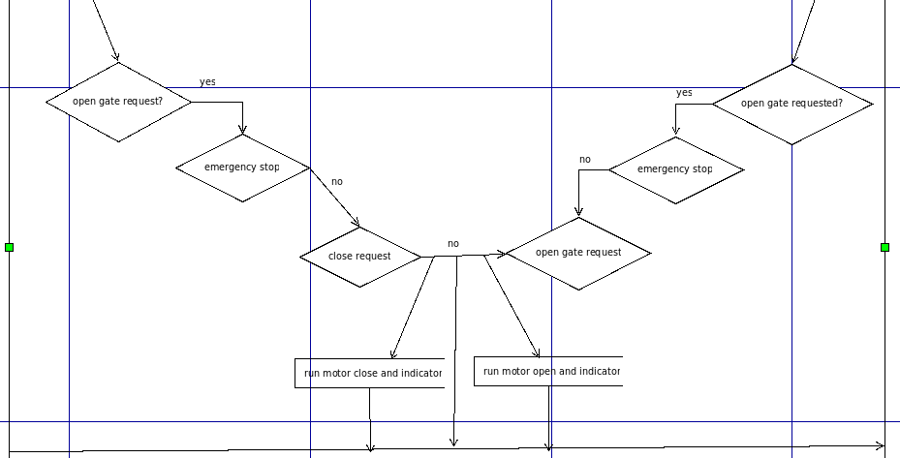**Flowchart of the system**

## Grafcet

The Grafcet (GRAphe Fonctionnel de Commande Etape/Transition) is a graphical representation of the elevator system's control logic. It depicts the various states and transitions that the gate goes through during its operation. The Grafcet for the automatic gate control system is shown below.

**Pseudo code:**

Start:

Set MotorUp to False

Set MotorDown to False

Set MotionUpLED to False

Set MotionDownLED to False

Loop:

If OpenGateButton is pressed:

Set MotorUp to True

Set MotionUpLED to True

Set MotionDownLED to False

If CloseGateButton is pressed:

Set MotorDown to True

Set MotionUpLED to False

Set MotionDownLED to True

If StopGateButton is pressed:

Set MotorUp to False

Set MotorDown to False

Set MotionUpLED to False

Set MotionDownLED to False

If UpLimit is triggered:

Set MotorUp to False

Set MotionUpLED to False

If DownLimit is triggered:

Set MotorDown to False

Set MotionDownLED to False

Go to Loop

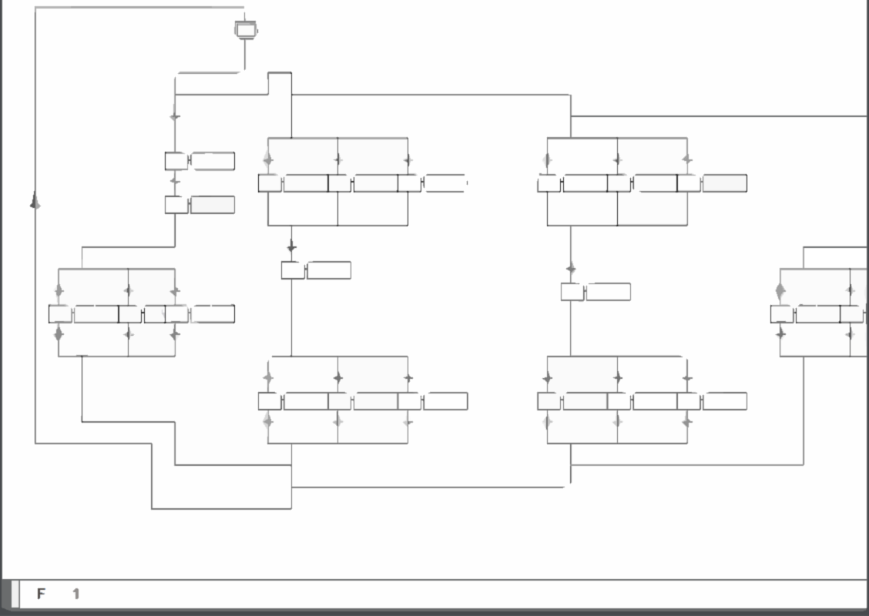

## Ladder Network

Simulation Results Based on the Grafcet, the ladder network can be developed using the ladder diagram language. The ladder network represents the program logic that controls the gate's movement. The specific details of the ladder network depend on the programming language and PLC hardware used. Here, we assume a typical ladder diagram representation, which can be created in the TIA Portal software.

Our Ladder Networks are shown below:

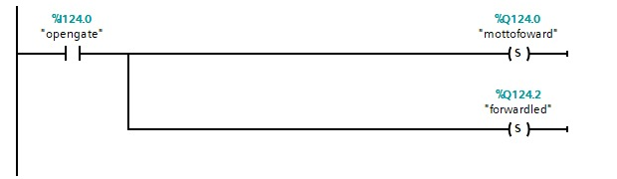

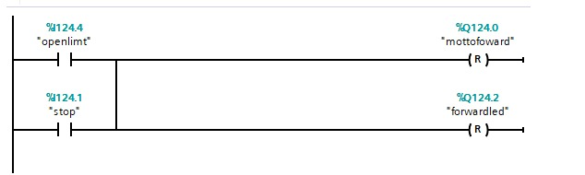

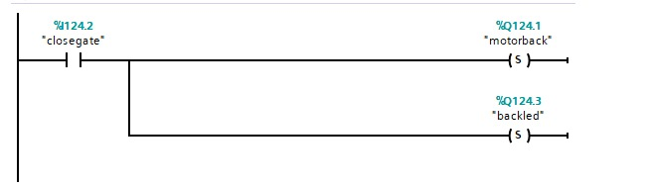

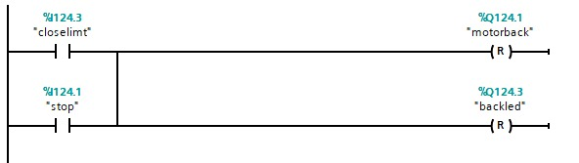

Figure 1: Ladder Network For Automatic Gate

## Simulation Results

The simulation of the automatic gate system is shown below. The simulation demonstrates the gate's behavior in response to user input and various conditions.

By executing the program within the simulation environment, we can observe the gate's movements and validate the correctness of the control logic. The simulation provides a virtual representation of the gate system, allowing us to evaluate its behavior without the need for physical hardware.

During the simulation, we can monitor the status of the inputs such as the open gate button, close gate button, stop gate button, up limit sensor, and down limit sensor. We can also observe the corresponding outputs, including the motor up, motor down, motion up LED, and motion down LED.

By analyzing the simulation results, we can ensure that the gate responds correctly to user input and various scenarios. We can verify that the gate moves up when triggered by the open gate button, down when triggered by the close gate button, and stops when the stop gate button is activated or when it reaches the upper or lower height limits. Additionally, we can observe the illumination of the motion up LED and motion down LED during the gate's movement.

The simulation serves as a valuable tool for testing and validating the functionality of the automatic gate system. It allows us to identify and rectify any issues or anomalies in the control logic before implementing the system in the physical environment.

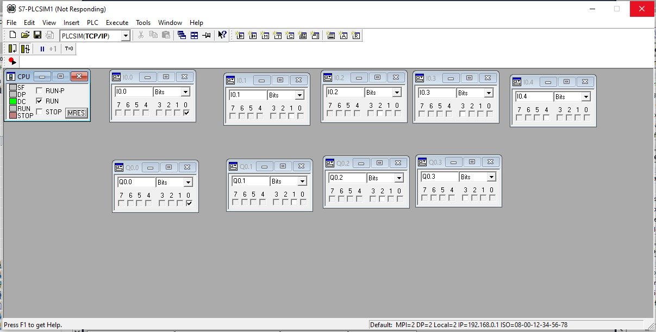

*Figure 2:Simulation Results*

## **Conclusion**

In conclusion, the implementation of the automatic gate control system using Siemens TIA Portal and ladder network programming offers efficient control over the gate's movements and ensures safe operation. The system's operating principle, based on the inputs and outputs defined in the table, allows for seamless control and monitoring of the gate's motion.

By utilizing sensors to detect various conditions such as the presence of vehicles, gate position limits, and emergency stops, the system responds accurately to different scenarios. The inputs, including the Open Gate Button, Close Gate Button, Stop Gate Button, Up Limit, and Down Limit sensors, enable precise control over the gate's motion and ensure the safety of individuals and vehicles.

The ladder network programming, designed in Siemens TIA Portal, provides a reliable framework for coordinating the inputs and outputs, allowing the gate to move up, move down, stop, and indicate its motion through the Motion Up LED and Motion Down LED. The logical structure of the ladder network ensures the proper sequencing of actions and the appropriate response to user input and sensor readings.

Furthermore, utilizing simulation capabilities in Siemens TIA Portal allows for thorough testing and validation of the control logic before actual deployment. This simulation environment provides a virtual representation of the gate system, enabling the observation and verification of its behavior without the need for physical hardware.

The automatic gate control system, developed using Siemens TIA Portal and ladder network programming, offers a robust and reliable solution for managing gate movements. The system's operating principle, supported by accurate sensor readings and precise control logic, ensures efficient and safe operation. The simulation capabilities in Siemens TIA Portal serve as a valuable tool for testing and validating the system's behavior, ensuring its functionality before implementation.