BASKETBALL

# INTRODUCTION

**Basketball** is a dynamic team sport played on a rectangular court by two teams of five players each. The objective is to score points by shooting a ball through the opponent's hoop, which is a rim mounted 10 feet above the ground. Basketball boasts a rich history from its invention by **James Naismith in 1891** to its evolution into a global phenomenon.

# BASKETBALL GAMEPLAY

Basketball gameplay comprises a dynamic blend of individual technical skill and strategic teamwork on a rectangular court. Two teams of five players each compete to score points by propelling a spherical ball through the opponent's rim, mounted ten feet above the ground.

Basketball gameplay elements include:

* **Offense:** Teams strategize to orchestrate plays, create scoring opportunities, and execute maneuvers like dribbling, passing, and shooting with precision and coordination.
* **Defense:** Players employ individual and collective defensive tactics to impede the opposing team's offensive efforts, including steals, blocks, and contesting passes.
* **Transitions:** Both teams quickly shift between offensive and defensive phases, requiring agility, anticipation, and efficient communication.
* **Fouls:** Contact violations are penalized with free throws or team turnovers, adding strategic considerations and influencing game flow.

**Basketball offense** is a complex and exhilarating art form, where teams create plays, utilize individual skills, and orchestrate movement to outsmart the defense and score points. Let's dissect its key components:

* **Pick-and-Roll:** A basic but effective play where a screener (usually the big man) sets a pick on a defender guarding a ball-handler, creating space for either player to attack the basket or initiate offense.
* **Passing**: Accurately and rapidly transferring the ball around the perimeter to find open teammates or set up scoring opportunities.
* **Shooting:** Executing various shots effectively from different distances and angles, including layups, jump shots, and three-pointers.

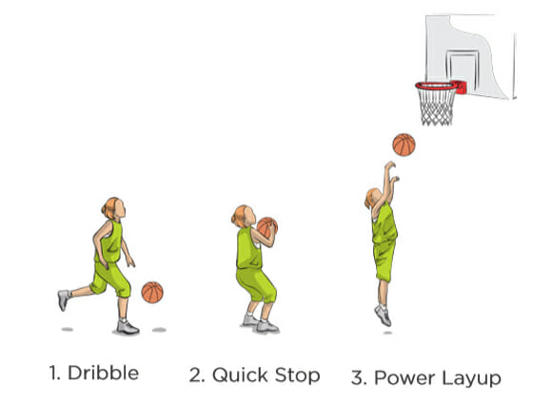 **Figure: layups**

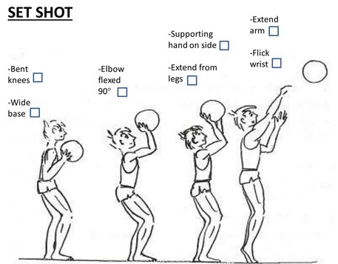**figure: Jump shorts**

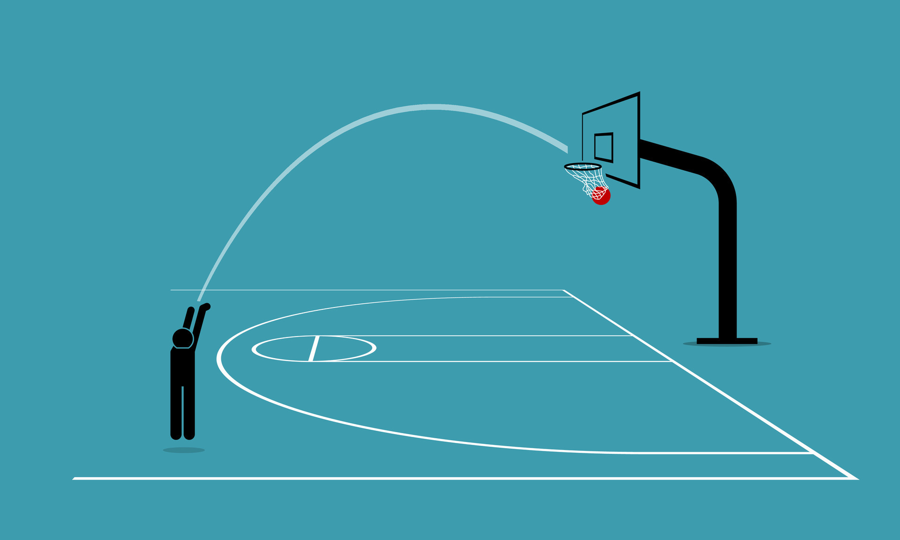**figure: Three-pointers**

* **Spacing**: Maintaining proper distance between teammates to avoid crowding and facilitate ball movement, passing lanes, and driving opportunities.
* **Cutting:** Moving without the ball towards the basket or open areas to receive a pass and potentially score.

**Basketball defense** is the art of thwarting the opponent's scoring aspirations. It's a strategic and cohesive effort, demanding individual discipline, coordinated movements, and an unyielding determination to prevent baskets. Let's explore the intricate web of defensive tactics:

* **Disrupt Offensive Rhythm:** Break down the opponent's offensive flow, forcing them into turnovers, contested shots, and inefficient offensive actions.
* **Limit Scoring Opportunities:** Closely guard offensive players, contest shots effectively, and prevent easy baskets near the rim.
* **Force Turnovers**: Interrogate passing lanes, anticipate offensive moves, and create opportunities to steal the ball or force bad passes.
* **Rebound Effectively:** Secure missed shots to gain possession and launch your own offensive transition or set up second-chance scoring opportunities.

# BASKETBALL RULES

Whether you're a newbie dribbling your first ball or a seasoned player aiming to refine your game, understanding the key rules of basketball is essential. Here's a quick rundown of the fundamental guidelines to follow:

* **Objective:** The objective of basketball is to score more points than the opposing team by shooting the ball through the opponent's hoop.
* **Teams:** Two teams of five players each compete on a rectangular court with a hoop at each end.
* **Court:** The court is 94 feet (28.65 meters) long and 50 feet (15.24 meters) wide. The hoop is 10 feet (3.05 meters) high above the ground.
* **Ball:** The ball is 29.5 inches (75 centimeters) in circumference and weighs 22 ounces (623.7 grams).
* **Gameplay:** The game is played in four quarters of 12 minutes each. The team with the most points at the end of the game wins.

# **Common Violations**

* **Traveling:** A violation that occurs when a player takes more than two steps without dribbling the ball.
* **Double Dribbling:** A violation that occurs when a player dribbles the ball with both hands consecutively.
* **Carrying the ball:** A violation that occurs when a player holds the ball with both hands or carries it illegally.
* **Out-of-Bounds:** A violation that occurs when the ball touches the ground or any other out-of-bounds object outside the court.
* **Foul:** An infraction of the rules that results in a penalty for the opposing team.

# **Common Fouls**

* **Personal Foul:** A foul that occurs when a player makes illegal contact with an opponent.
* **Technical Foul:** A foul that occurs when a player commits unsportsmanlike conduct.
* **Flagrant Foul:** A serious foul that occurs with excessive or malicious contact.

# **Common Scoring Plays**

* **Layup:** A shot made from close range, usually by driving to the basket and using one hand to scoop the ball through the hoop.
* **Jump Shot:** A shot made from a distance, usually by jumping into the air and releasing the ball at the peak of the jump.
* **Three-Pointer:** A shot made from beyond the three-point line, which is worth three points instead of two.
* **Free Throw:** A shot taken from the free throw line, which is worth one point.

# Consequence of rule violation in basketball

1. **Recognition and Whistle:**

* Referees observe the game closely to detect violations.
* Upon noticing a violation, they blow a whistle to stop play and signal the infraction.

1. **Stoppage of Play:**

* The game immediately pauses when the whistle is blown.
* Players must halt their actions and remain in their positions.

1. **Signal and Announcement:**

* Referees use specific hand signals to indicate the type of violation committed.
* They may also verbally announce the violation to players and spectators.

1. **Penalty Assessment**

Depending on the type of violation, the following penalties can be assessed**:**

* **Traveling**: Turnover, ball awarded to the opposing team.
* **Double dribbling**: Turnover, ball awarded to the opposing team.
* **Carrying the ball**: Turnover, ball awarded to the opposing team.
* **Out-of-bounds**: Turnover, ball awarded to the opposing team.
* **Three-second violation:**Turnover, ball awarded to the opposing team.
* **Offensive foul**: Free throws for the opposing team (number of throws depends on foul type).
* **Defensive foul:** Inbounds pass for the offensive team.
* **Technical foul:**One free throw for the opposing team, plus possession of the ball.
* **Unsportsmanlike conduct:** Technical foul or ejection, depending on severity.

1. **Resumption of Play:**

Once the penalty is assessed, play resumes according to the rules for that specific situation, such as:

* In-bounding the ball from the sideline.
* Taking free throws.
* Awarding possession to the opposing team.

1. **Game Continuation:**

* The game continues with the appropriate adjustments based on the penalty.
* Players and officials adapt to the new circumstances and proceed with play.

1. **Additional Considerations:**

* **Intentional vs. Unintentional Violations:** The severity of the penalty may vary depending on whether the violation was deemed intentional or unintentional.
* **Repeat Violations:** Players or teams may face escalating penalties for repeated violations of the same rule.

# BASKETBALL FIELD

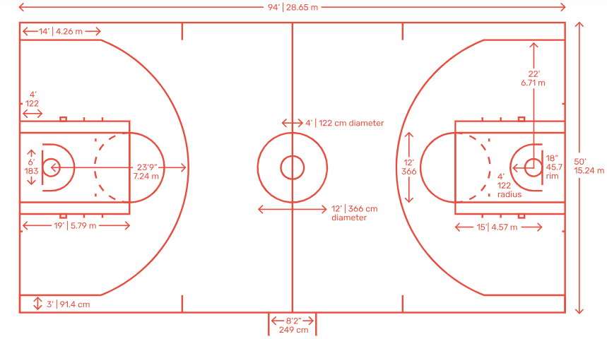**Figure: Basketball Field**

# CONCLUSION

In essence, basketball is more than just a sport. It's a thrilling spectacle, a test of physical and mental strength, and a testament to the power of teamwork and perseverance.