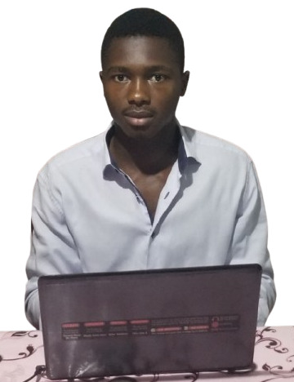

Djiotsa Djouake Christian Daryn

Fullstack Software Engineer | Mobile & Web Application Developer | AI Enthusiast | Solution-Oriented

LinkedIn: https://www.linkedin.com/in/djiotsa-christian-36470a253/

# About Me

I am a disciplined and results-driven Fullstack Software Engineer with extensive experience in designing, developing, and optimizing web and mobile applications. I specialize in creating scalable, user-centric solutions while collaborating closely with clients, marketing teams, UX designers, and development teams. I thrive on translating complex business requirements into intuitive workflows and high-performance applications. I am passionate about leveraging modern technologies and applied AI to solve real-world problems, improve operational efficiency, and deliver exceptional user experiences.

# Core Competencies

• Fullstack application development (web & mobile)

• Solution design and technical problem-solving

• Code optimization, testing, and debugging

• Agile collaboration with clients, marketing, UX, and development teams

• AI and NLP application integration (Named Entity Recognition)

• Workflow automation and performance evaluation systems

• Project planning and requirements translation into actionable solutions

# Experience

## Software Engineer – Ultrasoft Technologies SARL

February 2025 – Present | Yaoundé, Cameroon

• Developed and optimized web and mobile applications for clients in various sectors.

• Worked closely with marketing and UX teams to design user-centric solutions.

• Performed rigorous testing, debugging, and performance optimization across applications.

• Contributed to building scalable backend services for secure transactions, data management, and workflow automation.

## Software Developer – Hackerton

• Participated in designing and maintaining web applications, focusing on improving usability and efficiency.

• Collaborated with teams to implement client requirements into actionable software solutions.

## DevOps Engineer – HNG Tech

January 2025 – Present

• Implemented continuous integration and continuous deployment (CI/CD) pipelines to streamline development workflows.

• Managed cloud infrastructure and automated deployment processes to ensure scalability and reliability.

## Data Scientist – DataCamp

January 2025 – Present

• Analyzed and interpreted complex datasets to provide actionable insights.

• Developed predictive models and machine learning algorithms to support data-driven decision-making.

# Education

Bachelor of Engineering in Software Engineering – University of Buea | GPA: 3.37/4

Bachelor's in Physics Science – University of Dschang

# Certifications

• Software Design Thinking – IBM (3 certifications)

• Product Management – Pendo (2 certifications)

# Featured Projects

## MOMO MANAGE

Website: https://momo-manage.onrender.com/

A business management platform for small enterprises. I participated in the development of both mobile and web applications, performing testing and code optimization, while collaborating with clients, marketing, UX, and development teams. I helped create workflows for tracking transactions, managing employees, and visualizing income and expenses in an intuitive, user-friendly interface.

## Mhulo Portfolio

Website: https://portfolio-bootstrap5-fontawesome.onrender.com/

A professional portfolio website showcasing services and professional achievements. I contributed to both web and mobile design aspects, ensuring responsiveness and usability. I collaborated with UX designers and stakeholders to translate information into clear and engaging presentations.

## Employee Goal Tracker (EGT)

Website: https://github.com/yourusername/egt

A system for managing employee goals, tasks, and performance evaluation. I developed web and mobile functionalities, performing testing and code optimization, and collaborated with clients and internal teams to ensure workflow efficiency and actionable insights for performance tracking.

## Yemba Named Entity Recognition (NER)

Website: https://yembanerui.onrender.com

An AI-powered system for identifying entities in the Yemba language. I contributed to developing web and mobile applications, performed testing and optimizations, and worked with the team to design intuitive interfaces for efficient textual data processing and entity recognition.

## UltraCollecte

Website: https://payment-server.ultrasoft.cm/

I participated in the development of this secure payment application, both web and mobile. My work included testing and code optimization, while collaborating closely with clients, marketing teams, UX designers, and developers. I contributed to implementing robust transaction handling, ensuring data integrity, and designing scalable services that support reliable and efficient payment workflows. UltraCollecte streamlines financial operations for institutions, enabling client management, transaction recording, and reporting.

## Au Boulot

Website: https://auboulot.org/

I built the administration dashboard for this task and project management platform on web and mobile. My role involved testing, code optimization, and collaboration with clients, marketing, UX, and development teams. I implemented features for task assignment, progress tracking, and resource management, improving organizational efficiency and workflow transparency.

# Contact

Email: mhulodjiotsa@gmail.com

Phone: +237 656 222 624

Location: Douala, Cameroon

Availability: Onsite & Remote