***Ex1***

After looking at the hint message for ex1 we know that we should be looking for some basic arithmetic being performed on our input. With this knowledge lets begin with radare2 and the ghidra decompiler, to examine the decompiled code for the main function we use the “[pdg@main](mailto:pdg@main)” command. This will display all lines from the decompiled output so it is advised to “pipe” the output to “less” to be able to easily navigate it. A good place to start looking would be near any reference to the “Score!” message that we are trying to receive. By doing so we see that when the addition of our input values converted from ascii characters to integers equals hex 0x79e ex1 prints the “Score!” message.

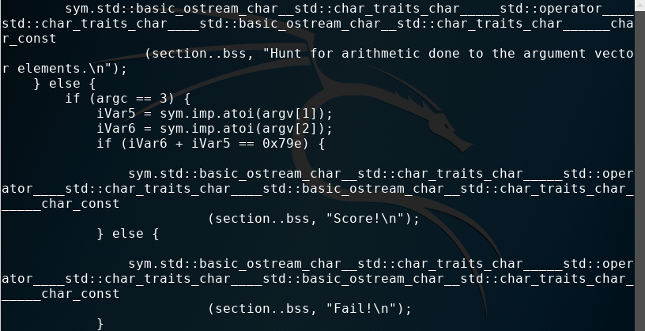

From here we just need to figure out what hex 0x79e is in decimal using the bc, binary calculator, command by setting its ibase, input base, value to 16 for hexidecimal since the default is 10.

