***Ex0***

In this challenge we are looking for a hard-coded string in the binary. When strings are hard-coded, we can use one of many tools to look through the binary for human readable text. In this help file we will demonstrate some of the tools available for problems like this one. Remember there is more than one way to solve this, so you are encouraged to try different tools once you have successfully received a “Score!” from the challenge.

* strings

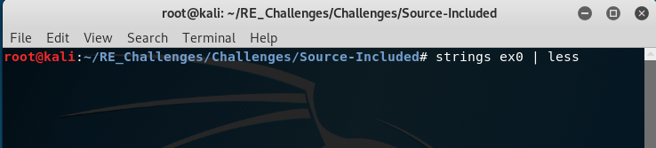To run this command simply type its name in the terminal windows with the binary in ex0 as its parameter, the amount of human readable text in a binary file can be quite large so in order to make it easier to sift through we will pipe “|” the input to a program, “less”, that will take its input and display it in a scroll-able page format.

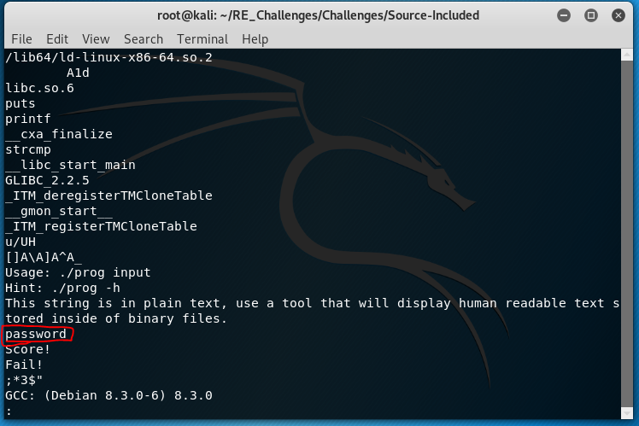

Notice that right before the “Score!” string that we are trying to get printed to the display is the string “password”. This is the hard coded string that we are comparing our input into ex0 with.

* Radare2

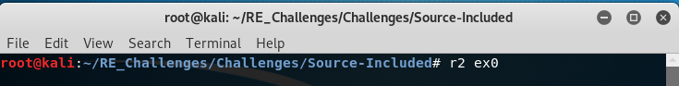Radare2 has an alias to reduce the amount of characters needed to run the command, “r2”, from here we just need to type the program we are analyzing, “ex0”.

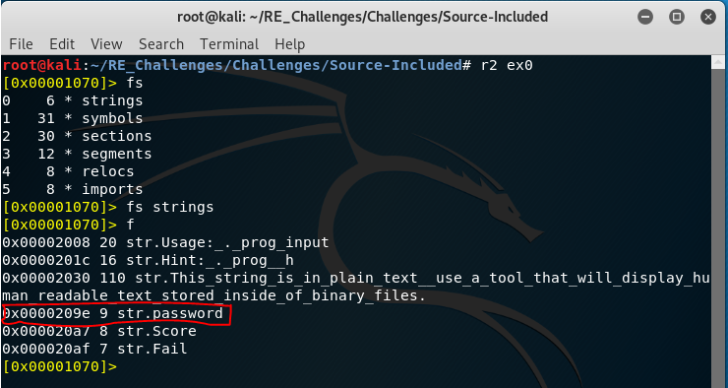When radare2 is loaded with a binary it makes note of key parts of a file and “flags” them. These flags are stored into a corresponding “flag space”. To view the flag spaces type “fs. Then, to change to a desired flag space we type “fs” with the space we want to enter. Then, list then with the flags “f” command. Notice that we get a much shorter list of strings but still has what we are looking for! This is because radare2 does not search for every possibly human readable string in the binary like the “strings” command.

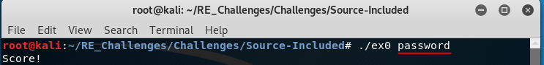Now that we have the input lets validate it and get a Score!