Installation:

Unzip attached update package for DIVeMB directly in the DIVeMB Build path.

Usage:

* Simulation needs to include a detailed engine and mil/sil MCM with MVA instrumentation and post-processing.
  + A MVA_collectAll.mat file with MVA norm names is needed
  + The standard workspace file (WS*.mat) is needed in original form including the sMP variable.
* **Automatic**: In the installation package there is already an adapted user post-processing function , which calls the PEMS evaluation.
* **Manual:** execution can be achieved by: dmsPemsEvaluateSim(‘<SimulationResultPath>’)

Available output:

* Evaluation results is stored within the structure variable “PEMS” within the file “PEMS_results.mat” in the simulation directory.  
  Direct result of 90% Percentil and 0% Power-Threshold can be obtained by PEMS.perc{1}(1)
* Plot figure as MATLAB figure “PEMS_results.fig” and standard picture “PEMS_results.jpg” in the simulation directory – direct result numbers can be read from the values in the bar plot.  
  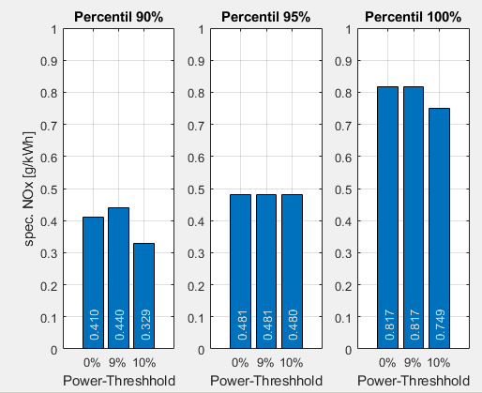

Limitations:

* Only WHTC work integrals of MDEG EU6 engines are within the code of dmsPemsEvaluateSim.m from a table provided by Metodi – extension for HDEP needed.
* DIVe Extension simulation have no coolant model currently, so a realistic limit by coolant heat up is not possible by simulation.
* The algorithms will exhibit different results on different sampling rates (e.g. 1Hz vs. 10Hz) as different Window sizes will be determined. E. g. one window start at 956s on 1Hz sampling, but at 655.7s on 10Hz sampling. What is correct in legal ways, needs to be determined still.

Options:

* In the code of dmsPemsEvaluateSim are values for the following settings:  
  + % settings of PEMS evaluation  
    data.percentiles = [90 95 100];  
    data.worklimitprz = [0 9 10];
  + %% Input values (legal settings)  
    zeitlimit = 900; % [s]  
    twalimit = 70; % [°C]  
    workcummmax = 1000; %kWh accumulated  
    legallimit = 0.46; %g/kWh Euro VI limit for NOx