FATLAB

BCSE301P

Software Engineering

Name: Arvind Chandrasekaran

Reg no: 21BCE1070

State Chart Diagram for Library System using starUML

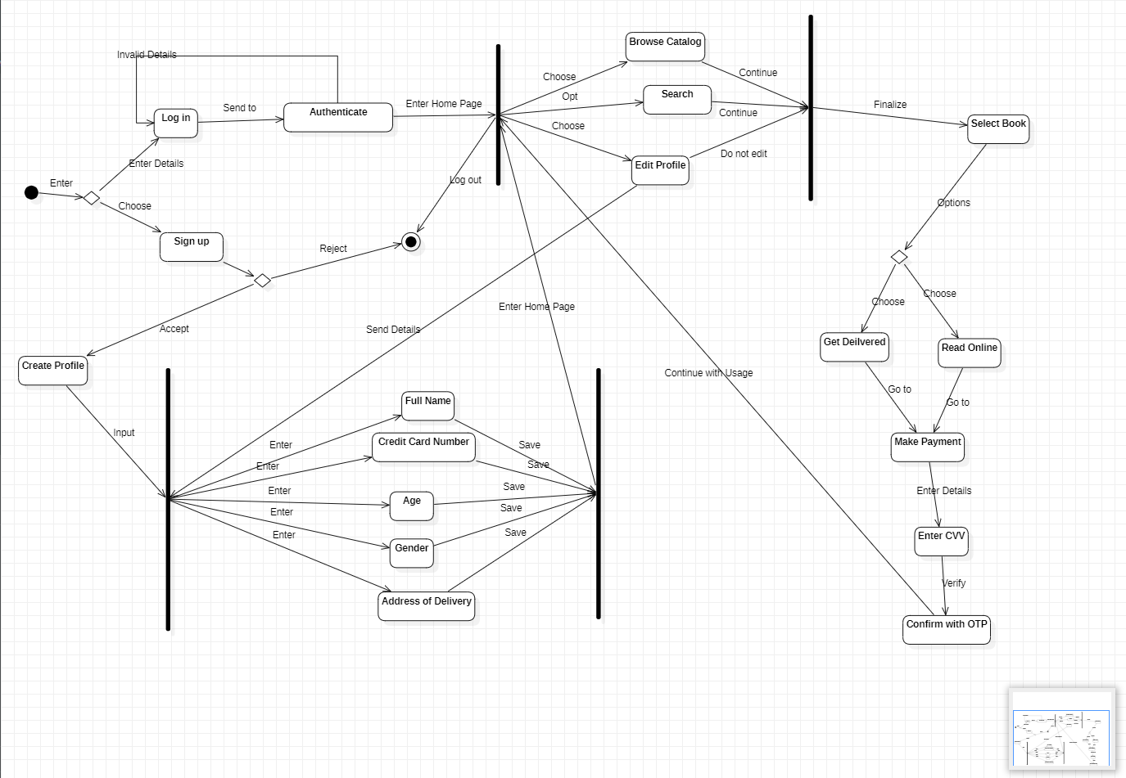

With timestap

