

**--------------------------------------------------------------------------------------------------------------------------------------**

**NAME: YOGESH J**

**REG NO: 21MIA1075**

**QUESTIONS SET:1**

1. The city music shop is planning to install a music kiosk in the waiting hall of its shop. The UI of the music kiosk provides the users with a one-stop music streaming station for all the music needs. The music lovers can easily search for any songs, stream and provide rating and reviews. The user can also download the songs, set it as their caller tune to their mobile devices. The application facilitates the user to identify and network the people with same musical interest by providing the logs of the users whoever searched, streamed and reviewed the songs earlier. It provides multi-featured search options for song selection and to network people.

1. Draw use case and sub use case diagram for at least two modules of the project

2. Draw the Entity Relationship Diagram for the project

**1).**

**1.1) Draw use case and sub use case diagram for at least two modules of the project.**

**Use Case Diagram:**

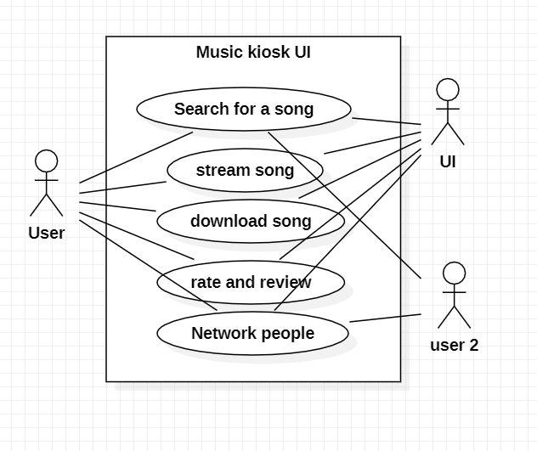

**Sub Use case diagram for the module: Search for a Song**

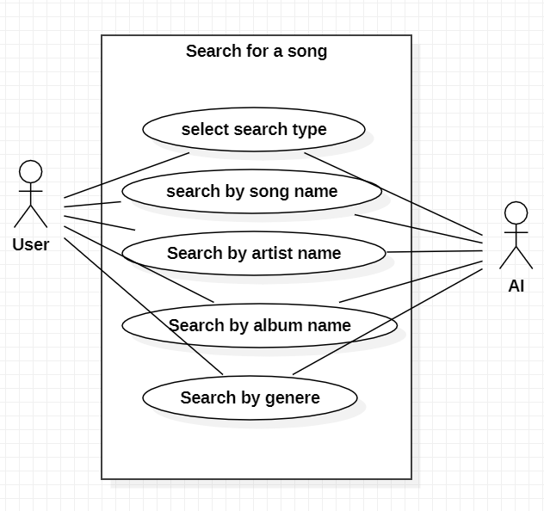

**Sub Use case diagram for the module: Stream Song**

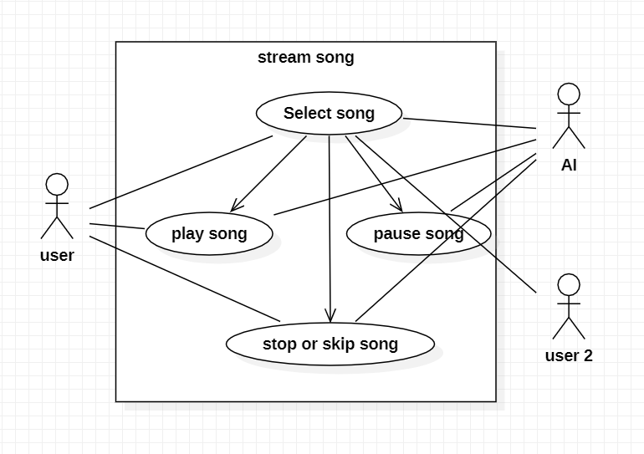

**OVERALL:**

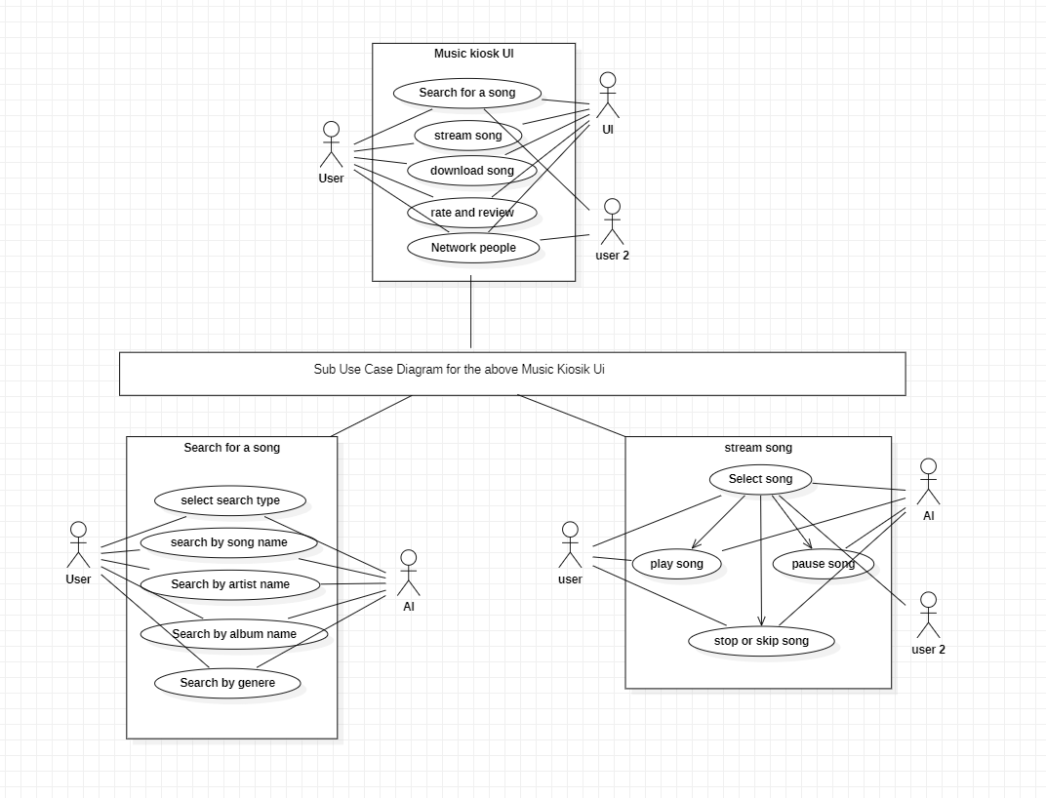

**********************************************************************************

**1.2)**

**Entities Used In The ER diagram**

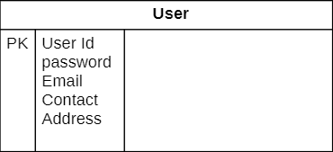

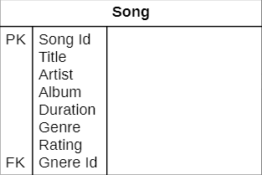

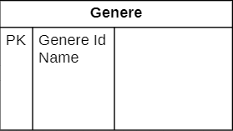

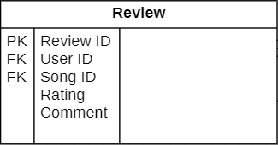

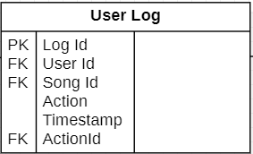

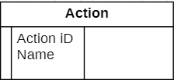

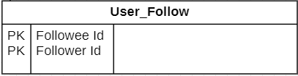

**Overall ER Diagram:**



