COS221  
Practical 5

Group 9

# Group Members

* Lesedi
* Sechaba
* Tebogo
* Unathi Dlamini u22553402
* Dean

# Task

The project involves collaborating with Hoop, a fictional streaming service, to develop and implement new features for its platform. The goal is to create a user-friendly streaming application that offers a curated collection of movies and TV series worldwide. The application should allow users to easily discover, and filter content based on genres, ratings, release dates, and more. Additionally, users should be able to view detailed information about each title, including cast, crew, plot summaries, and user reviews. Social features such as user profiles, rating, reviewing, and content sharing with friends are also desired.

# Overview

To carry out this task our team will design the required database by first researching the project scenario and creating diagrams to test and review the effectiveness of the database design. We will then create the database and populate it with data from the sources provided.  
The database will hosted on phpMyAdmin using the universities Wheatley server.  
Data will be sourced from the various database’s and Api’s provided and cleaned and augmented as need to fit our own database. We will use python for the data cleaning, augmenting and creation.

# Research

## Technology Trends of the Streaming Industry

## A major trend in the streaming industry is the shift towards microservices architecture, as opposed to monolithic applications. Given that microservices are beyond the scope of this course, we have adhered to a more basic architecture for this practical.

## Most major streaming sites utilize Content Delivery Networks (CDNs). CDNs consist of file servers that store titles as Binary Large Objects (BLOBs). These servers are strategically located worldwide, enabling users to access content from a nearby location, thereby reducing latency. For our practical, we will assume that the file servers are cloud-based applications set up separately from the Hoop web application. Each title can be accessed via a URL called fss_address, which links to the title stored in the CDN file server relative to the user's region.

## Content Trends of the Streaming Industry

## Streaming platforms such as Apple TV, Netflix, and Hulu invest millions in creating exclusive content. Exclusive content attracts new users since it is not available elsewhere. In recent years, these companies have also acquired the streaming rights to many older, more nostalgic titles to capitalize on the large millennial market. Therefore, it is essential for Hoop to have a good blend of both modern, fresh content and older classics.

## Streaming services must compete with social media platforms for user retention. Encouraging users to share the content they are watching on social media can attract new users to the site, increasing traffic. Social media platforms are also used to market new content and features.

## Movie/TV Show types and genres / Preferences

Some streaming services focus on niche genres, such as BroadwayHD, which specializes in Broadway and musical titles. However, most major platforms aim to offer something for everyone to attract the most users and generate more revenue. Recently, genres like true crime and video game adaptations have increased in popularity, but the top revenue-generating genres remain Adventure, Action, and Comedy. It is important for Hoop to offer a variety of genres.  
Having many genres means having vast amounts of content, which can leave users feeling overwhelmed by the choices. User preferences and recommendations help streaming services present content relevant to users' interests and tastes, mitigating this issue. Netflix uses reinforcement learning algorithms to generate recommendations for users. For Hoop we will simply base recommendations off of watched genres, studio and preferences.

References:  
<https://explodingtopics.com/blog/streaming-trends>

<https://blog.dreamfactory.com/microservices-trends/>

<https://www.makeuseof.com/tag/niche-streaming-services-hate-netflix/>

<https://www.statista.com/statistics/188658/movie-genres-in-north-america-by-box-office-revenue-since-1995/>

<https://research.netflix.com/research-area/recommendations>

# Relational Schema

Diagram:  
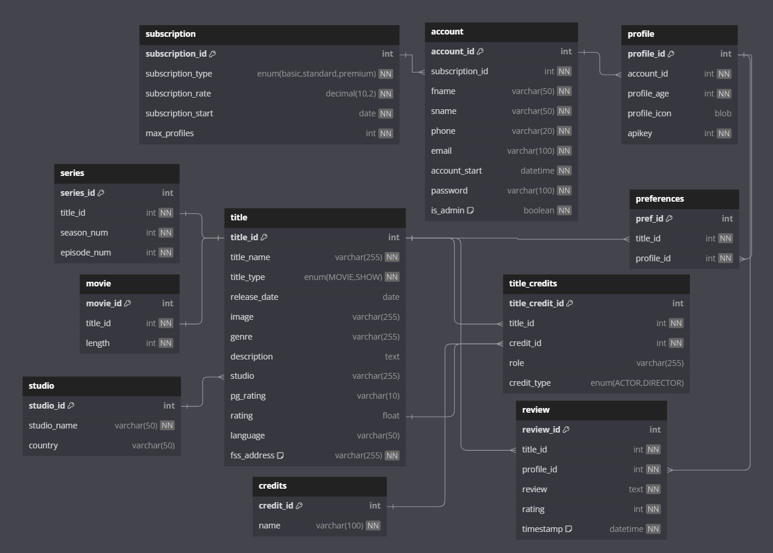  
SQL Code:  
--Creates the schema for the Hoop database

-- Recreate the database if it already exists

DROP DATABASE IF EXISTS COS221_HOOP;

-- Create Hoop database

CREATE DATABASE COS221_HOOP;

-- Use Hoop database

USE COS221_HOOP;

-- Create Tables and Relationships...

-- Create subscription table

CREATE TABLE IF NOT EXISTS subscription (

    subscription_id INT AUTO_INCREMENT PRIMARY KEY,

    subscription_type ENUM('basic', 'standard', 'premium') NOT NULL,

    subscription_rate DECIMAL(10, 2) NOT NULL,

    subscription_start DATE NOT NULL,

    max_profiles INT NOT NULL

);

-- Create account table

CREATE TABLE IF NOT EXISTS account (

    account_id INT AUTO_INCREMENT PRIMARY KEY,

    subscription_id INT NOT NULL,

    fname VARCHAR(50) NOT NULL,

    sname VARCHAR(50) NOT NULL,

    phone VARCHAR(20) NOT NULL,

    email VARCHAR(100) NOT NULL,

    account_start DATETIME NOT NULL,

    password VARCHAR(100) NOT NULL,

    is_admin BOOLEAN NOT NULL DEFAULT FALSE,

    FOREIGN KEY (subscription_id) REFERENCES subscription(subscription_id)

    ON DELETE CASCADE

);

-- Create profile table

CREATE TABLE IF NOT EXISTS profile (

    profile_id INT AUTO_INCREMENT PRIMARY KEY,

    account_id INT NOT NULL,

    profile_age INT NOT NULL,

    profile_icon BLOB,

    apikey INT NOT NULL,

    FOREIGN KEY (account_id) REFERENCES account(account_id)

    ON DELETE CASCADE

);

-- Create title table

CREATE TABLE IF NOT EXISTS title (

    title_id INT AUTO_INCREMENT PRIMARY KEY,

    title_name VARCHAR(255) NOT NULL,

    title_type ENUM('MOVIE', 'SHOW') NOT NULL,

    release_date DATE,

    image VARCHAR(255),

    genre VARCHAR(255),

    description TEXT,

    studio VARCHAR(255),

    pg_rating VARCHAR(10),

    rating FLOAT,

    language VARCHAR(50),

    fss_address VARCHAR(255) NOT NULL DEFAULT "https://www.fss_address.com",

    FOREIGN KEY (studio) REFERENCES studio(studio_id)

    ON DELETE CASCADE

);

-- Create series table

CREATE TABLE IF NOT EXISTS series (

    series_id INT AUTO_INCREMENT PRIMARY KEY,

    title_id INT NOT NULL,

    season_num INT NOT NULL,

    episode_num INT NOT NULL,

    FOREIGN KEY (title_id) REFERENCES title(title_id)

    ON DELETE CASCADE

);

-- Create movie table

CREATE TABLE IF NOT EXISTS movie (

    movie_id INT AUTO_INCREMENT PRIMARY KEY,

    title_id INT NOT NULL,

    length INT NOT NULL,

    FOREIGN KEY (title_id) REFERENCES title(title_id)

    ON DELETE CASCADE

);

-- Create credit table

CREATE TABLE IF NOT EXISTS credits (

    credit_id INT AUTO_INCREMENT PRIMARY KEY,

    name VARCHAR(100) NOT NULL

);

CREATE TABLE IF NOT EXISTS title_credits (

    title_credit_id INT AUTO_INCREMENT PRIMARY KEY,

    title_id INT NOT NULL,

    credit_id INT NOT NULL,

    role VARCHAR(255),

    credit_type ENUM('ACTOR', 'DIRECTOR'),

    FOREIGN KEY (title_id) REFERENCES title(title_id)

    ON DELETE CASCADE,

    FOREIGN KEY (credit_id) REFERENCES credits(credit_id)

    ON DELETE CASCADE

);

-- Create review table

CREATE TABLE IF NOT EXISTS review (

    review_id INT AUTO_INCREMENT PRIMARY KEY,

    title_id INT NOT NULL,

    profile_id INT NOT NULL,

    review TEXT NOT NULL,

    rating INT NOT NULL,

    timestamp DATETIME NOT NULL DEFAULT CURRENT_TIMESTAMP,

    FOREIGN KEY (title_id) REFERENCES title(title_id)

    ON DELETE CASCADE,

    FOREIGN KEY (profile_id) REFERENCES profile(profile_id)

    ON DELETE CASCADE

);

-- Create preferances table

CREATE TABLE IF NOT EXISTS preferences (

    pref_id INT AUTO_INCREMENT PRIMARY KEY,

    title_id INT NOT NULL,

    profile_id INT NOT NULL,

    FOREIGN KEY (title_id) REFERENCES title(title_id)

    ON DELETE CASCADE,

    FOREIGN KEY (profile_id) REFERENCES profile(profile_id)

    ON DELETE CASCADE

);

CREATE TABLE IF NOT EXISTS studio (

    studio_id INT AUTO_INCREMENT PRIMARY KEY,

    studio_name VARCHAR(50) NOT NULL,

    country VARCHAR(50)

);

--Trigger to ensure max_profiles is not violated

DELIMITER //

CREATE TRIGGER before_profile_insert BEFORE INSERT ON profile

FOR EACH ROW

BEGIN

    DECLARE profile_count INT;

    DECLARE max_profiles INT;

    SELECT s.max_profiles

    INTO max_profiles

    FROM subscription s

    JOIN account a ON s.subscription_id = a.subscription_id

    WHERE a.account_id = NEW.account_id;

    SELECT COUNT(*)

    INTO profile_count

    FROM profile

    WHERE account_id = NEW.account_id;

    IF profile_count >= max_profiles THEN

        SIGNAL SQLSTATE '45000'

        SET MESSAGE_TEXT = 'This account already has the maximum number of profiles.';

    END IF;

END//

DELIMITER ;

# Data Population

To populate our titles and credits data we used the credits.csv and titles.csv files from the provided source: [Netflix Movies and TV Shows (kaggle.com)](https://www.kaggle.com/datasets/dgoenrique/netflix-movies-and-tv-shows)  
This data had to be cleaned and manipulated using python so that it fit the schema of our database.  
The one attribute the title dataset lacked was a poster for each title. This data was populated from the OMDB API: <https://www.omdbapi.com/>

The imdb_id attribute from titles.csv was used in a get request along with an api key to fetch the poster for each title.  
A python script was also used to assign studios to each title.

Small tables such as the subscription table were manually populated due to the small number of records.

The python scripts used are included in the archive.

# Optimization

A trigger is used to enforce the max_profiles constraint. This constraint ensures that an account does not create more profiles than their subscription type allows for. The trigger is fired when a user attempts to add a new profile to their account. The function executes a statement to count all records in the profiles table where the account_id matches that of the user attempting to add a user. If the returned value is less than the max_profiles of the accounts subscription type, the profile is add. If not, a message is show to the user : 'This account already has the maximum number of profiles.'

This process could be optimized by keeping track of the current number of profiles in an attribute num_profiles in the account table. This would enable the function to simply read a single value and compare to max_profiles instead of performing a COUNT() on the entire profile table.

# Group Participation

* Dean:
  + Contributed towards creation and finalization of (E)ER diagram
  + Revised Relation Mapping
  + Wrote python scripts for portion of data population
  + Setup phpMyAdmin database and updated when necessary
  + Analyzed and identified optimization for constraint function
* Tebogo:
* Sechaba:
* Lesedi:
  + Created the front-end (HTML and CSS)
  + Created the JavaScript in charge of populating web pages using our api
  + Created the JavaScript in charge of populating the details page
* Unathi:
  + Contributed towards the creation of the (E)ER diagram
  + Creation of the Relational Mapping
  + Assisted in front end (details page)
  + Creation API functions for backend