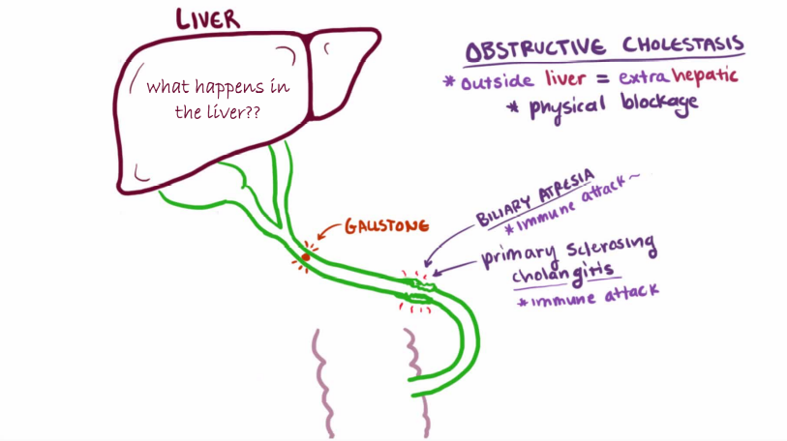
Cholestasis induces large scale alterations in the human liver transcriptome

Impaired formation or flow of bile results in hepatic retention of biliary constituents. This triggers a response aimed at limiting cholestatic liver injury. Animal studies revealed that multiple nuclear receptors mediate adaptive changes in the liver at the transcriptional level. These include the bile salt receptor FXR, which has a central role in preventing bile salt toxicity. To expand our limited knowledge of how the human liver adapts to cholestatic conditions, the department of surgery profiled protein-encoding transcripts and regulatory microRNAs (miRNA) in the liver of patients with extrahepatic cholestasis. miRNA’s regulate the expression of multiple mRNA’s and cause transcriptional or translational silencing and are frequently deregulated in diseases. Since miRNA regulate many target RNAs they may be useful as cancer biomarkers and therapeutics.
Total RNA was isolated from liver specimens of non-cholestatic patients with pancreatic tail cancer or benign liver tumors (control, n=9), initially jaundiced patients with periampullary malignancies receiving pre-operative biliary drainage (drained, n=10), and patients with cholestasis due to periampullary malignancies (cholestatic, n=9). mRNA (Sureprint G3 Human GE 60K V2) and miRNA (Sureprint G3 Human miRNA V19) expression profiles were determined using Agilent arrays.
As happens frequently, datasets are collected, but the proper evaluation of the data lags behind. Can you help the department of surgery to analyze, and possibly model the datasets they have gathered? Can you provide the department of surgery with novel leads for innovative cholestasis treatment options, based on analyses on this transcriptomics dataset? It is also important that you can present the data in a clear and innovative way, so that the researchers and also clinicians get excited and can use the data to develop novel treatment options. This means you may have to collaborate with researchers from the department of surgery who have provided you with the novel and unique transcriptomics dataset from cholestasis patients. Please be aware that this dataset contains yet unpublished data.
Contact person/stakeholder department of surgery: Dr. Zita Soons (AH)

