**#IDK**

Thinkful’s Front-End final capstone project – A responsive application that will solve the confusion between 2 people or a group whenever they are stuck on this EVERYDAY question: “Hey, where do you wanna go?” and the usual reply is “I Don’t Know”. Well I guess not anymore, the reply would be “Let’s IDK it” ;)

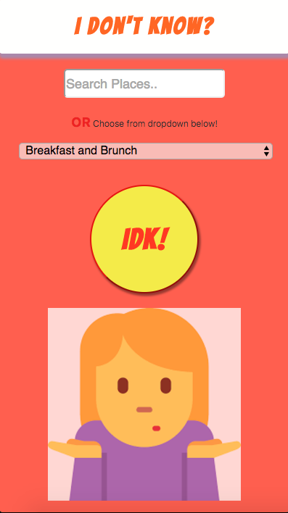 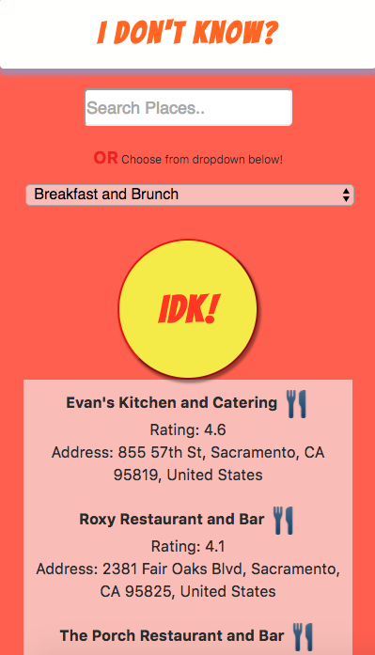

**Mobile**

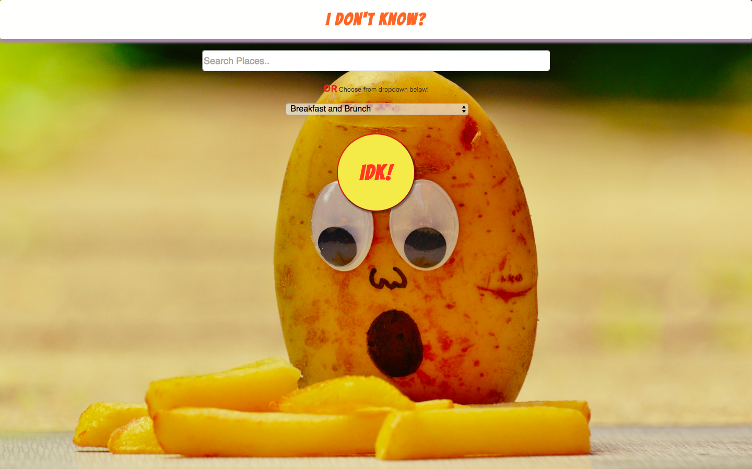 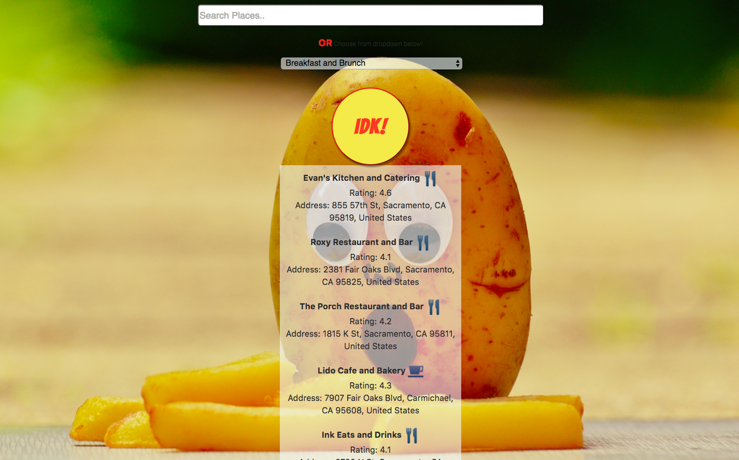

**Desktop**

**#Introduction**

IDK App allows you search for the places near you either by choosing on of the options from the dropdown or by typing the keywords in the “Search” bar to narrow the search to what you are looking for.

Currently the app will request you to grant your current location and based on that it will provide you the results that are within ~18miles of your radius.

**#Use Case**

Why you should use it? This application will give you the results to what you are looking for, it is simple and super easy to use. Trust me, even my grand ma can use it without any concern ;)

**While using DROPDOWN selection:** The places that are currently OPEN will be reflected as a result, so you don’t have to spend time finding out whether the place is open or closed and also you can select RATING if you want to broaden/narrow your search. **It runs on a recommendation model based metrics running on a weighted criteri price/dis /user ratings in addition to IDKs recomendatio n user can alos llook at results based on general criteria. IDK DOES THE HARD WORK FOR YOU!!!!!!!!**

**If you want quick recommendation without having to enter XYZ FILTERS use IDK. If you don’t know where you want to go don’t worry this is just 1-Click Recommendation Model**

**While using SEARCH bar:** The places that are currently OPEN or their RATING>4 will be reflected as a result, so the user can get a broader view of what’s out there.

**Live Site**

You can access IDK app @: **TBD**

**Technical**