**CSC 450 – Computer Networks**

**Assignment #5 Dijkstra’s Algorithm**

**Dr. Timofeyev**

**By:** Bradford Doughty, Samantha Santiago, and Caleb Snook

**Responsibilities**

**Bradford Doughty** – Polished and cleaned code, commented, tested for each node, and finished

PDF.

**Samantha Santiago** – Used Pandas for capturing .csv files, wrote initialization of algorithm, and

created format of PDF

**Caleb Snook** – Wrote code for solving shortest path tree, calculating least-cost paths, and tested for each node.

**Before Running Program**

* ONLY RUN IN LINUX
* Need Python version 2.7
* Need Pandas for CSV file
  + How to get Pandas:
    - sudo apt-get install python-pandas
    - OR yum install python-pandas
    - OR pip install pandas
  + If these are not working, link to Pandas provided below:
    - <https://pandas.pydata.org/pandas-docs/stable/index.html>
* Make sure CSV file is in the same directory as Python file

**How to Run Program**

* Open terminal
* Navigate to directory with Python file and CSV file
* Terminal command:
  + python [name of file].py topology.csv
* Once running, user prompted for the starting node. Type u, v, w, x, y, or z then hit ENTER
* Watch as program calculates the shortest path tree and costs of least-cost paths of the input node

**Screenshots**

Finally, screenshots of sample program runs are below:

Output for node u:

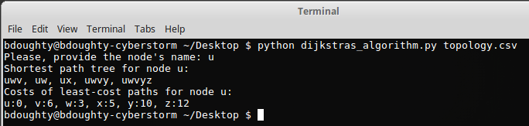

Output for node v:

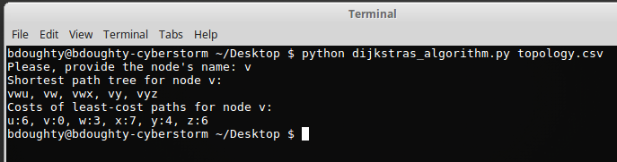

Output for node w:

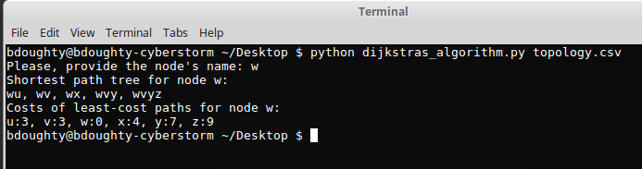

Output for node x:

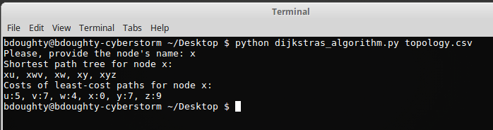

Output for node y:

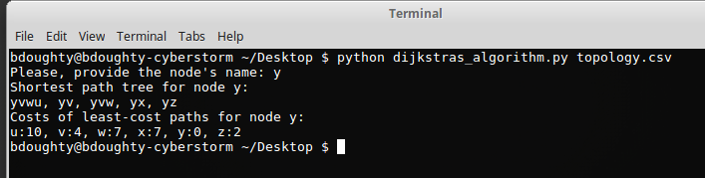

Output for node z:

