Contents
Intro 3
"How do I build and install this plugin?" 3
Prerequisites 3
Compatibility 3
Build and install only this plugin 4
Building KernelShark from source and this plugin with it 5
WARNING - loading plugin twice 5
"How do I enable/disable naps?" 6
"How do I use naps?" 7
Configuration 7
In the graph 8
Using naps as a library 8
Bugs & glitches 9
Recommendations 9

Intro
This document serves as a simple to grasp manual for the "naps" KernelShark plugin.

For a more technical look, read the doxygen-generated HTML API documentation and source code.

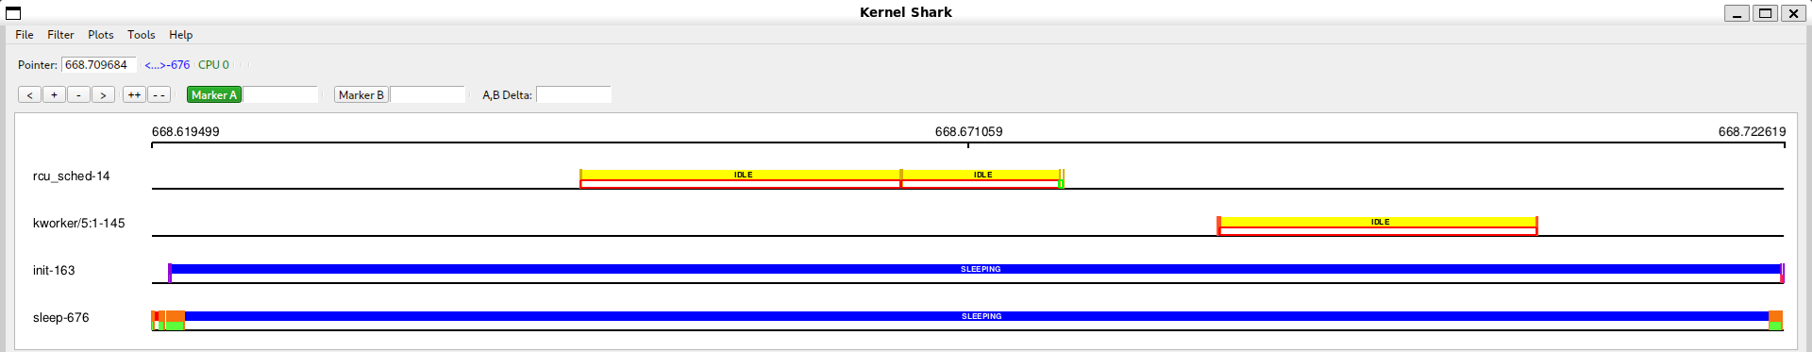
Figure 1 - working Naps

"How do I build and install this plugin?"
There are two ways to build the plugin, each outlined on their own page. But first, let's talk about prerequisites and compatibilities.

Prerequisites
- CMake of version at least 3.1.2
- KernelShark an its dependencies
  - version 2.4.0-couplebreak and higher for custom KernelShark
  - version 2.3.2 for unmodified KernelShark

Compatibility
Plugin is compatible with KernelShark's custom version 2.4.0-couplebreak and higher. Unmodified (version 2.3.2) KernelShark usage is achievable through a build argument, but discouraged, as the custom versions improve compatibility with other plugins.

With couplebreak on (this necessitates modified KernelShark), the plugin is fully compatible with every default KernelShark plugin. With couplebreak off, sched_events plugin is incompatible. In general, if any plugin changes event's PID data during data stream loading, this plugin will be incompatible with it.

If using unmodified KernelShark, couplebreak cannot be turned on and nap rectangles will not have the option to have their outlines be the same color as the owner task of a sched/sched_switch event.

No other dependencies are necessary, except the standard libraries of C and C++.

Build and install only this plugin

- Set your working directory in terminal as the build directory (best created in the project's root directory (see README.md), if not already present).
- Run cmake .. command (if the main CMakeLists.txt file isn't in the parent folder, provide cmake with its valid location).
If using an unmodified KernelShark copy, add -D_UNMODIFIED_KSHARK=1 to the command.
If Doxygen documentation is desired, include -D_DOXYGEN_DOC=1 in the command.
If trace-cmd header files aren't in /usr/include, specify so via -D_TRACEEVENT_INCLUDE_DIR=[PATH], where [PATH] is replaced by the path to the header files.
If trace-cmd shared libraries aren't in /usr/lib64, specify so via -D_TRACEEVENT_LIBS_DIR=[PATH], where [PATH] is replaced by the path to the shared libraries.
By default, the build type will be RelWithDebInfo - to change this, e.g. to Release, use the option -DCMAKE_BUILD_TYPE=Release.
If Qt6 files aren't in /usr/include/qt6, use the option -D_QT6_INCLUDE_DIR=[PATH], where [PATH] is replaced by the path to the Qt6 files.
Build instructions still expect that the specified directory has same inner structure as the default case (i.e. it contains QtCore, QtWidgets, etc.).
If KernelShark source files aren't in the relative path ../KS_fork/src from this directory, use option -D_KS_INCLUDE_DIR=[PATH], where [PATH] is replaced by the path to KernelShark source files.
If KernelShark's shared libraries (.so files) aren't in /usr/local/lib64, use the option -D_KS_SHARED_LIBS_DIR=[PATH], where [PATH] is replaced by the path to KernelShark shared libraries.
- Run make while still in the build directory.
If only a part of building is necessary, select a target of your choice.
Just running make builds: the plugin (target naps), symlink to the plugin SO (target naps_symlink) and, if specified, the Doxygen documentation (target docs).
- (Installation) Plug in the plugin into KernelShark - either via KernelShark's GUI or when starting it via the CLI with the -p option and location of the symlink or the SO itself.
IMPORTANT: Always install/load the plugin before loading a session where said plugin was active! Failure to do so will result in KernelShark not completely loading configuration menus or may even crash the whole program.

Use make clean to remove built binaries.

Building KernelShark from source and this plugin with it

- Ensure all source files (.c, .cpp, .h) of Naps are in the src/plugins subdirectory of your KernelShark project directory.
- Ensure the CMakeLists.txt file in said subdirectory contains instructions for building the plugin (copy the style of other Qt-using GUI plugins).
- Build KernelShark (plugins are built automatically).
- (Installation) Start KernelShark. Plugins built this way will be loaded automatically. If that for some reason failed, look for the SO as for any other default-built KernelShark plugin, again in GUI or via the CLI.

WARNING - loading plugin twice
If you have two or more versions of the plugin, do NOT load them at the same time - doing so WILL CRASH the program. Use either one or the other, but NEVER BOTH.

"How do I enable/disable naps?"

Enabling the plugin is very simple, since plugin follows standard KernelShark plugin loading behaviour. All one has to do is open KernelShark and navigate to Tools > Manage Plotting plugins toolbar menu (figure 2) button. If the plugin was loaded via the command-line interface, it will be shown in the list of plotting plugins as a checkbox plus the name, checkbox already being ticked. If not, it is possible to search for the plugin via provded Tools > Add plugin button - it's sufficient to find the symlink, but searching for the actual shared object file is possible too.
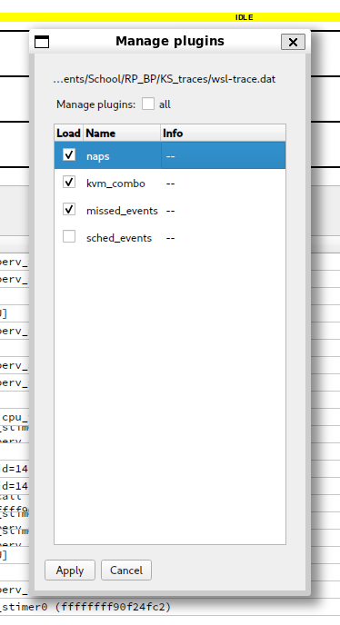

Figure 2 - Manage Plotting plugins with loaded Naps

Ticked checkbox means the plugin is enabled, empty checkbox means the plugin is disabled.

"How do I use naps?"

Configuration
Plugin configuration can be done at any time, even before any trace file is loaded.

If the plugin is enabled, additional button will appear in `Tools` menu with the label `Naps Configuration` (figure 3). Clicking on it will show a window dialog (figure 4), which will house configuraton options for the plugin. One of the two configuration options available for this plugin is the maximum amount of entries visible on the graph before the plugin is allowed to work. This configuration option can help if there are either not enough visible plugin shapes for a current zoom level or if there are too many and program memory is is too great. By default, the value is set to 10000 (ten thousand).

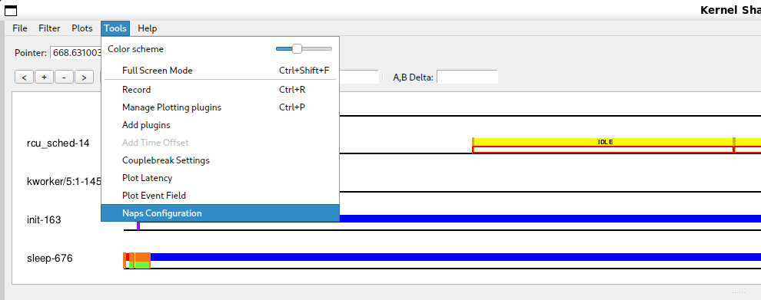
Figure 3 - Naps configuration button in the Tools menu

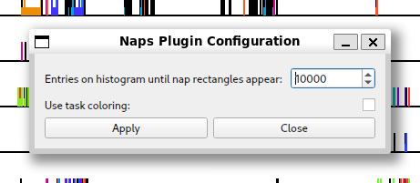
Figure 4 - Naps configuration window

The second configuration option is toggled via the labeled checkbox visible in (figure 4). The option is whether to color the nap rectangle's top and bottom outlines the same color as KernelShark uses for the task (figure 5). Otherwise, the same color as the one used for the filling will be used (figure 6). By default, this option is off.
Figure 5 - default coloring of a visualised nap

Figure 6 - task-like coloring of the top and bottom outlines of a visualised nap

Clicking on Apply button will confirm changes made to the configuration and close the window, showing a pop-up (figure 7) if the the operation was successful. Clicking on the Close button or the X button in the window header will close the window without applying any changes. Changes made to a window that hasn't applied them to the configuration will be lost and upon reopening, the window will again show what's in the currently applied configuration.

![Fig. 7](../images/NapsConfigSuccess.png)
Figure 7.

In regards to KernelShark's sessions, the configuration is NOT persistent and options included before will have to be adjusted again upon a new session or trace file load.

In the graph
Visualised nap has already been shown in figures 3 and 4, this section talks about these visualisations more.

To view naps in a graph of a trace, let KernelShark show you task plots. The plugin will automatically draw rectangles between switch and waking events, coloring them according to the previous state of the task that will then switch to another task. Top and bottom outlines of the rectangles are colored using the same color, or, if turned on in the configuration, using the task's own color. If the rectangle is wide enough, then the full name of the previous state of the task will be displayed as well (figure 8).

Figure 8 - a nap with multiple disk sleeps of different durations at the same zoom level

The rectangles will be visible as long as the zoom level allows two entries belonging to the same nap to also be visible and as long as there aren't too many entries visible on the graph (this can be adjusted in the configuration).

The rectangles cannot be interacted with in any capacity.

Using naps as a library
See technical documentation, as this is not intended usage of the plugin and such usage explanations will be omitted.

Bugs & glitches

No known bugs, but there were plenty of unexpected surprises during plugin testing - if more were discovered, contact the author via e-mail djsebofficial@gmail.com.

Recommendations

A few recommendations of usage by the author for the smoothest user experience.
Always preload Naps before loading a session. It can save the program from nasty surprises.
If having two versions of the plugin is desired, put them into different build directories.

It is recommended to turn on couplebreak in KernelShark to allow greater compatiblity with other plugins, especially sched_events.

It is recommended to not set the histogram limit in the configuration too high as to not make the plugin use too much memory with many nap rectangles being present.

While KernelShark's sessions work, they are a little buggy. This plugin attempts its best to not get in the way of their inner logic, but a warning should be issued that if the plugin isn't loaded beforehand, there might be unexpected behaviours, e.g. loading a session when the plugin was active won't add the plugin's menu to the Tools menu.

