Contents
Intro 3
"How do I build and install this plugin?" 3
Prerequisites 3
Compatibility 3
Build and install only this plugin 4
Building KernelShark from source and this plugin with it 4
WARNING - loading plugin twice 4
"How do I enable/disable noboxes?" 5
"How do I use noboxes?" 6
Issues 6
Using noboxes as a library 6
Bugs & glitches 7
Recommendations 7

Intro
This document serves as a simple to grasp manual for the "noboxes" KernelShark plugin.

"How do I build and install this plugin?"

Prerequisites
- CMake of version at least 3.1.2
- KernelShark and its dependencies
  - version 2.6.0-numatv and higher for custom KernelShark
- Doxygen for documentation

Compatibility
Plugin is compatible with KernelShark's custom version 2.6.0-numatv and higher.
Unmodified KernelShark usage is impossible, as the plugin needs a newly defined visibility mask
and its behaviour.

No other dependencies are necessary, except Doxygen for documentation.

Build and install only this plugin
- Set your working directory in terminal as the build directory (best created in the project's root directory (see [README](../../README.md)), if not already present).
- Run cmake .. command (if the main CMakeLists.txt file isn't in the parent folder, provide cmake with its valid location).
If Doxygen documentation is desired, include -D_DOXYGEN_DOC=1 in the command.
By default, the build type will be RelWithDebInfo - to change this, e.g. to Release, use the option -DCMAKE_BUILD_TYPE=Release.
If KernelShark source files aren't in the relative path ../KS_fork/src from this directory, use the option -D_KS_INCLUDE_DIR=[PATH], where [PATH] is replaced by the path to KernelShark source files.
If KernelShark's shared libraries (.so files) aren't in /usr/local/lib64, use the option -D_KS_SHARED_LIBS_DIR=[PATH], where [PATH] is replaced by the path to KernelShark shared libraries.
- Run make while still in the build directory.
If only a part of building is necessary, select a target of your choice.
Just running make builds: the plugin (target noboxes), symlink to the plugin SO (target noboxes_symlink) and, if specified, the Doxygen documentation (target docs).
- (Installation) Plug in the plugin into KernelShark - either via KernelShark's GUI or when starting it via the CLI with the -p option and location of the symlink or the SO itself.
- - IMPORTANT: Always install/load the plugin before loading a session where said plugin was active! Failure to do so may result in KernelShark's crash.

Use make clean to remove built binaries.

Building KernelShark from source and this plugin with it
- Ensure all source files (.c, .cpp, .h) of NoBoxes are in the src/plugins subdirectory of your KernelShark project directory.
- Ensure the CMakeLists.txt file in said subdirectory contains instructions for building the plugin (copy the style of other plugins, e.g. sched_events).
- Build KernelShark (plugins are built automatically).
- (Installation) Start KernelShark. Plugins built this way will be loaded automatically. If that for some reason failed, look for the SO as for any other default-built KernelShark plugin, again in GUI or via the CLI.

WARNING - loading plugin twice
If you have two or more versions of the plugin, do NOT load them at the same time - doing so WILL CRASH the
program. Use either one or the other, but NEVER BOTH.

"How do I enable/disable noboxes?"
Enabling the plugin is very simple. All one has to do is open KernelShark and navigate to
Tools > Manage Plotting plugins toolbar menu button. If the plugin was loaded via the command-line interface, it will be shown in the list of plotting plugins as a checkbox plus the name, checkbox already being ticked.
If not, it is possible to search for the plugin via provded Tools > Add plugin button - it's sufficient to find the symlink, but searching for the actual shared object file is possible too. As you can see, the plugin follows standard KernelShark plugin loading behaviour.

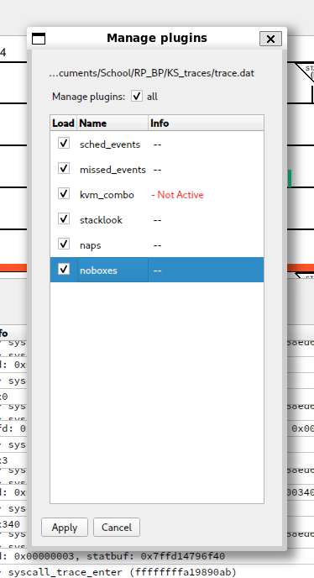
Figure 1.

Ticked checkbox means the plugin is enabled, empty checkbox means the plugin is disabled.

"How do I use noboxes?"
Simply having NoBoxes enabled will make some taskboxes (the rectangles KernelShark draws between its bins) not be drawn or be skipped when looking where to end a taskbox - on both task and CPU graphs.

To better visualise the differences when plugin is turned off and on, compare the two figures below:

Figure 2 - noboxes are OFF.

In this figure, ftrace/kernel_stack is the event with a large vertical line on the right, couplebreak/sched_waking[target] is the event with a large vertical line on the left; kernel stack event produces a large box until the end of the graph, waking target, while not doing any actual work on the CPU, makes it seem it does. There is also a large taskboxe going from the CPU graph below, which starts at another kernel stack event. There are other kernel stack events drawing taskboxes, like the one between the two highlighted events, drawing a blue taskbox.

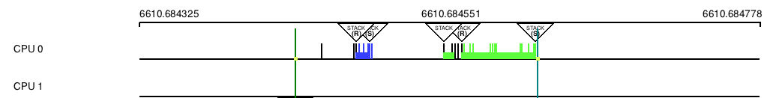
Figure 3 - noboxes are ON.

In ths figure, ftrace/kernel_stack is the event with a large vertical line on the right, couplebreak/sched_waking[target] is the event with a large vertical line on the left; there are no taskboxes stemming from or going into them. The bottom line is also gone (but may pop in and out on window updates, e.g. mouse hover that changes the window's visuals).

Issues
The plugin is fine, but the implementation is mostly a best-effort on KernelShark side - the plugin only activates
the behaviour, KernelShark controls what it means. If the taskboxes look a little strange, look at the KernelShark side
and contact the NOBOXES modification's developer(s).

Using noboxes as a library
See technical documentation, as this is not intended usage of the plugin and such usage explanations will be omitted.

Bugs & glitches
No known bugs, but there were plenty of unexpected surprises during plugin testing - if more were discovered, contact the author via e-mail djsebofficial@gmail.com.

Recommendations
A few recommendations of usage by the author for the smoothest user experience.

Always preload NoBoxes before loading a session. It can save the program from nasty surprises.

