PROJECT TOPIC: PlacePro

Group No.: G-171

Project Group Members:
- Advay Sharma – 2315000160 2. Akanksha Sahu - 2315000174
3. Jatin Kumar Tureha - 2315001016 4. Rudra Gupta - 2315001894
5. Vikram Singh - 2315002453

Project Supervisor: Mr. Manwatkar Sumedkumar Janardanji, Technical Trainer

About the Project:
PlacePro is a web-based placement intelligence platform designed to reduce the manual effort involved in managing college examination results, mock interviews and placement data. Institutions can upload Excel or CSV files exported from their existing portals. The system detects columns, suggests mappings, validates records and preserves original data for traceability. It organizes student performance into configurable skill domains, individual skills and assessment parameters. AI-assisted processing interprets unstructured interviewer feedback, proposes structured observations and generates concise summaries while keeping extracted suggestions distinguishable from approved scores. Role-based portals provide separate capabilities for administrators, trainers and students. Administrators and authorized trainers can review records, analyze performance, rank candidates and configure company-specific eligibility and skill criteria. PlacePro evaluates students against these criteria, explains eligibility outcomes and supports filtered shortlist generation with Excel/CSV export. Database constraints, import history, versioned rules and audit records support data integrity, duplicate prevention and accountable updates.
Motivation:
Colleges often maintain examination and interview results in separate systems and manually consolidate exported spreadsheets for placement activities. This creates repetitive work, inconsistent records, duplicate entries and difficulty comparing student skills with company requirements. PlacePro centralizes this workflow, improves traceability and helps students and placement teams understand performance through structured data and explainable analytics. It supports more efficient, evidence-based placement preparation and candidate shortlisting
Innovation:
- Dynamic column mapping and reusable import profiles for varying Excel/CSV formats.
- AI-assisted extraction and summarization of mixed-type interview feedback, with source traceability and human review.
- Configurable skill domains, parameters, scoring rules and student-specific applicability instead of fixed assessment fields.
- Concurrency-safe, idempotent imports and explicit revision handling to reduce duplicate or conflicting records.
- Explainable company matching that separates mandatory eligibility from weighted ranking and identifies missing data.
- Custom filters and permission-controlled Excel/CSV exports for company-specific shortlists.
Project Planning:
The project work is organized into phases covering requirement analysis, technology learning, database design, implementation, integration and verification. The schedule below follows the September 2026–March 2027 period specified in the university synopsis template.
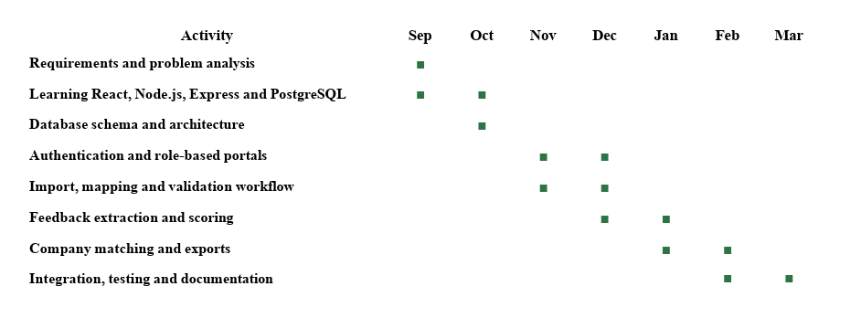

Tools required:
- Hardware Requirements: Computer/laptop with a modern multi-core processor, minimum 8 GB RAM (16 GB recommended), adequate storage and internet connectivity.
- Software Requirements: Windows/Linux/macOS, Node.js, npm, React/NeaxtJS, Vite, Express.js, PostgreSQL, a compatible SQL client, Git, VS Code, CSV/XLSX processing libraries, and an AI API/provider configured for feedback extraction.

Signature of Project Supervisor: _____________________

