**FIRST SEMINAR REPORt**

**on**

**information sharing in android using bluetooth**

submitted by:

**dhananjay sathe**

**chetan chopade**

**ritesh j. chetwanI**

**gaurav g. timkhede**

under the guidance of

**mrs. gauri chaudhary**



**department of computer technology**

YESHWANTRAO CHAVAN COLLEGE OF ENGINEERING

hingna road, WANADONGRI, NAGPUR-441110

year 2012-2013

index

list of tables

list of figures

**aBSTRACT**

Nowadays, at various public places such as colleges, hospitals, malls, railways etc there are various notifications to be spread such as requirement of blood in hospitals, updates in schools/colleges, new discount offers in malls and so on. Normally, Users are unaware of these services. To make user aware of such services, in this project we are trying to create user interface so that user can easily interact with the administrator and access such services. This interface makes user able to easily and effectively communicate to the administrator so that they do not face any difficulties. This interface also enables two way communication between the user and the system in which any user must able to fire their queries during interaction and get proper answer from administrator instantly.

chater 1

introduction

**aim and objective**

**AIM:**

To create a user interface for information sharing in Android using Bluetooth.

**OBJECTIVE:**

* The key objective of this project is that it should have a well-featured dynamic user interface so that the user can easily use and incorporate it.
* It should help to reduce direct person to person interaction at public places.
* It should help user to easily and effectively communicate with administrators so that they should not face any difficulties.
* An administrator should be able to add, update, delete and modify the information on day to day basis so that user can easily be informed about the changes made and know their interest.
* Any user must able to fire their queries during interaction and get proper answer from administrator instantly.

**SCOPE**

1. **Connection establishment**

When a user enters the target area. The system will send him an app (android application) request .if he has switched on the Bluetooth on his device and made his device discoverable. (This is only for the first time user who does not have the android application). If the user has the application installed (i.e. he is an old user) then he just has to start the application. The application will automatically ask for switching the Bluetooth to turn on. If the user has the application installed (i.e. he is an old user) then he just has to start the application. The application will automatically ask for switching the Bluetooth to turn on.

1. **Application features**

The various features covered in the system are:

* 1. **Fetch requisite details from server**

The user after establishing the connection can access the system using the android app's user friendly interface. The user access the system by entering a unique id (e.g. Patient ID, Student ID, or Customer ID). They will have all the options on it so that by just a Touch, user can fetch what he wants easily and quickly.

* 1. **Notifications**

System will send notifications (alerts) to the users available in the target area such asBlood alert (whenever there is a need of blood in the hospital system will send notification to all users), New Discount Offers (whenever there is a discount offer in the mall system will send discount coupons to all users) etc.

* 1. **Maps**

User will be able to access the map of the area such as the map of the hospital building. This will help user to find places where they want to go by just looking in the phone.

* 1. **Timing Schedules**

User will be able to get various timing schedules such as college time tables and hospital timings.

* 1. **Tips**

System will send various tips to the users which will help them in their work.

chapter 2

PROBLEM DEFINITION

To generate a user interface that provides an “effective” content sharing mechanism in Android for Bluetooth users so that user can access the various services available at public places without any actual interaction with the respective administrators. Using this interface, users must be able to fire their queries during interaction and get proper answer from administrator instantly.

**CHAPTER 3**

**LITERATURE SURVEY**

**[1] “Bluetooth-Based Android Interactive Applications for Smart Living”,** -By   
Ericsson Corp. Res., Stockholm [Kazantzidis, M.](http://ieeexplore.ieee.org/search/searchresult.jsp?searchWithin=p_Authors:.QT.Kazantzidis,%20M..QT.&newsearch=partialPref); [Kapoor, R.](http://ieeexplore.ieee.org/search/searchresult.jsp?searchWithin=p_Authors:.QT.Kapoor,%20R..QT.&newsearch=partialPref)

 Gerla, M., IEEE Dec. 2011

Top of ,,,,

According to this paper for smart living, interactive applications are increasingly important especially on interaction of people and the environment. In this work, a Bluetooth-based mobile sensor interactive application in Android was designed and implemented. An application framework of interactive applications is presented. The results show that animation view on the application changes along with the mobile sensor value. The power issue was also measured and concluded as extending handler timing to reduce the consumption.

# [2] "Bluetooth Performance Analysis in Personal Area Network (PAN)” -By

[Rashid, R.A.,](http://ieeexplore.ieee.org/search/searchresult.jsp?searchWithin=p_Authors:.QT.Rashid,%20R.A..QT.&newsearch=partialPref)Dept. of Telematic & Opt., Univ. of Technol. Malaysia, Johor   
[Yusoff, R.](http://ieeexplore.ieee.org/search/searchresult.jsp?searchWithin=p_Authors:.QT.Yusoff,%20R..QT.&newsearch=partialPref), IEEE Sept. 2006

According to this paper Bluetooth is a telecommunications industry specification operating in an unlicensed frequency band of 2.4 GHz that describes how mobile phones, computers, and personal digital assistants (PDAs) can be easily interconnected using a short-range wireless connection. In this study, a personal area network (PAN) was set up using three personal computers, two Bluetooth universal serial bus dongles, one serial Bluetooth module and also a Bluetooth mobile phone.

A graphical user interface (GUI) using Visual Basic 6.0 was built to display the system accessibility such as file and system properties, transferring text files, chatting program and network detection by Bluetooth's service discovery protocol (SDP).The Bluetooth system performance between two Bluetooth devices using the GUI and analyzed in terms of types, sizes of file and separation distance (within 8 meters), which were measured against transmission delay. The findings show that the transmission delay varies exponentially with the types and sizes of file even with different types of Bluetooth devices and increases with separation distance.

### [3] “[Performance evaluation of the Bluetooth-based public Internet access point](http://ieeexplore.ieee.org/xpl/articleDetails.jsp?tp=&arnumber=905527&contentType=Conference+Publications&pageNumber%3D2%26queryText%3Dbluetooth+based+information+sharing)” -By Yujin Lim; Jesung Kim; Sang Lyul Min; Joong Soo Ma, IEEE 2001

Bluetooth has been regarded as a promising solution to an inexpensive wireless connection. Although initial application of Bluetooth technology has been focused mainly on replacing cables between hand-held devices, general wireless telecommunication such as public Internet access via a Bluetooth-equipped device is expected to be one of the most popular applications in the near future. However, it is not well understood whether the performance of Bluetooth-based systems is sufficient for such an application. We present preliminary results of performance evaluation of a Bluetooth-based Internet access point. The evaluation is based on simulation of an Internet access model consisting of a Bluetooth-based network access point and a number of Bluetooth-equipped notebook computers.

The simulation results indicate that Bluetooth provides performance comparable to the fastest dial-up modem even when a number of users share a single Bluetooth radio unit. Better performance is expected when more than one Bluetooth radio unit are employed such that each unit services different users concurrently. However, a Bluetooth unit in a single radio range (about 10 m) interferes with each other since the channels established by each unit occasionally collide at the same frequency band. This paper analyzes the impact of such interference based on an analytical model of inter-channel interference. The analysis shows that the performance improves as the number of channels increases up to 40. We expect the proposed inter-channel interference model is useful in the design of systems facilitating multiple Bluetooth units.

# [4] “Bluetooth: an enabler for personal area networking”-By

[Johansson, P.](http://ieeexplore.ieee.org/search/searchresult.jsp?searchWithin=p_Authors:.QT.Johansson,%20P..QT.&newsearch=partialPref), Ericsson Corp. Res., Stockholm , [Kazantzidis, M.](http://ieeexplore.ieee.org/search/searchresult.jsp?searchWithin=p_Authors:.QT.Kazantzidis,%20M..QT.&newsearch=partialPref);  [Kapoor, R.](http://ieeexplore.ieee.org/search/searchresult.jsp?searchWithin=p_Authors:.QT.Kapoor,%20R..QT.&newsearch=partialPref);  [Gerla, M.](http://ieeexplore.ieee.org/search/searchresult.jsp?searchWithin=p_Authors:.QT.Gerla,%20M..QT.&newsearch=partialPref), IEEE Sep 2003

We find ourselves today often carrying numerous portable electronic devices, such as notebook computers, mobile phones, PDAs, digital cameras, and mp3/MD/DVD players, used to help and entertain us in our professional as well as private lives. For the most part, these devices are used separately, and their applications do not interact. Imagine, however, if they could interact directly and thus create a network where information may flow seamlessly between the devices-such a network of personal devices is often referred to as a personal area network, or PAN. Moreover, access to the Internet via a (public) wireless LAN access point and/or via a 3G UMTS mobile phone would enable the PAN to be constantly online. The strongest candidate to provide the cheap short-range radio links necessary to enable such networks is the Bluetooth wireless technology.

Seen from a networking perspective, a PAN will be expected to have participants, both of its “own” devices and “guest” devices from other PANs, continuously moving in and out of its coverage. To cope with this volatile nature of the network, the concept of ad hoc networking may be applied to create robust and flexible connectivity. A major technical step is taken when the Bluetooth  piconet network architecture, a strict star topology, is extended into a scatter net architecture, where piconets are interconnected.

**CHAPTER 4**

**DESIGN**

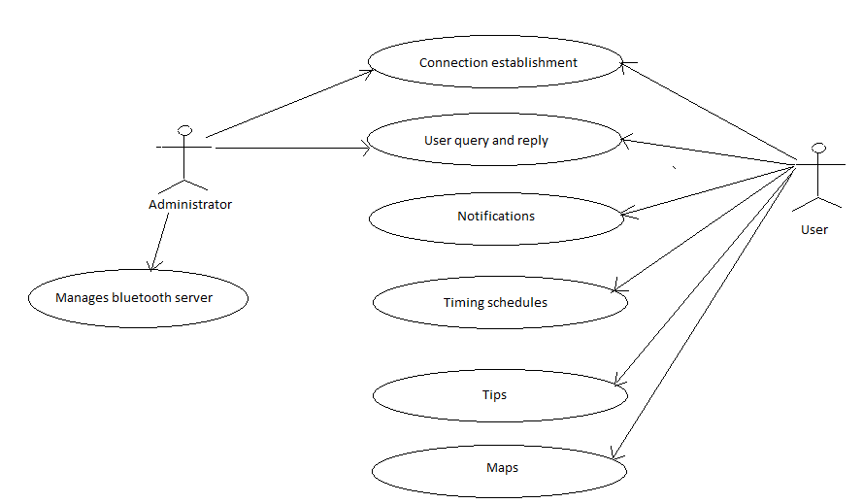

**CHAPTER 5**

**PLAN OF WORK**

**MODULE-1:-**

Detail study of the concept and proof of concept

(July-Aug).

**MODULE-2:-**

Development of server for the system and basic android application

(Aug-Sep-Oct).

**MODULE-3:-**

Creation of Database and system (server) specific to a domain of the computer.

(Oct-Nov-Dec)

**MODULE-4:-**

Enhancing the features of the android application feature like:

* + - Alerts
    - Billing Details
    - Maps
    - Schedules.

(Nov-Dec-Jan)

**MODULE-5:-**

To test the complete client and server for all the possible options.

(Dec-Jan Feb)

**REFERENCES**

* <http://seminarprojects.com/Thread-android-full-report#ixzz21LpFsD9H>
* <http://dspace.unimap.edu.my/dspace/bitstream/123456789/2911/5/Literature%20review.pdf>
* <http://www.bluetoothinformation.com/>
* <http://bluetoothprojects.blogspot.in/>