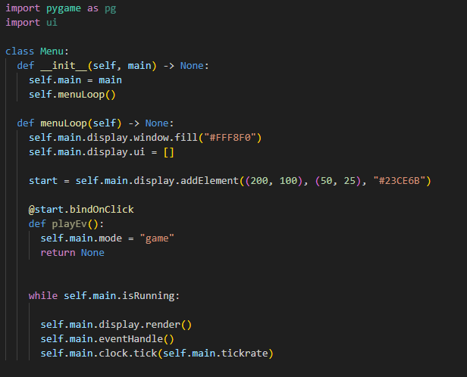

Play button doesn’t work

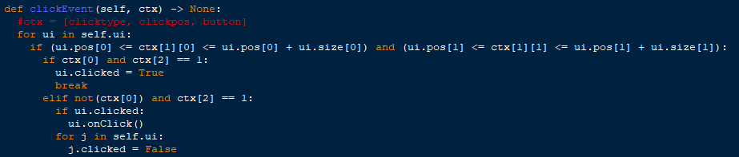

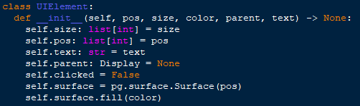

Pos was used instead of size at self.surface

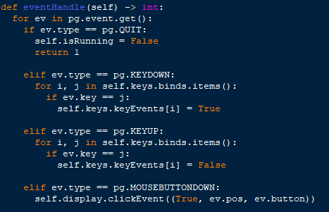

No event handle for mousebuttonup

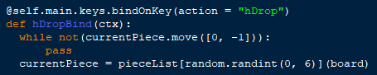

Variables called outside their scope

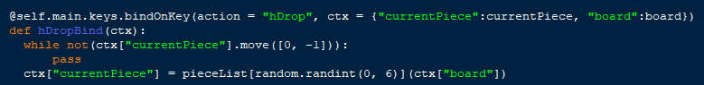

Mutating a dictionary causes object to not be mutated