Create a script that loops through all the stocks for each quarter and outputs the following information:

* The ticker symbol
* Quarterly change from the opening price at the beginning of a given quarter to the closing price at the end of that quarter.
* The percentage change from the opening price at the beginning of a given quarter to the closing price at the end of that quarter.
* The total stock volume of the stock. The result should match the following image:
* 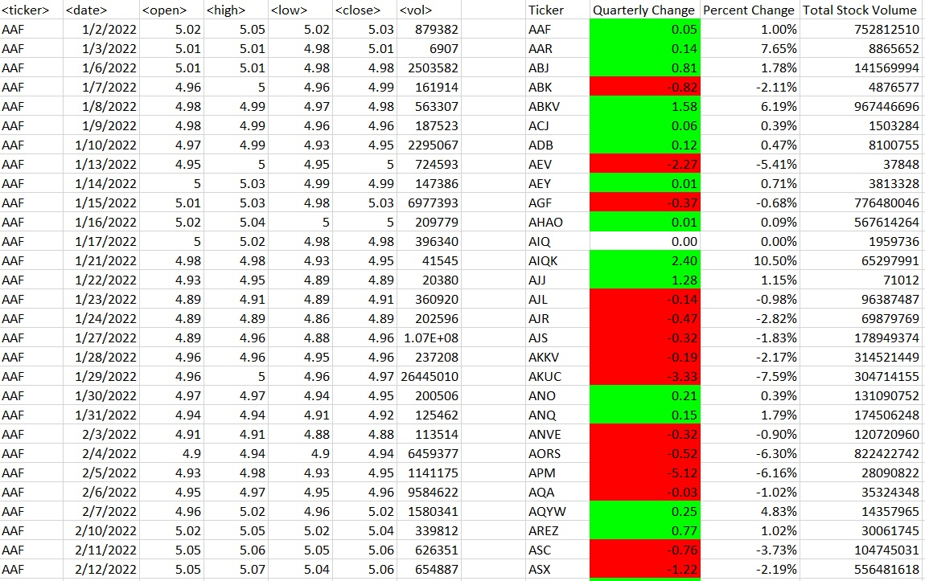

Add functionality to your script to return the stock with the "Greatest % increase", "Greatest % decrease", and "Greatest total volume". The solution should match the following image:

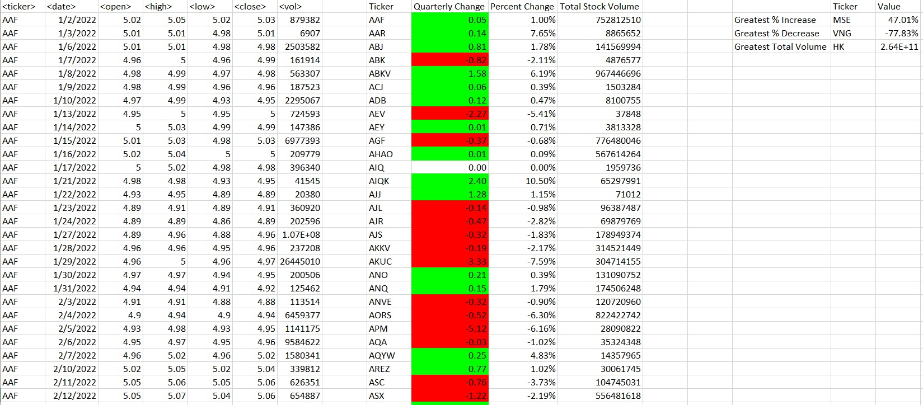

* Make the appropriate adjustments to your VBA script to enable it to run on every worksheet (that is, every quarter) at once.