D’Jon Harrison
Module 2.2 Assignment
Flowchart:
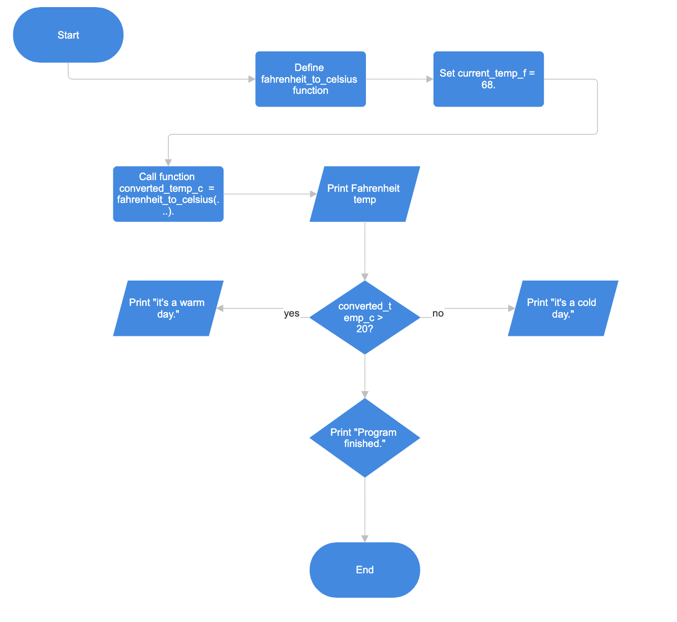

Screenshot 1: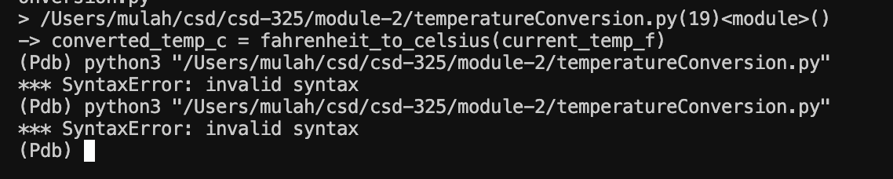

Screenshot 2:
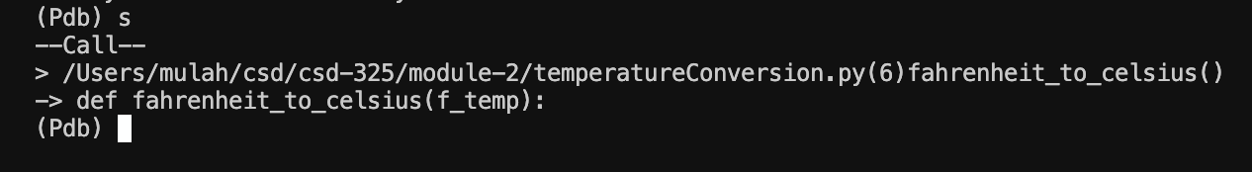

Screenshot 3:
