D’Jon Harrison
Module 1.2 Assignment
Github Link: https://github.com/DJonJasmine/csd-340.git
Local Directory Screenshot:
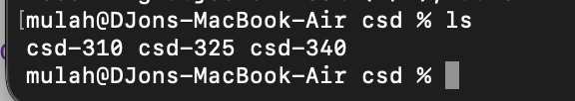

Github Repo Screenshot: