How to Create Tables
- Select in the Word document where you would like to insert a table
- Select the Insert tab
- Select Table
  - Use the grided window to select the number of rows and columns
  - Or select Insert Table and manually enter the number of rows and columns
    - Select OK
- Once inserted, table formatting options such as borders, shading, and text alignment can be accessed using the Table Design and Layout tabs

Screenshot of Steps:
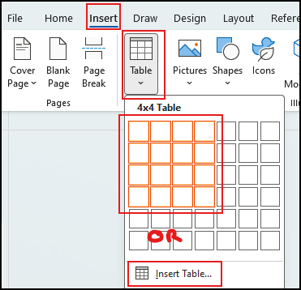

Example:

How to Insert Charts
- Select in the Word document where you would like to insert a chart
- Select the Insert tab
- Select Chart
- Choose a chart type (for example, Column, Bar, or Line)
- Select OK
- An Excel worksheet window will open automatically. Enter or update the data as needed
- Close the Excel window to return to Word

Screenshot of Steps:
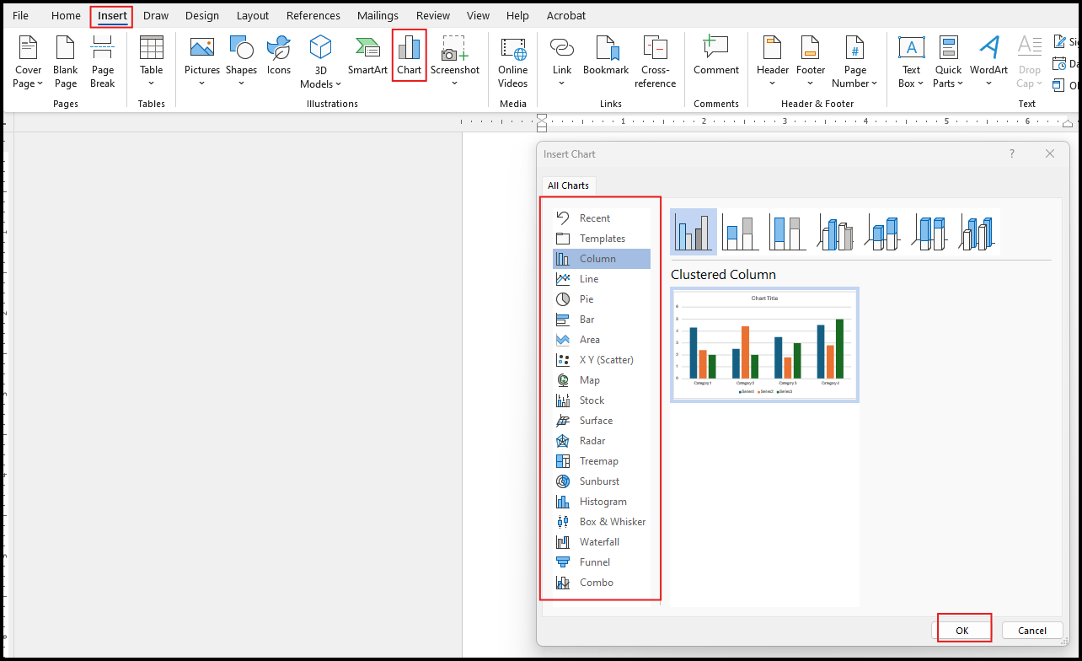

Example:

