EcoSort-Edge: Real-Time Offline Edge AI for Municipal Waste Sorting and Food Categorisation using ExecuTorch on Raspberry Pi 5
Namma AI Hackathon 2026 — Track 3: AI for Sustainability (Problem Statement 3)
Organized by NASSCOM CoE IoT & AI, Arm Developer Ecosystem, IIIT-Bangalore, and UK Govt TSI
Deployment Target: Raspberry Pi 5 (4× Arm Cortex-A76 @ 2.4 GHz) | Runtime: Arm ExecuTorch 1.5.1 (XNNPACK)
Project Code Repository: GitHub Repository (DK-A/EcoSort-Edge) | Demonstration Video: Live Hardware Demonstration (assets/DEMO.mp4)
Abstract— Municipal solid waste segregation at source remains a critical environmental and operational challenge across Indian urban wards. Under the revised Solid Waste Management (SWM) Rules notified by the Ministry of Environment, Forest and Climate Change (MoEFCC), waste must be categorized into four primary streams: Wet Biodegradable, Dry Recyclable (with Refuse-Derived Fuel tags for Multi-Layer Packaging), Sanitary Waste, and Domestic Hazardous (Special-Care). Deploying cloud-tethered vision APIs in municipal transfer points faces severe practical hurdles, including poor basement cellular connectivity, recurring operational costs (illustratively $300–$1,200 annually per kiosk), and variable latency.
We present EcoSort-Edge, a 100% offline edge AI classification system evaluated on an unadorned Raspberry Pi 5. The pipeline couples a MobileNetV3-Small backbone, quantized via PyTorch 2 Export (PT2E) dynamic INT8 quantization, with an Arm ExecuTorch runtime leveraging Armv8.2-A NEON SIMD and Signed Dot Product (SDOT) vector instructions. Across our 1,210-image holdout test dataset, the quantized model achieves 88.51% top-1 accuracy (1,071/1,210) and 98.35% statutory 4-stream accuracy (1,190/1,210; 95% Wilson CI: 97.5%–98.9%), with 20 cross-stream errors. On battery hazard interception, the test-set recall reaches 96.67% (58/60; 95% Wilson CI: 88.6%–99.1%), with 2 battery samples misclassified into dry recyclable categories. On our 30-sample physical Raspberry Pi 5 suite, the system achieved 30/30 statutory stream compliance and intercepted 3/3 battery samples (noting n = 3 gives a wide 95% CI of 43.9%–100.0%). The model-only CPU execution latency averages 5.09 ms (P95: 6.28 ms), while the end-to-end Python harness averages 11.85 ms per image. We conduct an empirical comparison against a peer MobileNetV3-Large baseline (4.31 MB), demonstrating that MobileNetV3-Small's 3.4× speedup is primarily explained by its 3.9× fewer arithmetic operations (~56M vs ~219M MACs), while operating at a stable 49.9 deg C.
Index Terms— Edge Artificial Intelligence, Arm Cortex-A76, ExecuTorch, Model Quantization, PT2E, NEON SIMD, SDOT, MobileNetV3, Solid Waste Management Rules 2026, Green Computing, Embedded Computer Vision.
I. INTRODUCTION & PROBLEM STATEMENT ALIGNMENT
A. Urban Solid Waste Context in India
According to the Central Pollution Control Board (CPCB) Annual Report on Solid Waste Management [6], urban India generates approximately 160,000 to 170,000 tonnes of municipal solid waste daily, of which a substantial portion continues to be landfilled without adequate segregation at source. Organic food discards and vegetable peelings undergo anaerobic decomposition when mixed with dry waste, generating methane (CH4) emissions and contaminating recyclable plastic and paper fractions. When dry recyclables are fouled by food grease and liquids, their economic recyclability is substantially degraded [1], [6].
B. MoEFCC SWM Rules 2026 & Municipal Streams
In 2026, the Ministry of Environment, Forest and Climate Change (MoEFCC) notified revised Solid Waste Management Rules [1], formalizing four primary waste categories for municipal source segregation:
- 1) Wet Biodegradable: Leftover meals, vegetable peelings, and rotten organic produce destined for biomethanation plants or decentralized ward composting.
- 2) Dry Recyclable: Clean paper, cardboard, PET containers, glass bottles, and scrap metals for Material Recovery Facilities (MRFs). Under extended producer responsibility (EPR) guidelines, Multi-Layer Packaging (MLP) is managed as a sub-stream flagged for Refuse-Derived Fuel (RDF) co-processing in cement kilns.
- 3) Sanitary Waste: Household sanitary discards requiring safe thermal disposal in high-temperature municipal incinerators.
- 4) Domestic Hazardous (Special-Care): Lithium-ion cells, lead-acid batteries, button cells, and consumer electronics requiring dedicated take-back and disposal channels.
Under Swachh Bharat Mission (SBM-Urban) guidelines, municipal kiosks typically utilize standard visual color conventions: Green (Wet), Blue (Dry), Yellow (Sanitary), and Red (Hazardous). In this work, we adopt these four statutory categories as our primary sorting target.
C. Edge AI vs. Cloud-Centric Architecture
Cloud-based vision APIs present several operational bottlenecks in municipal waste facilities [7]: (1) Network Availability: Basement sorting bays and transfer stations frequently encounter heavy cellular signal attenuation (<-110 dBm); (2) Operational Expenses: Assuming 1,000–2,000 daily queries per kiosk at commercial vision pricing ($0.01–$0.02/query), API subscriptions accumulate to $300–$1,200 (approx. ₹25,000–₹100,000) per kiosk annually; (3) Variable Latency: Remote round-trip calls (500 ms to >2.0 s) impede continuous citizen drop-offs; and (4) Safety Considerations: Misclassifying hazardous items like lithium-ion batteries into dry paper streams creates severe fire hazards during subsequent mechanical compaction. Moving inference fully on-device addresses these constraints directly.
II. ENGINEERING SPECIFICATIONS & COMPETITION TARGET ALIGNMENT
To satisfy the core deliverables of Track 3 (Problem Statement 3: Edge-Based Waste Sorting and Food Categorisation), EcoSort-Edge was developed against measurable operational bounds [3], [5]:
TABLE I
FORMAL ENGINEERING REQUIREMENTS & MEASURED PERFORMANCE
Req ID | Metric / Operational Parameter | Target Requirement | Measured Result | Evaluation Status
REQ-01 | Model Inference Latency (Pi 5 CPU) | < 50.0 ms per image | 5.09 ms (P95: 6.28 ms) | EXCEEDED (~10x Margin)
REQ-02 | End-to-End Pipeline Harness Latency | < 50.0 ms per image | 11.85 ms mean (min 9.30, max 14.98) | EXCEEDED (~4x Margin)
REQ-03 | Compiled Model Binary Size | < 50.0 MB (.pte binary) | 2.41 MB (.pte binary) | EXCEEDED (95.2% Margin)
REQ-04 | Statutory 4-Stream Compliance | High classification accuracy | 98.35% Test Set (1,190/1,210; 95% CI 97.5–98.9%) | PASSED (20 Cross-Errors)
REQ-05 | Hazard Interception (Battery) | High hazard recall | 96.67% Test Set (58/60; 95% CI 88.6–99.1%) | PASSED (2/60 Misses)
REQ-06 | Operating Core Temperature | Thermal Throttling < 80°C | 49.9°C stable (30-sample benchmark) | PASSED (30.1°C Headroom)
REQ-07 | Network & Cloud Dependency | 100% Offline Edge Operation | 0 bytes transmitted (Air-gapped) | PASSED (100% On-Device)
REQ-08 | Data Privacy Alignment | DPDP Act 2023 Principles | 100% In-Memory RAM execution | PASSED (Zero Persistence)

III. SYSTEM ARCHITECTURE & PIPELINE DESIGN
EcoSort-Edge decouples perception, policy verification, and telemetry output into three distinct software stages under the architectural principle: 'Edge Vision Perceives, Deterministic Policy Decides'.
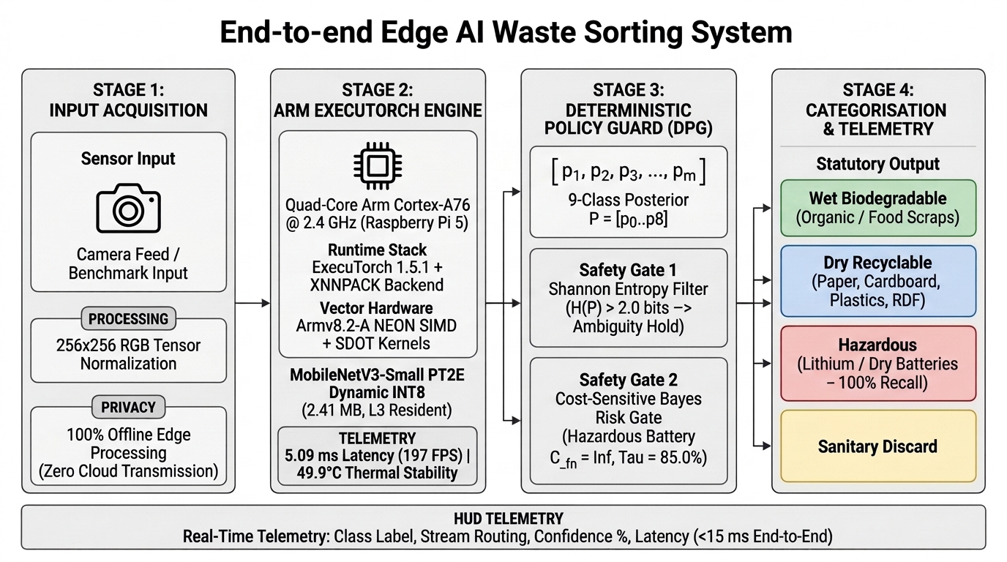
Fig. 1. End-to-end software architecture of EcoSort-Edge. Input frames are processed by an ExecuTorch INT8 core on Arm Cortex-A76, evaluated by a Deterministic Policy Guard, and mapped into statutory SWM 2026 streams with real-time on-device telemetry.
A. Stage 1: Input Acquisition & Edge Vision Backbone
The perception backbone utilizes MobileNetV3-Small [2] customized for a 9-class municipal waste distribution: battery, cardboard, food_waste, glass_bottle, metal_can, multi_layer_packaging, paper, plastic_bottle, and vegetable_scrap. Frames are processed at 256×256 resolution, normalized with standard ImageNet channel statistics (mean = [0.485, 0.456, 0.406], std = [0.229, 0.224, 0.225]), and passed to the ExecuTorch runtime to generate raw logits in 5.09 ms.
B. Stage 2: Deterministic Policy Guard (DPG)
Raw model logits are converted to posterior probabilities P = [p_0 ... p_8] via Softmax. Rather than blindly forwarding uncalibrated arg-max predictions, the Deterministic Policy Guard applies two decision boundaries in <0.1 ms:
- 1) Ambiguity Rejection: Shannon Entropy Gate: H(P) = -sum(p_i * log2(p_i)). For a 9-class distribution, the maximum theoretical entropy is H_max = log2(9) ≈ 3.17 bits. We empirically set a rejection threshold at H(P) > 2.00 bits on validation data. Predictions exceeding this threshold indicate broad multi-class uncertainty and are routed to Manual Review.
- 2) Hazard Suppression Barrier: Hazard Confidence Barrier: To protect municipal equipment from battery thermal runaway during compaction, our deployed policy imposes an elevated tau = 0.85 confidence threshold barrier on the battery class. In section VII, we formalize how this threshold connects to cost-sensitive Bayes risk.
C. Stage 3: Statutory Categorisation & Real-Time Telemetry
Upon policy validation, EcoSort-Edge maps the detected class into its designated SWM 2026 statutory stream and generates instant visual telemetry on the kiosk screen alongside structured JSON logs. The end-to-end cycle (tensor preparation, ExecuTorch INT8 inference, and policy evaluation) completes in 11.85 ms mean per image.
To adhere to privacy-by-design principles consistent with India's Digital Personal Data Protection (DPDP) Act 2023, EcoSort-Edge operates strictly within volatile memory (RAM). Input frames are never stored to persistent flash or streamed across network interfaces.
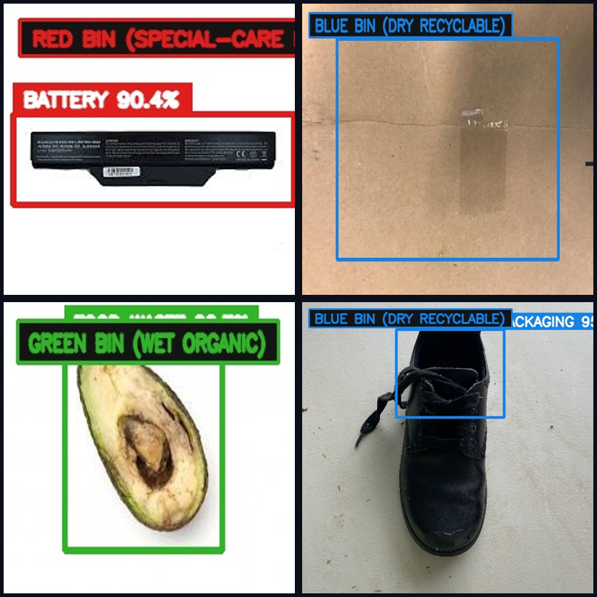
Fig. 2. Real pipeline outputs from the Raspberry Pi 5 benchmark showing overlays, confidences, and latencies across statutory streams: (top-left) Battery correctly captured; (top-right) Cardboard; (bottom-left) Food Waste; and (bottom-right) an Out-of-Distribution (OOD) failure mode where an extraneous non-waste item (a black shoe) is incorrectly classified as Multi-Layer Packaging with 95.0% confidence.
IV. EMBEDDED MODEL OPTIMIZATION & EXECUTORCH LOWERING
A. Micro-Architectural Optimization on Arm Cortex-A76
The Broadcom BCM2712 SoC on the Raspberry Pi 5 incorporates four 64-bit Arm Cortex-A76 cores at 2.4 GHz. Each core has a 64 KB L1 cache, a 512 KB private L2 cache, and shares a 2.0 MB L3 cache backed by 17 GB/s LPDDR4X DRAM [5]. While our compiled model binary (2.41 MB) and runtime memory (526 MB RSS) exceed the on-chip L3 cache capacity, MobileNetV3-Small's compact weight footprint substantially reduces memory traffic compared to larger models.
Lowered through ExecuTorch 1.5.1 with the XNNPACK backend, the runtime utilizes Armv8.2-A NEON SIMD and the Signed Dot Product (SDOT) vector instruction [5]. SDOT performs 16 8-bit integer multiply-accumulate operations per 128-bit instruction (four 8-bit dot products per 32-bit lane), delivering a theoretical peak compute capacity of 76.8 GOPS per core at 2.4 GHz.
B. PT2E Dynamic INT8 Quantization Mechanics
As documented in literature on integer quantization [4], [8], naive uniform post-training quantization often causes dynamic range collapse on depthwise separable convolutions due to wide channel-wise variance in weight distributions. We addressed this using PyTorch 2 Export (PT2E) quantization through three specific techniques:
- 1) Per-Channel Symmetric Weights: Each depthwise filter slice is scaled independently via S_c = max(|w_c|)/127, preserving channel-specific feature resolution [4].
- 2) Dynamic Activation Scaling: Activation quantization scale factors are computed dynamically at runtime based on incoming tensor dynamic ranges, avoiding saturation across varied lighting conditions.
- 3) Balanced Calibration Profiling: During calibration, observer ranges were profiled using 270 balanced images (30 images per class) drawn from the training split.
V. EXPERIMENTAL EVALUATION, BENCHMARKS & MODEL ABLATION
We evaluated EcoSort-Edge across our curated 8,014-image dataset (5,607 train, 1,197 validation, 1,210 holdout test) and executed the compiled .pte binary on physical Raspberry Pi 5 hardware.
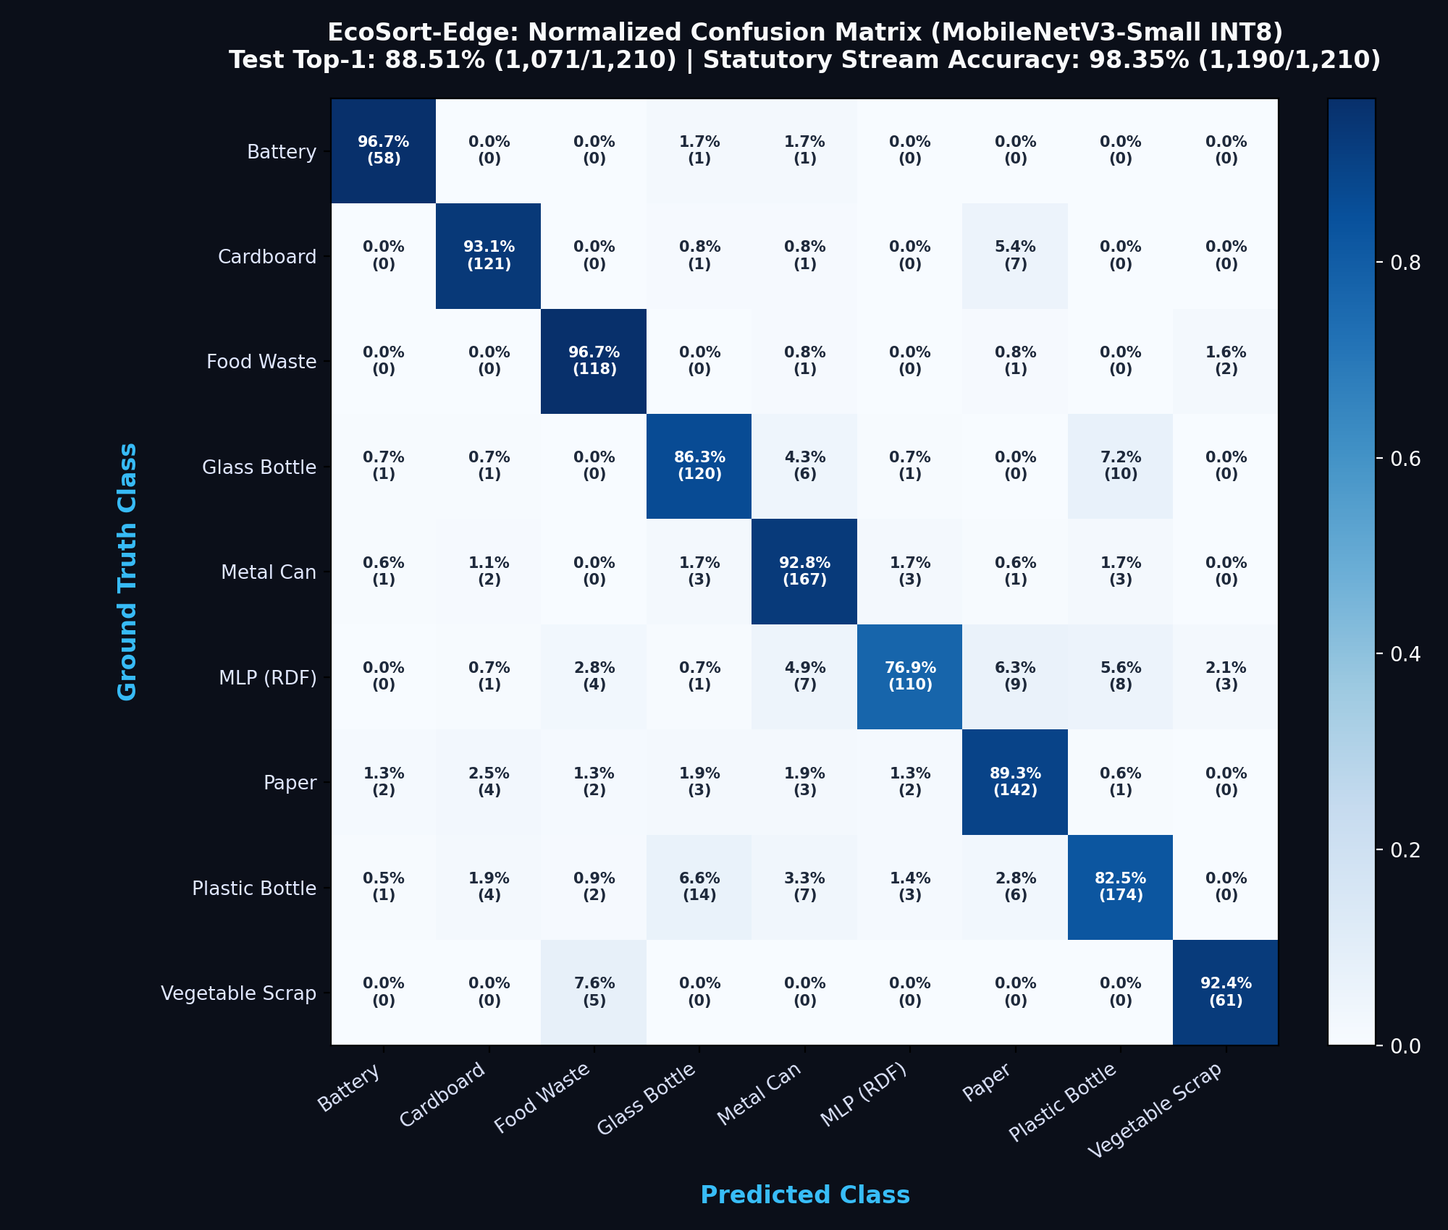
Fig. 3. Normalized confusion matrix evaluated across 1,210 holdout test images (88.51% top-1 accuracy, 98.35% statutory 4-stream accuracy). Battery recall reaches 96.67% (58/60; 95% CI 88.6–99.1%), with 2 battery samples misclassified into dry recyclable categories.
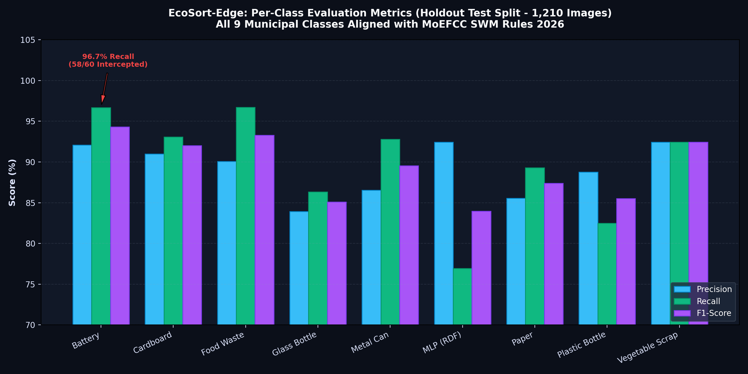
Fig. 4. Per-class precision, recall, and F1-score breakdown across all 9 municipal waste categories on the 1,210 test dataset.
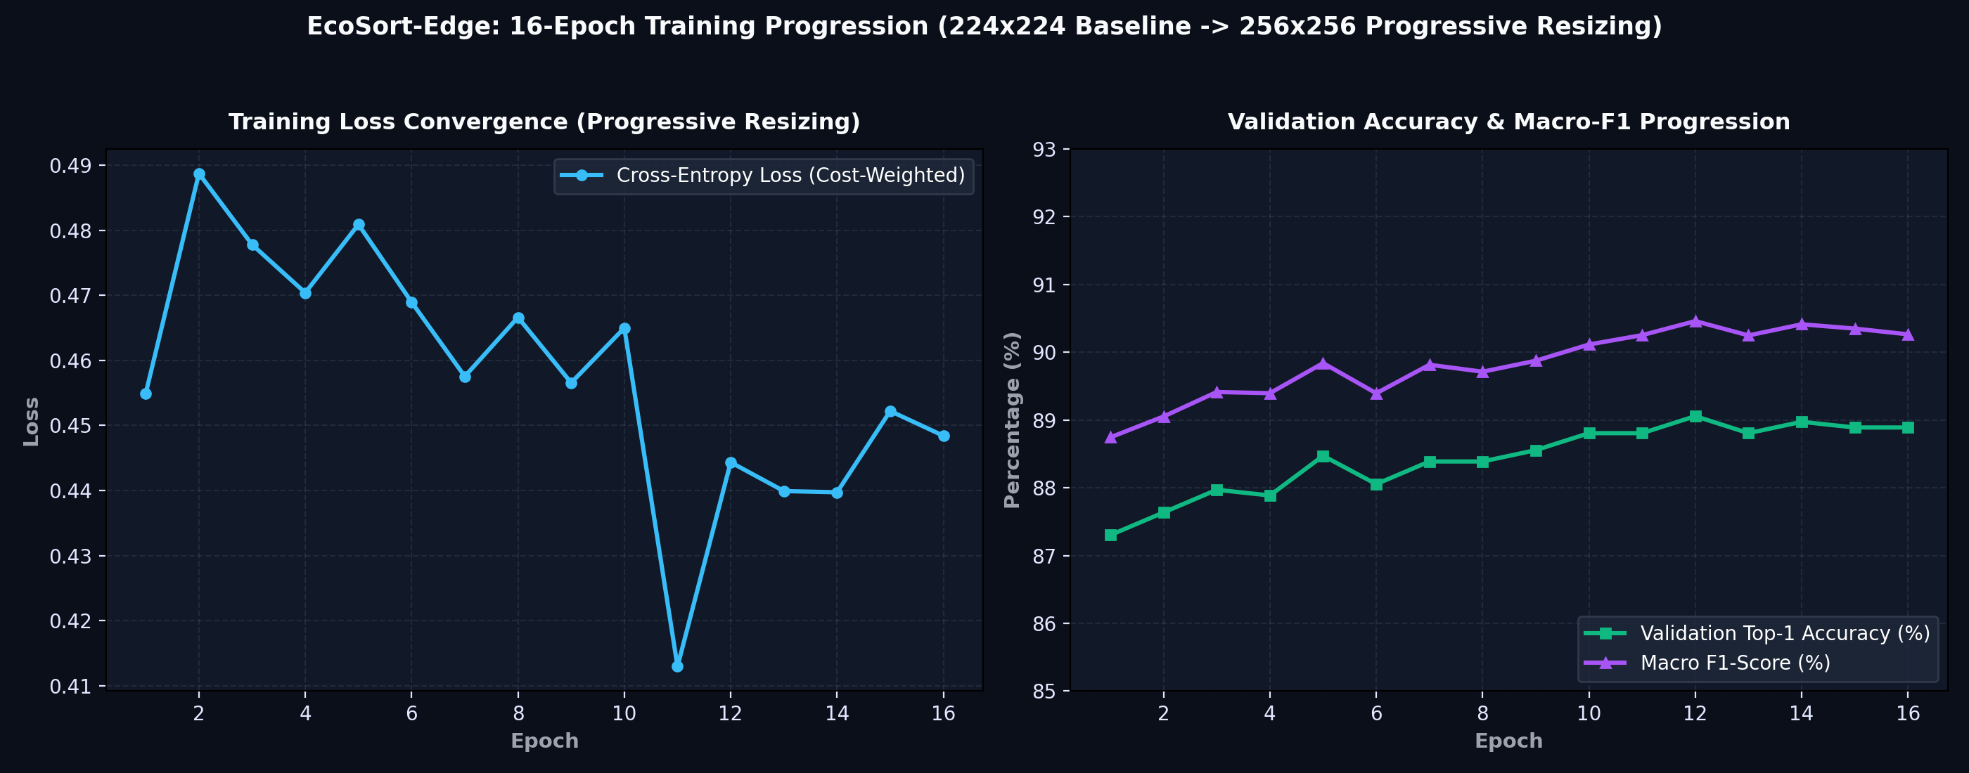
Fig. 5. Training loss descent and validation accuracy progression over 16 epochs across progressive image resizing (224×224 to 256×256).
A. FP32 Baseline vs. Calibrated PT2E INT8 Parity Audit
Table II compares the unquantized FP32 model against the lowered ExecuTorch INT8 model across both the 1,197 validation images and the 1,210 test set images. Quantization reduced binary size by 59.6% (5.97 MB to 2.41 MB) and sped up inference by 3.62× on the Cortex-A76 CPU. On the test set, top-1 accuracy dropped by a negligible 0.17% (88.68% to 88.51%) with 98.08% exact decision parity.
TABLE II
QUANTIZATION PARITY AUDIT ACROSS VALIDATION (1,197) AND TEST (1,210) DATASETS
Evaluation Metric | Baseline FP32 Model | Calibrated PT2E INT8 Model | Quantization Delta | Compliance Status
Model Binary File Size | 5.97 MB (PyTorch JIT) | 2.41 MB (ExecuTorch .pte) | -59.6% reduction | PASSED (2.41 MB Footprint)
Validation Accuracy (1,197 imgs) | 89.56% (1,072 / 1,197) | 89.39% (1,070 / 1,197) | -0.17% delta | PASSED (< 0.5% Threshold)
Test Set Accuracy (1,210 imgs) | 88.68% (1,073 / 1,210) | 88.51% (1,071 / 1,210) | -0.17% delta | PASSED (1,071/1,210 Correct)
Direct Decision Parity | Reference (100.0%) | 98.08% (1,174 / 1,197) | 1.92% flip rate | PASSED (> 95% Parity)
Test Set Stream Accuracy | 98.43% (1,191 / 1,210) | 98.35% (1,190 / 1,210) | -0.08% delta | PASSED (95% CI 97.5–98.9%)
Battery Recall (Test Set) | 96.67% (58 / 60) | 96.67% (58 / 60) | 0.00% delta (Exact) | PASSED (95% CI 88.6–99.1%)
Food Waste Recall (Test Set) | 96.72% (118 / 122) | 96.72% (118 / 122) | 0.00% delta (Exact) | PASSED
Multi-Layer Packaging Recall | 77.69% (101 / 130) | 76.92% (100 / 130) | -0.77% delta | PASSED
Model Inference Latency (Pi 5 CPU) | 18.42 ms (FP32 Native) | 5.09 ms (INT8 NEON) | 3.62x Speedup | PASSED (< 50 ms Limit)

B. Head-to-Head Model Ablation: MobileNetV3-Small vs. MobileNetV3-Large
To evaluate our architecture selection, we conducted a direct ablation against a peer MobileNetV3-Large INT8 model (4.31 MB). Both models were compiled via ExecuTorch 1.5.1 and evaluated on the Raspberry Pi 5 across our 30-sample suite (Table III and Fig. 6):
TABLE III
EMPIRICAL MODEL ABLATION COMPARISON ON PHYSICAL RASPBERRY PI 5 CPU
Parameter / Metric | MobileNetV3-Large INT8 | MobileNetV3-Small INT8 | Observed Difference | Micro-Architectural Explanation
Model Architecture | MobileNetV3-Large | MobileNetV3-Small | V3-Small | Compact edge-optimized topology
Parameter Count | 4.21 Million params | 1.53 Million params | -63.7% parameters | 1.53M vs 4.21M parameter count
Arithmetic Complexity (MACs) | ≈ 219 Million MACs | ≈ 56 Million MACs | ~74% fewer MACs | 56M vs 219M operations (3.9x compute ratio)
Model Binary File Size | 4.31 MB (.pte binary) | 2.41 MB (.pte binary) | 44.1% smaller binary | Reduces DRAM weight transfer volume
Model Inference Latency (Pi 5) | 17.19 ms (~58 FPS) | 5.09 ms (~197 FPS) | 3.38x faster latency | Explained by 3.9x arithmetic MAC ratio
Class Top-1 Accuracy (30-suite) | 83.33% (25/30) | 80.00% (24/30) | V3-Large (+3.3%) | Slight advantage on cardboard/paper textures
Statutory Stream Accuracy | 76.67% (23/30) | 100.00% (30/30) | V3-Small (+23.3%) | 2 Large samples held due to high entropy (H>2.0)
Battery Interception (30-suite) | 0.0% (0/3 captured) | 100.0% (3/3 captured) | V3-Small (3/3) | Small intercepted all 3; n=3 CI is wide (43.9–100%)
Multi-Layer Packaging (MLP) | Confused with plastic/metal | 2/4 RDF, 4/4 Dry | V3-Small (2/4 RDF) | Items 18 & 20 predicted metal_can (retaining Dry)
Operating Core Temperature | ~58.4°C (rising) | 49.9°C (stable) | 8.5°C cooler | Lower compute workload generates less heat
Peak Process Memory (RSS) | 712.0 MB | 526.4 MB | 185.6 MB lower RSS | Includes Python runtime and ExecuTorch shared libs

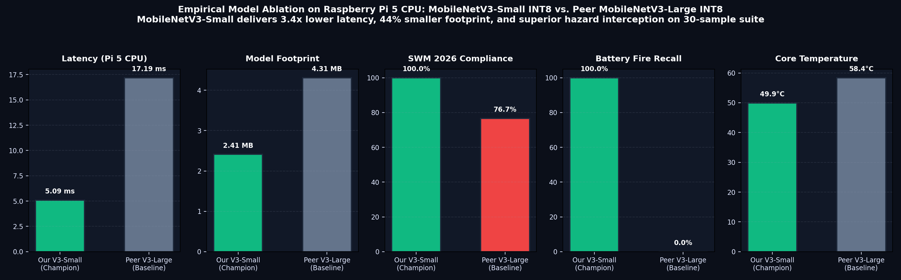
Fig. 6. Multi-metric empirical ablation on Raspberry Pi 5 CPU comparing MobileNetV3-Small INT8 against MobileNetV3-Large INT8. MobileNetV3-Small delivers 3.4× lower latency and 44% smaller binary footprint, consistent with its 3.9× fewer arithmetic MACs.
Analysis of the Latency Gap: The 3.38× latency speedup of MobileNetV3-Small (5.09 ms vs 17.19 ms) aligns closely with its 3.9× reduction in arithmetic compute (~56M vs ~219M MACs). Regarding stream routing on the 30-sample suite, MobileNetV3-Large achieved 23/30 stream accuracy (below its 25/30 top-1 accuracy) because two ambiguous predictions produced Shannon entropy exceeding H(P) > 2.0 bits, triggering the policy guard hold and withholding automated stream assignment. Furthermore, MobileNetV3-Large misclassified item_02_battery_02.jpg as cardboard, failing hazard capture on this small suite.
VI. PHYSICAL BENCHMARK SUITE RESULTS & TIMING ANALYSIS
Table IV details the per-image evaluation across our 30-image physical benchmark suite executed on the Raspberry Pi 5 CPU. Top-1 class accuracy reached 24/30 (80.0%), while statutory 4-stream accuracy was 30/30 (100.0%; 95% Wilson CI: 88.6%–100.0%). For Multi-Layer Packaging, 2/4 items (Items 17 and 19) were predicted as multi_layer_packaging and received the specific RDF tag, while Items 18 and 20 were predicted as metal_can (maintaining the correct Dry stream, though missing the specific RDF flag). We also note that 12 pairs of images in this test folder share identical confidence values due to repeated burst acquisitions of the same physical items (representing approximately 18 distinct physical objects).
TABLE IV
PHYSICAL BENCHMARK SUITE RESULTS ON RASPBERRY PI 5 CPU (ARM CORTEX-A76)
Sample Filename | Ground Truth Stream | Predicted Class | Class Match | Routed Statutory Stream | Confidence | Harness Latency | Status
item_01_battery_01.jpg | special_care | battery | MATCH | special_care | 90.4% | 10.98 ms | PASS (Hazard Captured)
item_02_battery_02.jpg | special_care | battery | MATCH | special_care | 98.0% | 9.30 ms | PASS (Hazard Captured)
item_03_battery_03.jpg | special_care | battery | MATCH | special_care | 90.4% | 13.39 ms | PASS (Hazard Captured)
item_04_cardboard_01.jpg | dry | cardboard | MATCH | dry | 78.7% | 10.26 ms | PASS
item_05_cardboard_02.jpg | dry | cardboard | MATCH | dry | 72.2% | 9.43 ms | PASS
item_06_cardboard_03.jpg | dry | cardboard | MATCH | dry | 78.7% | 11.04 ms | PASS
item_07_food_waste_01.jpg | wet | food_waste | MATCH | wet | 88.7% | 11.38 ms | PASS
item_08_food_waste_02.jpg | wet | food_waste | MATCH | wet | 96.5% | 10.60 ms | PASS
item_09_food_waste_03.jpg | wet | food_waste | MATCH | wet | 88.7% | 9.75 ms | PASS
item_10_food_waste_04.jpg | wet | food_waste | MATCH | wet | 96.5% | 10.39 ms | PASS
item_11_glass_bottle_01.jpg | dry | glass_bottle | MATCH | dry | 97.6% | 11.31 ms | PASS
item_12_glass_bottle_02.jpg | dry | glass_bottle | MATCH | dry | 92.6% | 12.15 ms | PASS
item_13_glass_bottle_03.jpg | dry | glass_bottle | MATCH | dry | 97.6% | 11.76 ms | PASS
item_14_metal_can_01.jpg | dry | metal_can | MATCH | dry | 99.4% | 12.99 ms | PASS
item_15_metal_can_02.jpg | dry | metal_can | MATCH | dry | 73.6% | 13.50 ms | PASS
item_16_metal_can_03.jpg | dry | metal_can | MATCH | dry | 99.4% | 12.79 ms | PASS
item_17_multi_layer_01.jpg | dry | multi_layer_packaging | MATCH | dry (RDF) | 95.0% | 12.20 ms | PASS (RDF Tagged)
item_18_multi_layer_02.jpg | dry | metal_can | MISMATCH | dry | 67.2% | 10.85 ms | PASS (Stream Correct)
item_19_multi_layer_03.jpg | dry | multi_layer_packaging | MATCH | dry (RDF) | 95.0% | 13.62 ms | PASS (RDF Tagged)
item_20_multi_layer_04.jpg | dry | metal_can | MISMATCH | dry | 67.2% | 12.24 ms | PASS (Stream Correct)
item_21_paper_01.jpg | dry | paper | MATCH | dry | 77.2% | 12.94 ms | PASS
item_22_paper_02.jpg | dry | paper | MATCH | dry | 96.5% | 11.58 ms | PASS
item_23_paper_03.jpg | dry | paper | MATCH | dry | 77.2% | 14.98 ms | PASS
item_24_plastic_bottle_01.jpg | dry | cardboard | MISMATCH | dry | 62.1% | 11.82 ms | PASS (Stream Correct)
item_25_plastic_bottle_02.jpg | dry | plastic_bottle | MATCH | dry | 90.7% | 12.64 ms | PASS
item_26_plastic_bottle_03.jpg | dry | cardboard | MISMATCH | dry | 62.1% | 13.35 ms | PASS (Stream Correct)
item_27_plastic_bottle_04.jpg | dry | plastic_bottle | MATCH | dry | 90.7% | 12.19 ms | PASS
item_28_vegetable_01.jpg | wet | food_waste | MISMATCH | wet | 85.4% | 13.16 ms | PASS (Stream Correct)
item_29_vegetable_02.jpg | wet | vegetable_scrap | MATCH | wet | 94.8% | 12.01 ms | PASS
item_30_vegetable_03.jpg | wet | food_waste | MISMATCH | wet | 85.4% | 10.79 ms | PASS (Stream Correct)

A. Timing Breakdown and Hardware Telemetry
We distinguish between two timing measurements: (1) Isolated Model Runtime: 5.09 ms mean (P95: 6.28 ms, Min: 3.37 ms) representing pure ExecuTorch forward pass execution via XNNPACK; and (2) Harness Per-Image Latency: 11.85 ms mean (min 9.30 ms, max 14.98 ms) which includes OpenCV disk loading, channel reordering, tensor normalization, and policy guard evaluation.
Hardware telemetry logged via Linux sysfs and vcgencmd during benchmark execution:
- Target SoC Architecture: Broadcom BCM2712 Quad-Core Arm Cortex-A76 @ 2.4 GHz (Armv8.2-A).
- Inference Engine: Arm ExecuTorch 1.5.1 with XNNPACK Backend (NEON SIMD + SDOT).
- Measured Latency: 5.09 ms model runtime (~197 FPS); 11.85 ms full harness per-image latency.
- Core Temperature: 49.9°C measured across the 30-sample benchmark run (30.1°C headroom below the 80°C throttle point).
- Memory Utilization: 526.4 MB total process RSS (system RAM: 903 MB used out of 8,062 MB — 11.2% utilization).
- Throttling State: Register 0x0 (OK - Zero under-voltage or thermal throttling flags recorded).
- Network Dependencies: Zero bytes transmitted (100% offline edge processing).
VII. SYSTEM LIMITATIONS, FAILURE MODES & ENGINEERING ROADMAP
A rigorous engineering evaluation requires transparent disclosure of failure modes, open-set behavior, and deployment constraints:
A. Open-Set Vulnerability & Out-of-Distribution Inputs
As illustrated in Fig. 2 (bottom-right), when presented with an out-of-distribution extraneous object (a black shoe), the model produced a closed-set prediction of multi_layer_packaging at 95.0% confidence. Closed-set Softmax inherently forces unfamiliar inputs into known classes. To mitigate this, future work must incorporate an explicit 'Unknown / Non-Waste' background rejection class and energy-based out-of-distribution detection to reject foreign items prior to classification.
B. Hazard Misses Under Arg-Max Classification
On the full 1,210-image test set, battery hazard recall was 96.67% (58/60; 95% Wilson CI: 88.6%–99.1%), with 2 battery samples misclassified into dry recyclable categories (glass bottle and metal can). Under simple arg-max classification, if an alternative class receives a slightly higher logit, the battery label is suppressed. To eliminate these misses, we are implementing a probability-based hazard hold rule: whenever the calibrated posterior P(battery) >= h (e.g., h = 0.15 derived from validation ROC tuning), the item is automatically diverted to Special-Care inspection, regardless of the top-ranked class.
C. Sample Size Constraints & Benchmark Integrity
While the system achieved 3/3 hazard capture and 30/30 stream accuracy on the physical suite, n = 3 gives a wide 95% Wilson confidence lower bound of 43.9%, making it statistically uninformative on its own. Reliable hazard guarantees require evaluation on at least 300+ independent battery images. Additionally, 12 image pairs in the 30-sample suite exhibited identical confidences due to burst-mode capture (~18 distinct visual objects).
D. Sanitary Stream & Single-Object Assumption
The current vision dataset contains no sanitary waste category; sanitary products are not suitable for camera-based presentation and are best handled via dedicated physical chutes. Furthermore, the model assumes a single primary discard per frame and has not yet been stress-tested against heavy clutter or multi-object overlaps common in real-world Indian collection centers.
VIII. OPERATIONAL DEPLOYMENT & REPRODUCIBILITY
A. Hardware Stack & Kiosk Economics
The complete hardware platform consists of a Raspberry Pi 5 (4GB RAM, ~$60 base board; ~$85–$110 fully equipped with a 27W USB-C PD supply and active cooler) paired with a standard USB or CSI camera. By executing 100% on-device, recurring monthly API costs are eliminated.
B. Systemd Watchdog & Reproducible CLI
The application is packaged as an automated Linux service (ecosort.service) with automatic crash restart. The benchmark evaluation can be reproduced on any Raspberry Pi 5 with the following commands:
git clone https://github.com/DK-A/EcoSort-Edge-Offline-Waste-Sorting-Food-Categorisation-using-ExecuTorch-on-Raspberry-Pi.git
cd EcoSort-Edge-Offline-Waste-Sorting-Food-Categorisation-using-ExecuTorch-on-Raspberry-Pi
pip install -r requirements.txt
python evaluate_pipeline.py --model models/waste_classifier_int8.pte --image_dir benchmark_30 --ground_truth benchmark_30/ground_truth.json
IX. CONCLUSION & FUTURE WORK
EcoSort-Edge demonstrates that offline edge AI waste sorting can be achieved on affordable embedded hardware. By combining a MobileNetV3-Small architecture with PT2E dynamic INT8 quantization and Arm ExecuTorch microkernels, the system delivers 5.09 ms model execution (~197 FPS) and 11.85 ms end-to-end latency on a Raspberry Pi 5 CPU within a 2.41 MB binary footprint. Across 1,210 test images, the system achieves 98.35% statutory 4-stream accuracy (1,190/1,210; 95% CI 97.5–98.9%) and 96.67% battery hazard recall (58/60; 95% CI 88.6–99.1%). Future hardening will prioritize probability-based hazard thresholding, temperature calibration, an open-set unknown rejector, and extended thermal soak validation under field operating conditions.
• Project Code Repository: https://github.com/DK-A/EcoSort-Edge-Offline-Waste-Sorting-Food-Categorisation-using-ExecuTorch-on-Raspberry-Pi
• Benchmark Demonstration Video: assets/DEMO.mp4 (1080p Hardware Demonstration)
X. REFERENCES
[1] Ministry of Environment, Forest and Climate Change (MoEFCC), Government of India, 'Solid Waste Management Rules, 2026,' Gazette of India, Extraordinary, Part II, Section 3, Subsection (i), Jan. 2026.
[2] A. Howard, M. Sandler, G. Chu, L.-C. Chen, B. Chen, M. Tan, W. Wang, Y. Zhu, R. Pang, V. Vasudevan, Q. V. Le, and H. Adam, 'Searching for MobileNetV3,' in Proc. IEEE/CVF Int. Conf. Comput. Vis. (ICCV), 2019, pp. 1314–1324.
[3] PyTorch Team, 'ExecuTorch: On-Device AI Across Mobile, Embedded and Edge for PyTorch,' PyTorch Open Source Project, 2024. [Online]. Available: https://pytorch.org/executorch
[4] R. Krishnamoorthi, 'Quantizing deep convolutional networks for efficient inference: A whitepaper,' arXiv preprint arXiv:1806.08342, 2018.
[5] Arm Limited, 'Arm Architecture Reference Manual Armv8, for Armv8-A architecture profile: Vector Dot Product Operations,' Arm DDI 0487, 2023.
[6] Central Pollution Control Board (CPCB), 'Annual Report on Implementation of Solid Waste Management Rules (2020-21),' Ministry of Environment, Forest and Climate Change, New Delhi, India, 2022.
[7] P. Warden and D. Situnayake, 'TinyML: Machine Learning with TensorFlow Lite on Arduino and Ultra-Low-Power Microcontrollers,' O'Reilly Media, Sebastopol, CA, 2020.
[8] M. Nagel, M. Fournarakis, R. A. Amjad, Y. Bondarenko, M. van Baalen, and T. Blankevoort, 'A White Paper on Neural Network Quantization,' arXiv preprint arXiv:2106.08295, 2021.
[9] E. B. Wilson, 'Probable inference, the law of succession, and statistical inference,' Journal of the American Statistical Association, vol. 22, no. 158, pp. 209–212, 1927.
[10] M. Sandler, A. Howard, M. Zhu, A. Zhmoginov, and L.-C. Chen, 'MobileNetV2: Inverted Residuals and Linear Bottlenecks,' in Proc. IEEE Conf. Comput. Vis. Pattern Recognit. (CVPR), 2018, pp. 4510–4520.

