**Description :**

It’s a simple game in the style of “Flappy Bird”.Gameplay will consist of the player tapping the screen to control (For Android) and tapping space (For Windows) to control the plane to move up and down to avoid rocks and go as far as player can with unbelievably unsafe environment.Each rock passed will grant a point.It’s a lightweight cross-platform “Flappy Bird” clone for android and windows.

**Mad plane game using Unity 3D :**

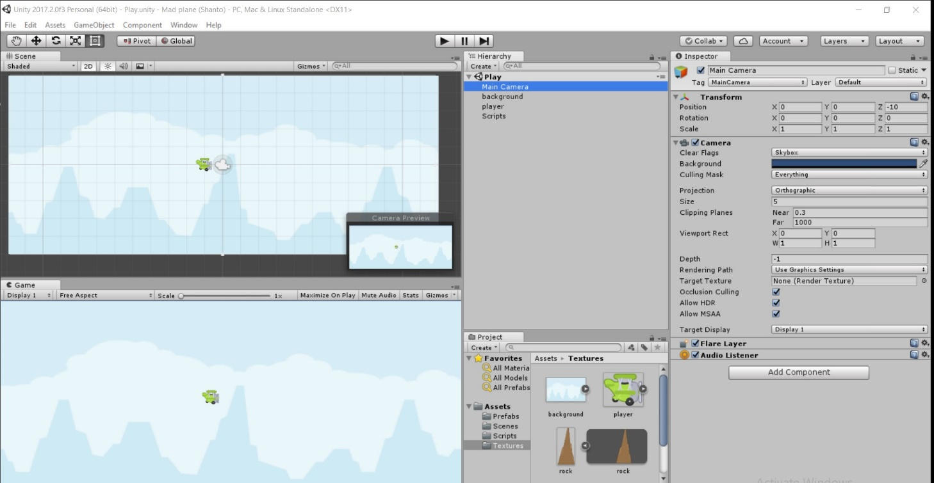

**C sharp language scripts :**

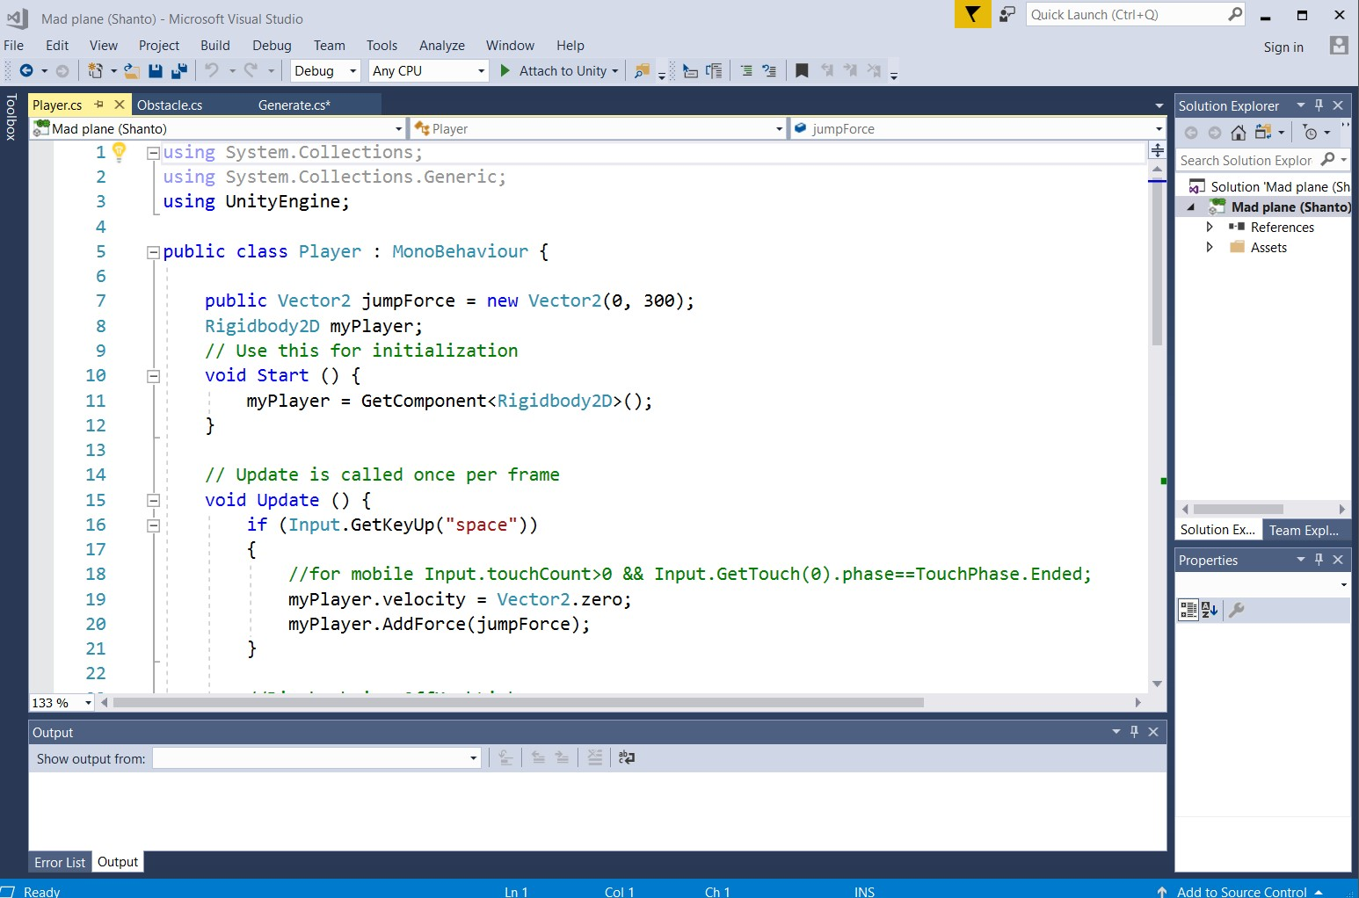

**Contact :** shanto1709@cseku.ac.bd