


算法分析与设计

学 院 计算机科学与工程
学 号 11703990404
姓 名 邓桥
指 导 教 师 宋承云
使 用 教 材 算法设计与分析基础
编 写 时 间 2019.10.19

实验3图搜索及最短路径实验
实验目的：
- 掌握图算法的思想，熟练掌握图算法的经典求解问题。
- 编写代码实现图算法中的搜索算法及最短路径算法。
实验内容：
Ex1：用伪代码描述Dijkstra算法并实现。用程序分别实现求解加权无向图和加权有向图的Dijkstra算法（分别用P260习题9.3的2b,2a进行验证）。
Ex1算法描述：
算法 Dijkstra（G，s）
//单起点最短路径的Dijkstra算法
//输入：具非负权重加权连通图G=<V,E>以及它的顶点s
//输出：对于V中的每个顶点v来说，从s到v的最短路径的长度dv
以及路径上的倒数第二个顶点pv
Initialize(Q) //将顶点优先队列初始化为空
for V中的每一个顶点v
dv <- ∞; pv <- null
Insert(Q,v,dv)//初始化优先队列中顶点的优先级
ds <- 0; Decrease(Q,s,ds)//将s的优先级更新为ds
Vt <- ∅
for i <- 0 to |V|-1 do
u* <- DeleteMin(Q)//删除优先级最小的元素
Vt <- Vt∪{u*}
for V-Vt中每一个和u*相邻的顶点u do
if du*+w(u*,u)<du
du <- du*+w(u*,u); pu <- u*
Decrease(Q,u,du)
Ex1源代码：
package t3;

public class Main {

public static void main(String[] args) {
// TODO Auto-generated method stub

bookGraph();
}

private static void bookGraph(){
// Graph graph = new Graph(5);
// Edge[] edges = new Edge[10];
//
// edges[0] = new Edge(0,1,10);
// edges[1] = new Edge(0,3,5);
// edges[2] = new Edge(1,2,1);
// edges[3] = new Edge(1,3,2);
// edges[4] = new Edge(2,4,4);
// edges[5] = new Edge(3,1,3);
// edges[6] = new Edge(3,2,9);
// edges[7] = new Edge(3,4,2);
// edges[8] = new Edge(4,0,7);
// edges[9] = new Edge(4,2,6);

// Graph graph = new Graph(5);
// Edge[] edges = new Edge[7];
//
// edges[0] = new Edge(1,0,3);
// edges[1] = new Edge(0,3,7);
// edges[2] = new Edge(1,2,4);
// edges[3] = new Edge(3,1,2);
// edges[4] = new Edge(2,4,6);
// edges[5] = new Edge(3,2,5);
// edges[6] = new Edge(4,3,4);

Graph graph = new Graph(12);
Edge[] edges = new Edge[40];

edges[0] = new Edge(0,1,3);
edges[1] = new Edge(0,2,5);
edges[2] = new Edge(0,3,4);
edges[3] = new Edge(1,4,3);
edges[4] = new Edge(1,5,6);
edges[5] = new Edge(2,3,2);
edges[6] = new Edge(2,6,4);
edges[7] = new Edge(3,4,1);
edges[8] = new Edge(3,7,5);
edges[9] = new Edge(4,5,2);
edges[10] = new Edge(4,8,4);
edges[11] = new Edge(5,9,5);
edges[12] = new Edge(6,7,3);
edges[13] = new Edge(6,10,6);
edges[14] = new Edge(7,8,6);
edges[15] = new Edge(7,10,7);
edges[16] = new Edge(8,9,3);
edges[17] = new Edge(8,11,5);
edges[18] = new Edge(9,11,9);
edges[19] = new Edge(10,11,8);
edges[20] = new Edge(1,0,3);
edges[21] = new Edge(2,0,5);
edges[22] = new Edge(3,0,4);
edges[23] = new Edge(4,1,3);
edges[24] = new Edge(5,1,6);
edges[25] = new Edge(3,2,2);
edges[26] = new Edge(6,2,4);
edges[27] = new Edge(4,3,1);
edges[28] = new Edge(7,3,5);
edges[29] = new Edge(5,4,2);
edges[30] = new Edge(8,4,4);
edges[31] = new Edge(9,5,5);
edges[32] = new Edge(7,6,3);
edges[33] = new Edge(10,6,6);
edges[34] = new Edge(8,7,6);
edges[35] = new Edge(10,7,7);
edges[36] = new Edge(9,8,3);
edges[37] = new Edge(11,9,5);
edges[38] = new Edge(11,9,9);
edges[39] = new Edge(11,10,8);
for(int i = 0;i<40;i++)
graph.insertEdge(edges[i]);

graph.bianli();
graph.DIJKSTRA(0);
}

}
package t3;

import java.util.*;

public class Graph {

private LinkedList<Edge>[] edgeLinks;
private int vNum; //顶点数
private int edgeNum; //边数
private int[] distance; //存放v.d
private int[] prenode; //存放前驱节点
private LinkedList<Integer> S; //已经求到最短路径的顶点集合
private LinkedList<Integer> Q; //尚未求到最短路径的顶点集合
public static final int INF = 10000; //无穷大
public static final int NIL = -1; //表示不存在
static char[] cc= {'a','b','c','d','e','f','g','h','i','j','k','l'};
public Graph(int vnum){
this.vNum = vnum;
edgeLinks = new LinkedList[vnum];
edgeNum = 0;
distance = new int[vnum];
prenode = new int[vnum];
for(int i = 0;i<vnum;i++)
edgeLinks[i] = new LinkedList<>();
}

public void insertEdge(Edge edge){
int v1 = edge.getV1();
edgeLinks[v1].add(edge);
edgeNum++;
}

public void bianli(){
System.out.println("共有 "+vNum+" 个顶点， "+edgeNum+" 条边");
for(int i = 0;i<vNum;i++){
LinkedList<Edge> list = (LinkedList<Edge>) edgeLinks[i].clone();
while(!list.isEmpty()){
Edge edge = list.pop();
System.out.println(edge.toString());
}
}
}

/**
* 对最短路径估计和前驱节点进行初始化
* @param start
*/
public void INITIALIZE_SINGLE_SOURCE(int start){
for(int i = 0;i<vNum;i++){
distance[i] = INF;
prenode[i] = NIL;
}
distance[start] = 0;
}
public void RELAX(Edge edge){
int v1 = edge.getV1();
int v2 = edge.getV2();
int w = edge.getWeight();
if(distance[v2]>distance[v1]+w){
distance[v2] = distance[v1]+w;
prenode[v2] = v1;
}
}

public void DIJKSTRA(int start){

INITIALIZE_SINGLE_SOURCE(start);

S = new LinkedList<>();
Q = new LinkedList<>();
for(int i = 0;i<vNum;i++){
Q.add(i);
}

while(!Q.isEmpty()){
int u = EXTRACT_MIN(Q);
S.add(u);
LinkedList<Edge> list = (LinkedList<Edge>) edgeLinks[u].clone();
while(!list.isEmpty()){
Edge edge = list.pop();
RELAX(edge);
}
}

ShowResult();

}

private int EXTRACT_MIN(LinkedList<Integer> q){

if(q.isEmpty())
return -1;

int min = q.getFirst();
for(int i = 0;i<q.size();i++){
int v = q.get(i);
if(distance[min]>distance[v]){
min = v;
}
}
int min2 = min;
q.remove(q.indexOf(min));
return min;
}

private void ShowResult(){
System.out.println("=========Result==========");
Stack<Integer>[] routes = new Stack[vNum];
for(int i = 0;i<vNum;i++){
routes[i] = new Stack<>();
int j = i;
while(j != NIL){
routes[i].push(j);
j = prenode[j];
}

System.out.print(cc[i]+"("+distance[i]+") : ");
while(!routes[i].isEmpty()){
int k = routes[i].pop();
System.out.print("-->"+cc[k]);
}
System.out.println();
}
}
}
package t3;

/**
* 边
* @author sdu20
*
*/
public class Edge {

private int v1;
private int v2;
private int weight;
static char[] ccc= {'a','b','c','d','e','f','g','h','i','j','k','l'};
public Edge(int v1,int v2,int weight){
this.v1 = v1;
this.v2 = v2;
this.weight = weight;
}

public boolean equals(Edge edge){
return this.v1==edge.getV1() && this.v2==edge.getV2() &&this.weight == edge.getWeight();
}

public int getV1(){
return v1;
}

public int getV2(){
return v2;
}

public int getWeight(){
return weight;
}

public String toString(){
String str = "[ "+ccc[v1]+" , "+ccc[v2]+" , "+weight+" ]";
return str;
}

}
运行（测试）过程及结果：
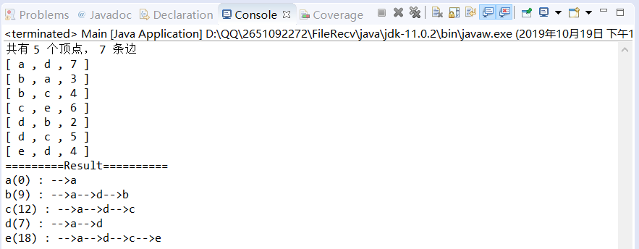
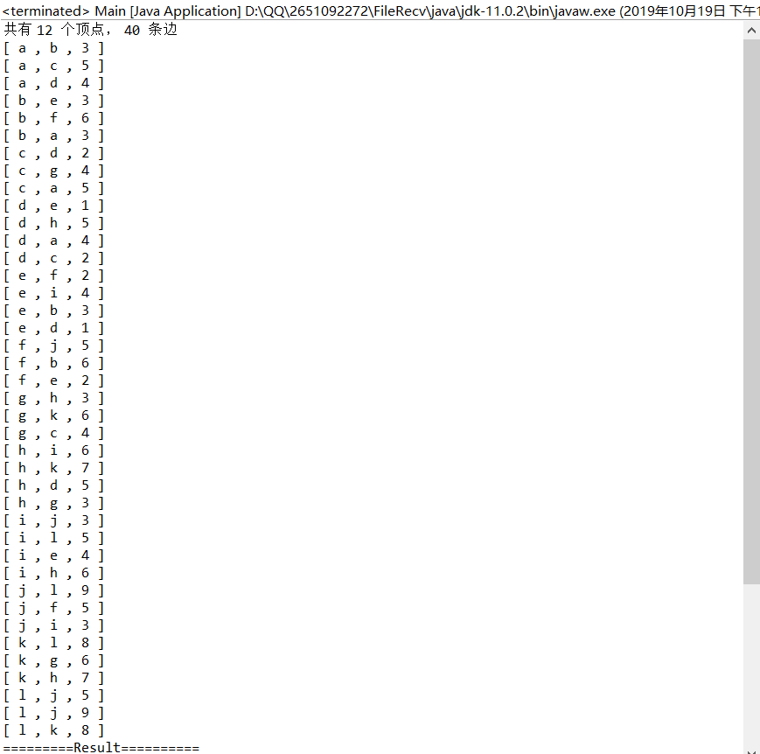
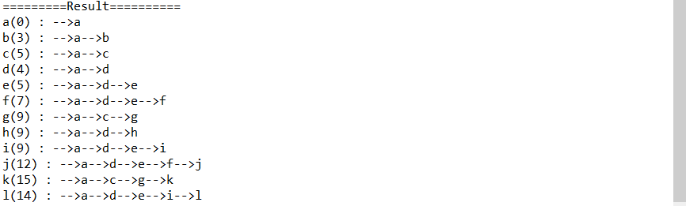
总结：
通过本次实验，我掌握了图算法的思想，并能熟练掌握图算法的经典求解问题，最终还编写代码实现图算法中的搜索算法及最短路径算法。另外，我了解了Dijkstra算法的时间效率依赖于用来实现优先队列的数据结构以及用来表示输入图本身的数据结构。无论是Prim算法还是Dijiksta算法的最差效率都会更好一些。然而，这种结构过于复杂而且开销十分可观，这种改进基本上只具有理论上的价值。

