DataInsight Agent – n8n AI Data Analyst
Implementation Guide | Google Sheets + OpenAI + AI Agent + Gmail
Dnyaneshvar Khairnar | Pune, Maharashtra

Project Overview
DataInsight Agent is an n8n-based AI Data Analyst workflow. A user sends a natural-language request through chat. The AI Agent understands the request, retrieves spreadsheet data through Google Sheets, analyzes the data using an OpenAI chat model, maintains short-term conversation context using Simple Memory, and can deliver the result through Gmail.

Tool used: - n8n website. It’s an as a visual automation and workflow orchestration platform.
Instead of writing a lot of code to connect different applications, you can connect them using nodes.
Why n8n-> Automation + Integration + Orchestration (A workflow is the complete process.)
• n8n Cloud or self-hosted n8n instance.
• Google account with access to the target Google Sheet.
• OpenAI API credential/model configured in n8n.
• Gmail credential configured for sending reports.
• Google Sheet containing structured data with a header row.
Agent Link: - https://dk1997.app.n8n.cloud/workflow/F2SfL2LywV5kqmnI
Think of n8n as a visual automation and workflow orchestration platform.

2. Architecture
User → Chat Trigger → AI Agent → Google Sheets Tool → Data Analysis → Gmail → Email Report
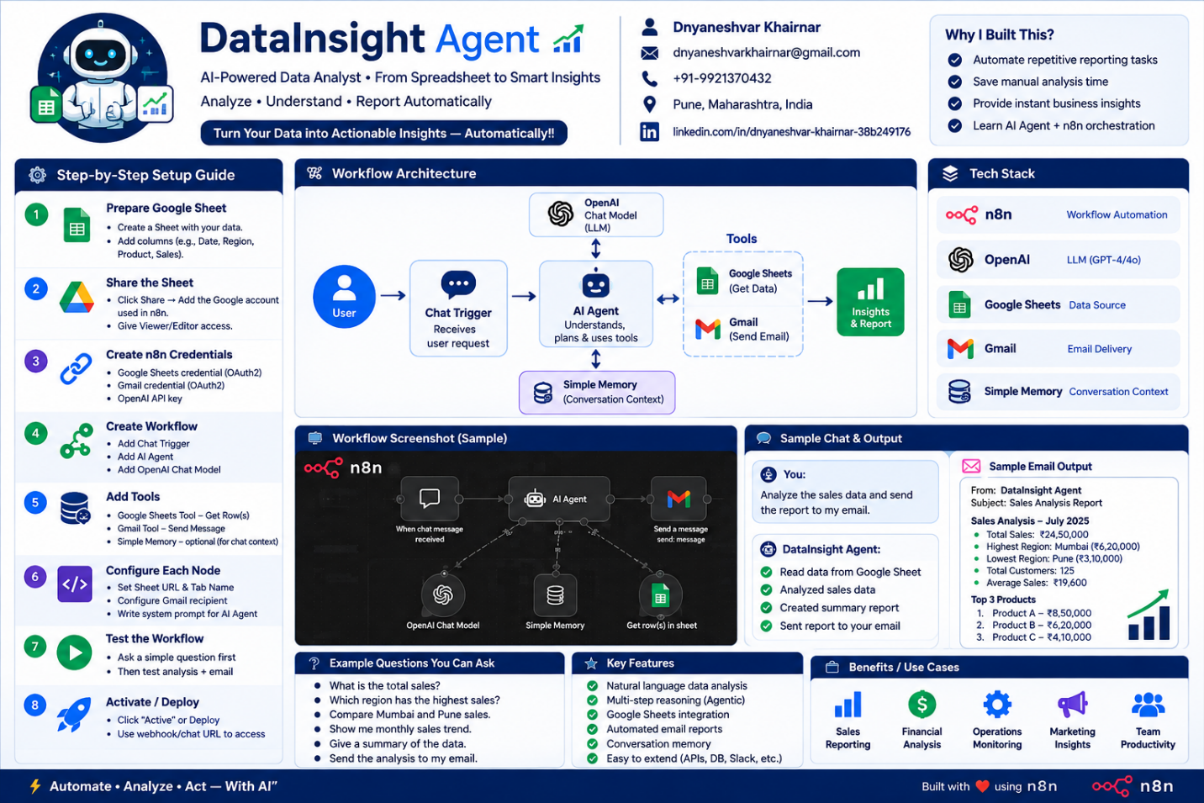

Each Component: -
- Chat Trigger “Take input from user” -> Entry point to start the workflow.
It waits for user to type something
chatInput = "Show me total sales"
sessionId = "3d7425..."(generate session_id for each request)
action = "sendMessage"(to do action)

- AI Agent — "Brain + Decision Maker"
Its not similar as chat-gpt The Agent has the ability to:
a)Understand the request b)Decide what action is needed c) Use tools d) Analyze tool results e) Perform multiple steps f) Produce a final answer

An AI Agent is an LLM-based system that can reason about a task and use external tools to perform actions. In my workflow, the agent can retrieve data from Google Sheets, analyze it, and use Gmail to send the resulting report.

- OpenAI Chat Model — "Brain / Language Understanding"
connected to the AI Agent's Chat Model input.
This is the actual LLM.
Think of it as the intelligence that understands language and generates responses.

- Simple Memory: - its store the chat Conversation
Simple Memory gives the AI a similar short-term conversational context.

DataInsight Agent –Implementation Steps
n8n • OpenAI • Google Sheets • Simple Memory • Gmail
1. Prepare Google Sheet
Create the data sheet with clear headers such as Date, Region, Product, Customer and Sales. Share the sheet with the Google account used by n8n.
2. Configure Credentials
Add Google Sheets, OpenAI and Gmail credentials in n8n.
3. Add Chat Trigger
Add 'When chat message received'. This receives the user's question and starts the workflow.
4. Add AI Agent + OpenAI Model
Add the AI Agent and connect the OpenAI Chat Model. Give the Agent instructions to retrieve, analyze and explain spreadsheet data.
5. Add Simple Memory
Connect Simple Memory to the Agent's Memory input so follow-up questions can use the current conversation context.
6. Add Google Sheets Tool
Use Google Sheets → Sheet Within Document → Get Row(s). Select the actual spreadsheet and tab. Test it first and confirm that real rows are returned.
7. Add Gmail
Configure Gmail → Send a message. Set recipient and subject. Map the verified AI Agent response into the Message field using Expression mode.
8. Test End-to-End
Ask: 'What is the total sales?' Then test: 'Which region has the highest sales?' Finally test: 'Analyze the data and send the report to my email.'
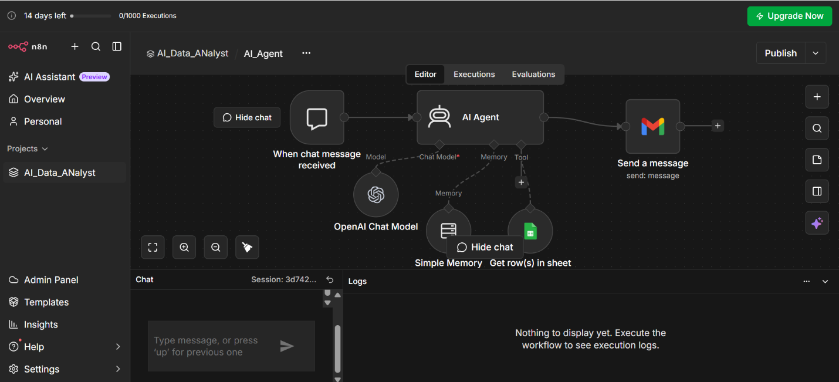
Snapshot 1 – n8n workflow: Chat Trigger → AI Agent → Gmail, with OpenAI Model, Simple Memory and Google Sheets.
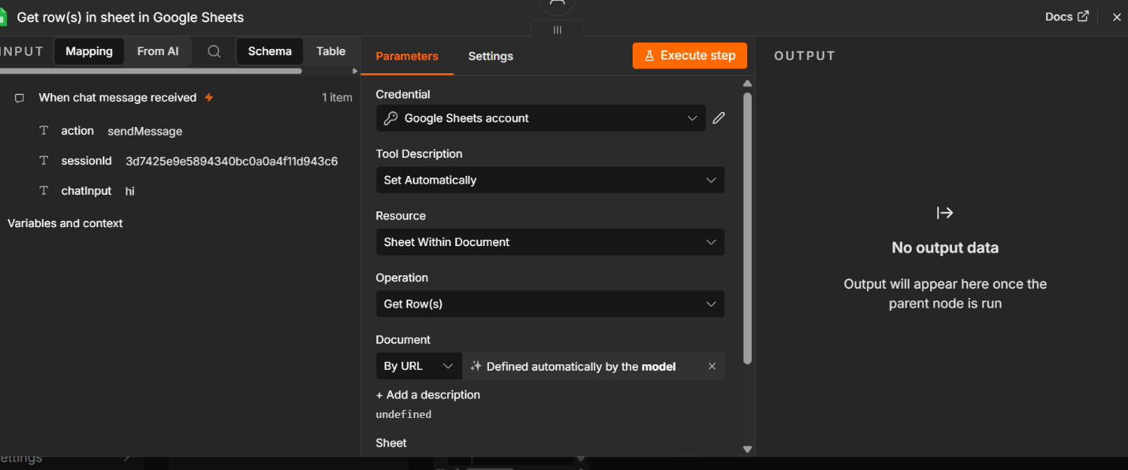
Snapshot 2 – Google Sheets Get Row(s) configuration.
Final Flow: User → Chat Trigger → AI Agent → Google Sheets → Analyze → Gmail → Report

Simple to understand
Simple to understand
 | Gen AI | AI Agent | Agentic AI
Main idea | Gives you an answer | Performs a task | Manages a complete goal
Decision making | Mostly you | Agent decides next action | Multiple systems/agents decide & coordinate
Tools | Usually not required | Uses tools | Uses many tools/systems
Planning | No real planning | Basic planning | Advanced planning
Loop | One response | Multiple steps until task finishes | Multiple coordinated loops
Human role | Give prompt | Give task | Give goal
Example | "Suggest hotels in Mumbai" | "Find and book a hotel" | "Plan my entire Mumbai trip within ₹50,000"

