PUNE INSTITUTE OF COMPUTER TECHNOLOGY
DHANKAWADI, PUNE – 43.

SCHEDULE OF LAB EXPERIMENTS

ACADEMIC YEAR: 2019-2020
Date: 16/12/2019

DEPARTMENT: COMPUTER ENGINEERING

CLASS: S.E. SEMESTER: II

SUBJECT: Computer Graphics Laboratory SUBJECT CODE: 210255

EXPT.NO | PROBLEM STATEMENT | Scheduled Date
Group A
A1 | Write C++ program to draw the following pattern using Line drawing algorithms. Use Bresenham’s line drawing algorithms for square and DDA line drawing algorithm for diamond.  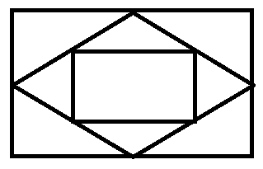 | 16/12/19 – 27/12/19
A2 | Write C++ program to draw inscribed and Circumscribed circles in the triangle as shown in an example below. Use Bresenham’s Circle drawing algorithm for outer circle and DDA circle for inner circle. Use any Line drawing algorithm for drawing triangle  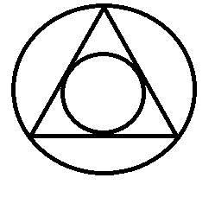 | 30/12/19-  10/1/20
A3 | Write C++/Java program to draw 2-D object and perform following basic transformations,  a) Scaling  b) Translation  c) Rotation  Use operator overloading. | 13/1/20-  18/1/20
A4 | Write C++ program to draw the polygons by using the mouse. Choose colors by clicking on the designed color pane. Use window port to draw. Use DDA algorithm for line drawing. | 20/1/20-  25/1/20
A5 | Write C++/Java program to draw a 4X4 chessboard rotated 45˚ with the horizontal axis. Use Bresenham algorithm to draw all the lines. Use seed fill algorithm to fill black squares of the rotated chessboard. | 27/1/20-  7/2/20
Group B
B1 | Write C++/Java program for line drawing using DDA or Bresenham’s algorithm with patterns such as solid, dotted, dashed, dash dot and thick. | 10/2/20 – 15/2/20
B2 | Write C++/Java program to draw a convex polygon and fill it with desired color using Seed fill algorithm. Use mouse interfacing to draw polygon. | 17/2/20 – 22/2/20
B3 | Write C++/Java program to implement Cohen-Sutherland line clipping algorithm for given window. Draw line using mouse interfacing to draw polygon | 24/2/20 – 6/3/20
B4 | Write C++/Java program to implement reflection of2-D object about X axis, Y axis and about X=Y axis. Also rotate object about arbitrary point given by user. | 9/3/20 – 14/3/20
B5 | Write C++/Java program to generate Hilbert curve using concept of fractals. | 16/3/20 – 21/3/20
Group C
C1 | Write C++/Java program to draw 3-D cube and perform following transformations on it using OpenGL. A) Scaling b) Translation c) Rotation about one axis. | 23/3/20 – 28/3/20
C2 | Write C++/Java program to simulate any one of or similar scene-  - Clock with pendulum  - National Flag hoisting  - Vehicle/boat locomotion  - Water drop falling into the water and generated waves after impact  - Kaleidoscope views generation (at least 3 colorful patterns)  - simulate any data structure like stack, queue, and trees using graphics | 30/3/20 – 4/4/20
 | CGL Practical Mock Test | 6/4/20-11/4/20

- * Mini Project: To design animation clip/ Game

Mrs. Rutuja A. Kulkarni Prof. M.S.Takalikar
Subject Coordinator Head of Department
(Computer Engineering)

