Tamarus 10 Application Software
1. Tamarus 10
- Application Name: Tamarus 10
- Version: 1.0
- Purpose/Objective:
  - The application helps in controlling and configuring the Radio Frequency.
- Target Audience: Tamarus 10 Application consumers.
- Expected Outcomes:
Controlling and configuring multiple Radio Frequency unit within Tamarus 10 application.

2. System Requirements\A 10 System Requirements

3. Features and Functionality
- Core Features:
  - Radio Frequency – On/Off
  - Radio Frequency – Fine Tuning Bands
  - Radio Frequency Signal – Increase/Decrease
- Optional Features:
  - Set Password

4. User Interface (UI) Design
- Wireframes/Mockups:
  - Attach images or describe key screens.
Initialise Screen: When Tamarus 10 loads up the following screen would be displayed. This screen shows up for a second before loading the Home Screen.

Key Features:
- Background: Dark Black background.
- Logo: Centred, representing the company logo.
- Progress Bar: Positioned below the logo, sleek, with a vibrant blue color to signify progress.



Home Screen: The below screen can be called as also the Dashboard screen.
Header Section: Battery Dashboard
Number of Batteries: A numeric display of number of batteries available – 3.
Consolidated Battery Percentage: A visually representation of the average battery percentage.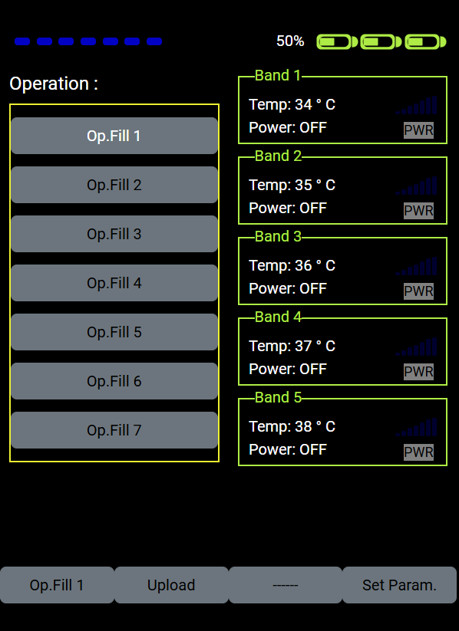

Main Screen Elements:
- Operations List (Vertical, Left):
  - Displays the 1–7 operations.
  - Highlight current operation when navigating with Up/Down Arrows.
- Bands Display (Vertical, Right):
  - Displays 5 Bands for the selected operation.
  - Navigation:
    - Use Left/Right Arrows to scroll between bands.
    - Highlighted band becomes visually distinct.
  - Status Display:
    - Temperature.
    - Power State (Off/On).
    - Unit State (Off/On).
    - Radio Frequency Signals.
- Action Buttons (Bottom of Screen):
  - Button 1 (Current Operation): Displays the current operation and band selection.
  - Button 2 ("Upload"): Uploads the selected configuration and applies it.
  - Button 3 (No Action): Placeholder for future functionality.
  - Button 4 ("Set Param"): Navigates to a parameter configuration screen.
  - 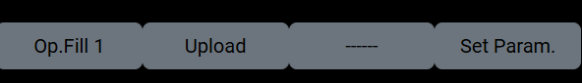

Interactive Behaviour
- Button Highlighting:
  - The current selection (Operation) highlights as the user navigates.
  - Highlight style: colour change.
- Confirmation:
  - On pressing Enter, the system performs the action for the highlighted button or activates the band/operation.

Figure Icons for Band States
- Switched Off:
  - Icon: Greyed-out power symbol with Unit "Off" label.
  - 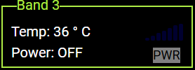
- Switched On (Unit Off):
  - Icon: Blue power symbol with Unit Off.
  - 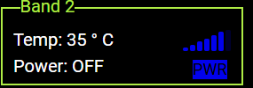
- Switched On (Unit On):
  - Icon: Green power symbol with an active indicator Unit On.
  - 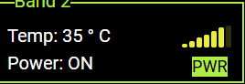

Workflow:
- Navigate to Operation:
  - Use Up/Down Arrows to select "Operation 3."
  - Press Enter to confirm.
- Perform Action:
  - Press Enter to execute the action for the highlighted band or upload the configuration.

Configuration Screen: The Configuration Screen allows users to set and modify Radio Frequency settings. This screen is protected to ensure only authorized access. To enter the configuration screen, the user must input a six-digit numeric password.
Configuration Screen Layout
1. Access Control
- Password Input:
  - A six-digit numeric field is displayed (-_ - _ - _ - _ - _ - _).
  - Each digit is represented by an underscore.
  - The user navigates between digits and sets their values.
- Navigation:
  - Up/Down Arrows: Increment or decrement the value of the currently selected digit (0–9 in a loop).
  - Left/Right Arrows: Move the cursor to the next or previous digit.
  - Enter Key: Confirms the input and submits the password for validation.
- Feedback:
  - Correct Password: Displays a success message and transitions to the configuration settings.
  - Incorrect Password: Displays an error message.

2. Configuration Menu
Once the correct password is entered, the user gains access to the Radio Frequency Settings.
- Menu Options:
  - Set Frequency:
    - Slider field for adjusting the frequency using the navigation button
  - Signal Strength:
    - Bar Signal (0-7).
    - Slider field for adjusting the signal strength using the navigation button
  - Save:
    - Saves all changes.
- Interactive Feedback:
  - Confirmation in Save Button Highlighting the yellow colour.
Interactive Features
Password Entry
- Default State:
  - The first digit is highlighted.
- Adjust Values:
  - Use Up/Down Arrows to change the digit value (0–9).
  - Current digit updates in real-time.
- Navigate Digits:
  - Use Left/Right Arrows to move to the next or previous digit.
- Submit:
  - Press Enter after all six digits are set to validate the password.
Example Workflow
- Enter Password:
  - Navigate to the password field.
  - Use arrow keys to input 000000.
  - Press Enter to validate.
- Access Configuration:
  - Configure the desired Frequency.
  - Adjust Signal Strength
  - Toggle Power On/Off.
  - Press Save to apply changes.

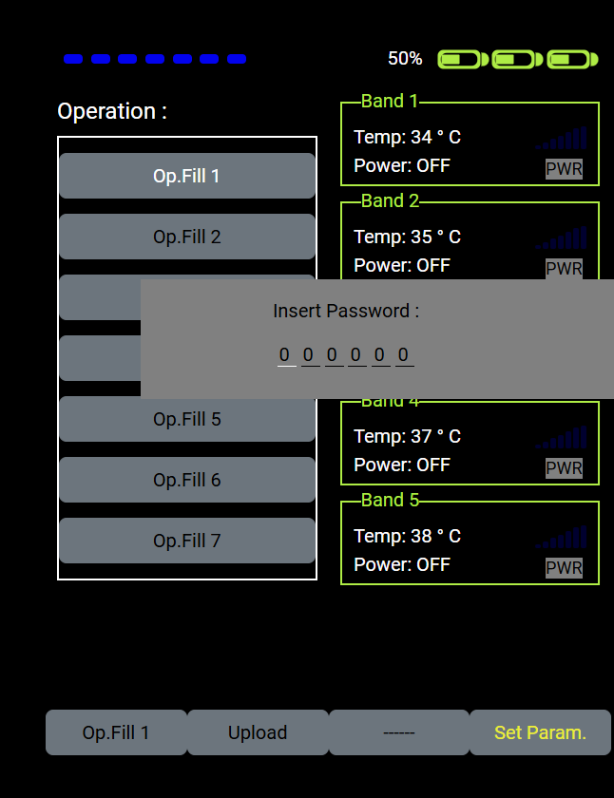

Once password has validated, it would display the configuration screen shown below

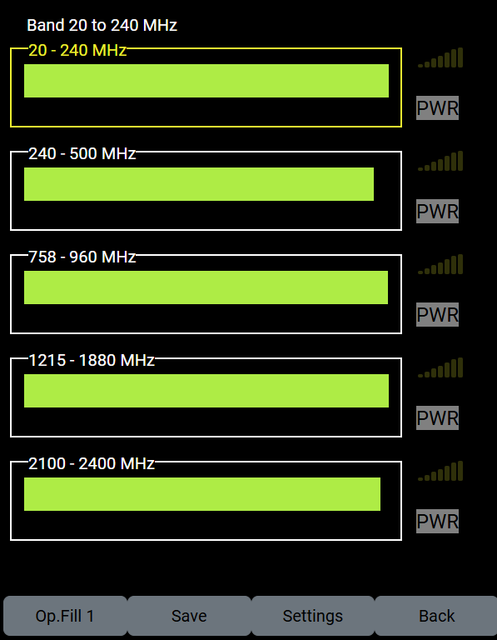

Band Control:
The Configuration Screen also supports managing Frequency Bands for each operational fill (Op.Fill). Each Op.Fill consists of five bands, and each band can be individually selected and configured to the desired frequency range.

Band Splitting:
Each band can be further divided into up to six different frequency ranges, enabling more granular control over the frequency spectrum.

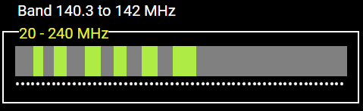

It can be achieved by using the combination of left/right up/down button.

Radio Frequency Signal Control:

The Configuration Screen allows users to manage and configure Signal Frequency Ranges for each operational fill (Op.Fill). Each Op.Fill includes five bands, and each band can be individually configured to operate within a desired frequency range.

Frequency Adjustment:
- The signal frequency range spans from 0 to 7.
- Users can increase or decrease the frequency value using the Up and Down navigation buttons to achieve the desired output.
- The interface ensures precise control over the frequency settings, enabling customization for specific operational needs.



Band Power:
- The Band Power feature is controlled via a toggle button.
- Users can switch the power ON or OFF by using the Up and Down navigation buttons, providing control over the power state for each band.
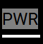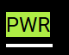

The Configuration Screen includes four functional buttons displayed at the bottom of the interface, each serving a specific purpose:
- Current Op.Fill:
  - This button displays the currently selected operational fill (Op.Fill) for user reference.
- Save:
  - The "Save" button stores the selected configuration settings for the current Op.Fill.
  - Note: The saved configurations will only become operational when they are uploaded using the "Upload" button available on the Home Screen.
- Settings:
  - The "Settings" button navigates to the Settings Screen, where users can update the password for accessing protected screens.
- Back:
  - The "Back" button returns the user to the Home Screen without saving the current configurations.

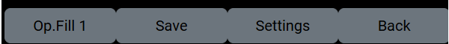
Settings Screen:

The settings screen helps to change the password for the Tamarus 10.

Set New Password
  - A six-digit numeric field is displayed ( -_ - _ - _ - _ - _ - _).
  - Each digit is represented by an underscore.
  - The user navigates between digits and sets their values.
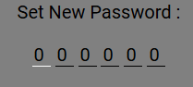

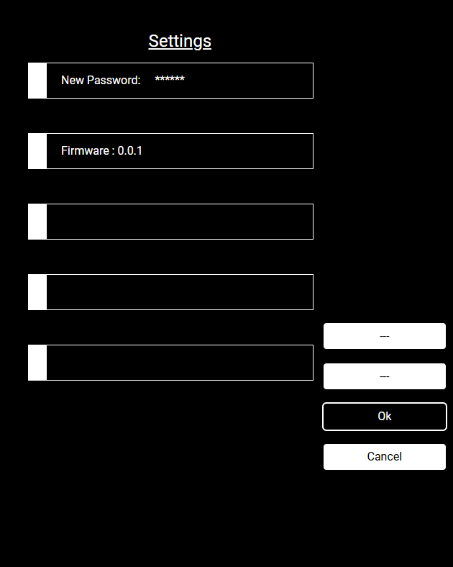

Set Password Entry
- Default State:
  - The first digit is highlighted.
- Adjust Values:
  - Use Up/Down Arrows to change the digit value (0–9).
  - Current digit updates in real-time.
- Navigate Digits:
  - Use Left/Right Arrows to move to the next or previous digit.
- Submit:
  - Press Enter after all six digits are to set the password.
Example Workflow
- Enter Password:
  - Navigate to the password field.
  - Use arrow keys to input 123456.
  - Press Enter to validate.
  - Press Ok to apply changes.

Destroy Configurations
On Pressing ‘D’ Button. It prompts Destroy Configuration. On Confirmation It destroys Configuration and resets to factory value.

Covet
On Pressing ‘C’ Button. It resets to home screen.

Battery Charging Screen:
While battery is charging it displays the following battery charge screen
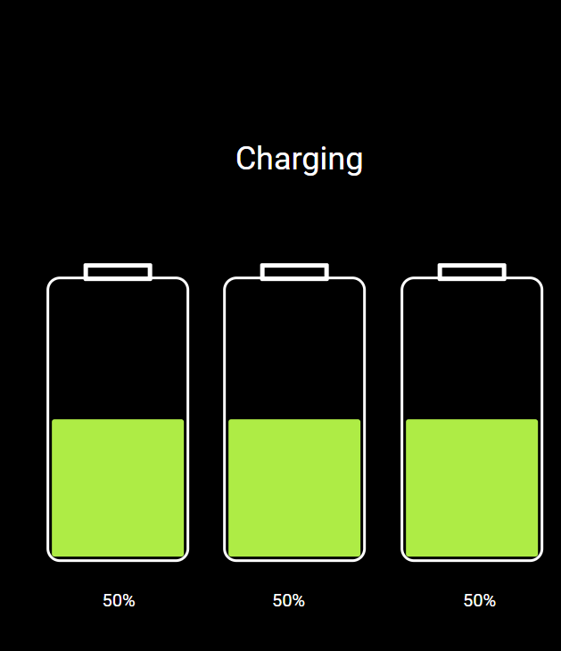

Alert and Warning message:

The Tamarus 10 displays alert message with red background

The Tamarus 10 displays warning message with amber background with alert message having higher priority.

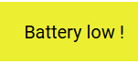

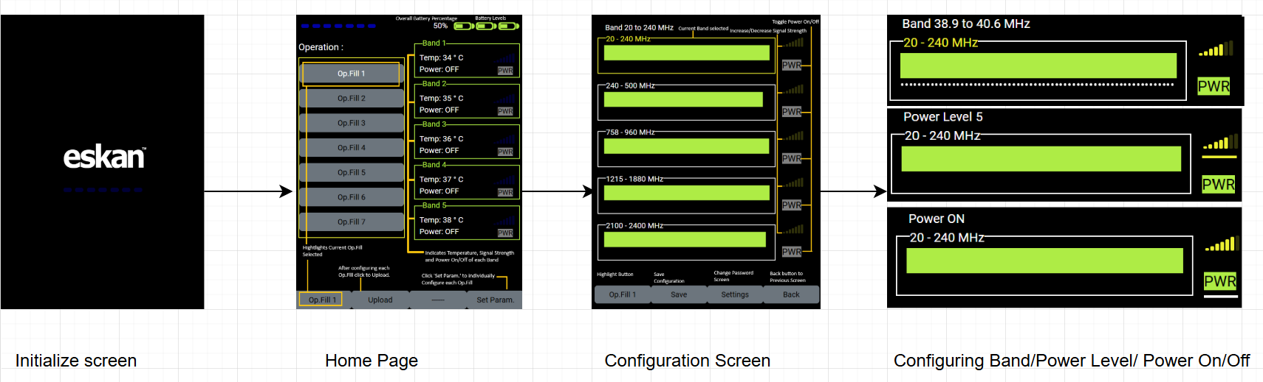
User Flow Diagram:

5. Technical Architecture
- Technology Stack:
  - Frontend: (HTML, JavaScript, JQuery, CSS)
- Integration Points:
  - Integration with Tamarus Unit’s.
6. Development Plan
- Development Phases:
It is a HTML, CSS, JavaScript application.
Overview
This JavaScript file contains functionality for a WebSocket-based system managing various screens, operations, and configurations for the Tamarus 10 platform. Key features include:
- WebSocket communication with a server for real-time data updates.
- User interface navigation and interaction.
- Handling configurations like radio frequency settings, power modes, and passwords.
- Dynamic UI updates based on system states.

Key Functionalities
1. WebSocket Communication
- WebSocket Initialization:
javascript
const socket = new WebSocket('ws://127.0.0.1:8080');
Establishes a WebSocket connection to the specified server address.
- Listeners:
  - On Open: Confirms connection establishment.
  - On Message: Processes incoming data, either parsing JSON objects or updating UI elements.
- Send Message:
  - Encapsulates and sends JSON messages:
javascript
const sendMessage = (message) => {
socket.send(JSON.stringify(message));
};

2. UI Screens and Navigation
The UI consists of multiple screens, each with unique elements and navigation logic:
Screens:
- Initialization Screen (#initScreen): Placeholder for the loading phase.
- Main Screen (#mainScreen): Displays battery, operation, and band statuses.
- Configuration Screen (#configScreen): Allows setting radio frequency ranges and power states.
- Password Screen (#passwordScreen): Ensures authorized access with a six-digit numeric password.
Navigation:
- Arrow Keys (Up, Down, Left, Right): Navigate through elements.
- Enter Key: Executes actions for the currently highlighted element.

3. Command Handling
Commands are encapsulated in JSON objects and sent via WebSocket. Example commands include:
- Get Configuration:
{
"type": "GET",
"command": "user/config",
"body": {}
}
- Set Password:
{
"type": "PUT",
"command": "user/passwordVerify",
"body": {"password": "123456"}
}
Defined Commands:
- configGetCommand: Fetch configuration settings.
- passwordVerifyCommand: Validate passwords.
- destroyPutCommand: Confirm destruction of data.
- opFillCommand: Manage operational fills.

4. Configuration Management
Radio Frequency Settings:
- Manage radio frequency bands and ranges for operations.
- Example:
  - Band 1: 20 MHz - 240 MHz
  - Band 2: 240 MHz - 500 MHz
State Representation:
- Power State:
  - Off: Gray indicator.
  - On (Unit Off): Green indicator without activity.
  - On (Unit On): Active green indicator with operational signals.
Dynamic Ranges:
- Adjustments based on user interaction:
  - Signal strength sliders.
  - Frequency range inputs.

5. Password Security
- Input Handling: Navigate digits using arrow keys, adjusting values incrementally.
- Validation:
  - Accepts or rejects based on the server response.

6. Battery and Operation Status
- Displays real-time updates:
  - Battery percentage and health.
  - Operation and band configurations.
- Example UI Updates:
  - Battery status:
DisplayBatteryPercentage(data, m_span_btr);
  - Temperature for each band:
buttonel.innerText = `Temp: ${data.RadioFrequencyPath[i].Temperature} °C`;

Utility Functions
Navigation Handlers
- navArrowKeyup, navArrowKeyDown, navArrowKeyEnter: Manage UI navigation and updates.
Dynamic Display
- setConfig: Updates configuration settings on the screen.
- setProgressFrequencyBand: Adjusts frequency bands dynamically.

