iRobot Roomba

The roomba integration allows you to control your iRobot Roomba vacuum or iRobot Braava m-series mop.
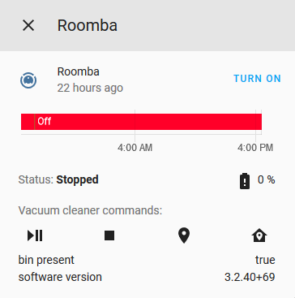
This platform has been tested and is confirmed to be working with the iRobot Roomba s9+, Roomba 980, Roomba 890, and Braava jet m6 models, but should also work fine with any Wi-Fi enabled Roomba or Braava like the 690 or the 960.

Configuration
To add your Roomba to your installation, go to Configuration >> Integrations in the UI, click the button with + sign and from the list of integrations select iRobot Roomba.
To add your Roomba vacuum to your installation, add the following to your configuration.yaml file:
# Example configuration.yaml entry
roomba:
- host: IP_ADDRESS_OR_HOSTNAME
blid: BLID
password: PASSWORD
YAML
Copy

CONFIGURATION VARIABLES
host
(string)(Required)
The hostname or IP address of the Roomba.
blid
(string)(Required)
The username (BLID) for your device.
password
(string)(Required)
The password for your device.
certificate
(string)(Optional)
Path to your certificate store.
Default value:
/etc/ssl/certs/ca-certificates.crt
continuous
(boolean)(Optional)
Whether to operate in continuous mode.
Default value:
true
delay
(integer)(Optional)
Custom connection delay (in seconds) for periodic mode
Default value:
1
The Roomba’s MQTT server only allows a single connection. Enabling continuous mode will force the App to connect via the cloud to your Roomba. More info here

Integration Entities
The Roomba Integration will add the following sensors.
Sensors:
- roomba_battery_level : The status of your battery
- roomba_bin_full (if Roomba has the capacity to do) : Bin Full status

MULTIPLE ROOMBA VACUUMS
# Example configuration.yaml entry
roomba:
- host: IP_ADDRESS_OR_HOSTNAME_1
blid: BLID_1
password: PASSWORD_1
- host: IP_ADDRESS_OR_HOSTNAME_2
blid: BLID_2
password: PASSWORD_2
continuous: false
delay: 5
YAML
Copy

RETRIEVING YOUR CREDENTIALS
Please refer to here or here to retrieve both the BLID (username) and the password.


IoT class: Local Push
Introduced in release: 0.51
This integration is configurable via UI
Source: View on GitHub

Categories
- Vacuum

