**Spotify**

The Spotify media player integration lets you control your Spotify account playback and browse the [Spotify](https://www.spotify.com/) media library from Home Assistant.

**Prerequisites**

* An active Spotify account. A premium account is not required, but recommended. Premium accounts can be controlled (pause, play, next, etc.), while free accounts can only be used for browsing and current playback status.
* Spotify compatible playback [source](https://www.home-assistant.io/integrations/spotify/#selecting-output-source) device
* A Spotify Developer application. Instructions for that are in the next step.

**CREATE A SPOTIFY APPLICATION**

For Home Assistant to communicate with Spotify, we need to create an application at Spotify using the Spotify Developer website. This will provide you with the Spotify application credentials Home Assistant needs to allow you to log in with your Spotify account.

1. If Spotify was previously integrated with your Home Assistant with *outdated* credentials, it might be required to remove these old Spotify account credentials using the [Home Assistant Application Credentials dashboard](https://my.home-assistant.io/redirect/application_credentials" \t "_blank).
2. Log in to the [Spotify Developer Dashboard](https://developer.spotify.com/dashboard).
3. Select the **[Create app](https://developer.spotify.com/dashboard/create)** button in the top right.

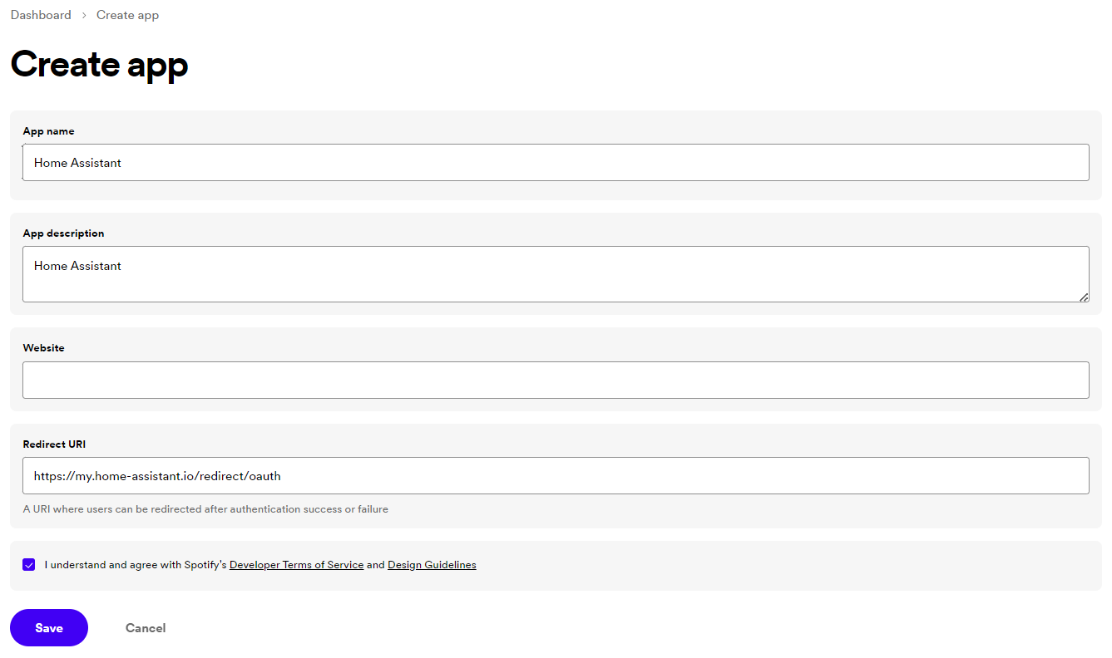

1. Enter a name and description; feel free to use any name and description you like.

Set the *“Redirect URI”* to the following:

https://my.home-assistant.io/redirect/oauth

Please copy and paste the exact URL above. You **do not** have to change it.



1. Select Web API.
2. Check the box to agree with the requirements and click the **Save** button to confirm the application creation.
3. Spotify will now show the new application you have just created. Select the **Settings** button in the top right to configure it.

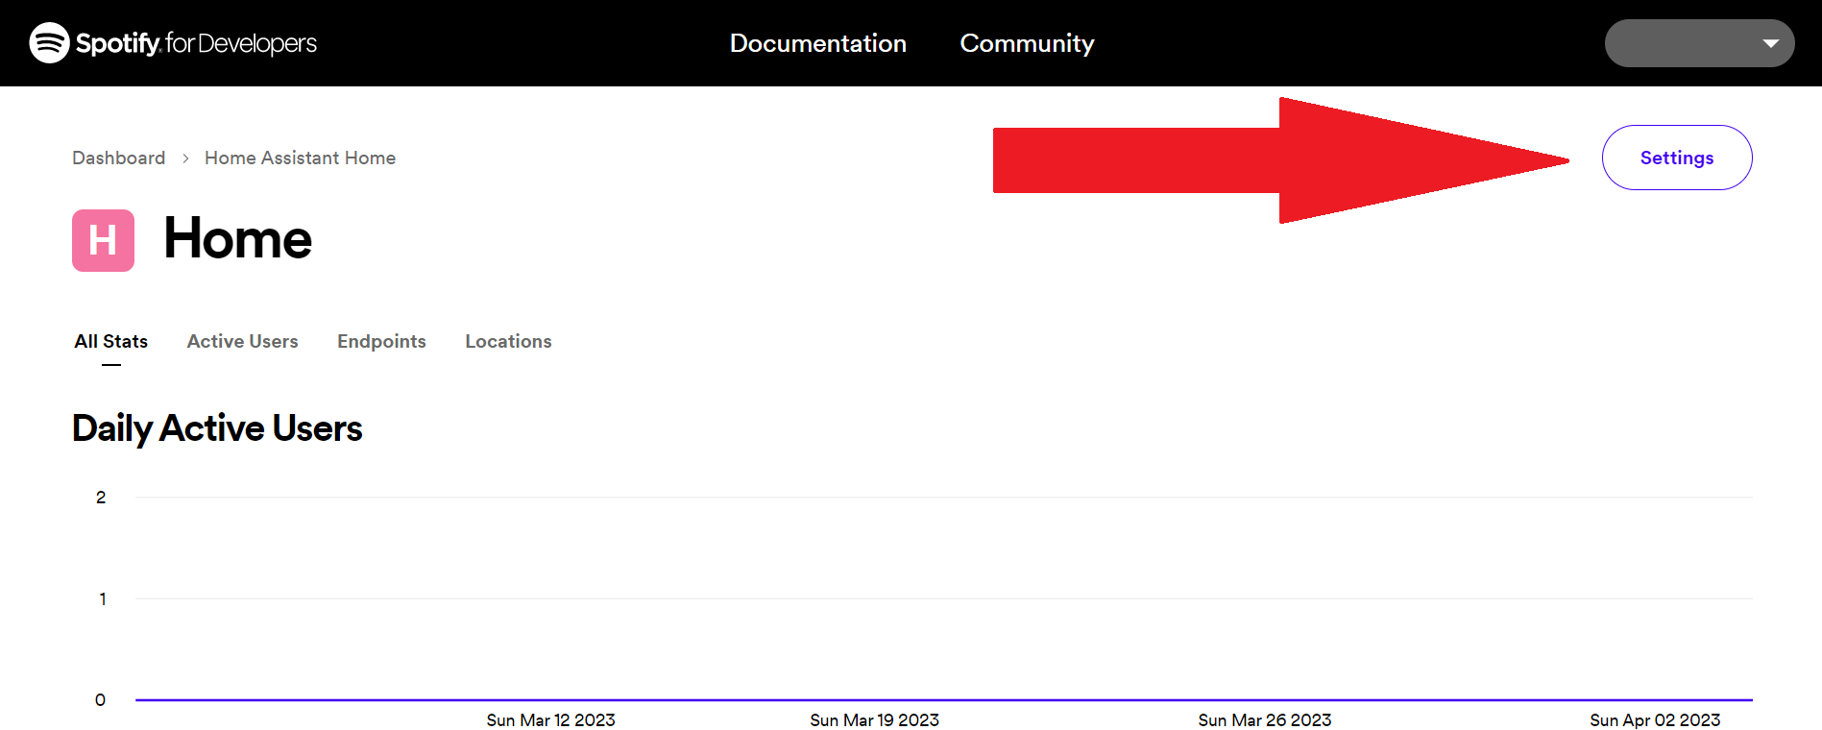

1. Before we can start configuring Home Assistant, we need to grab the application credentials Home Assistant needs.

Select on the **View client secret** button to reveal the client secret.

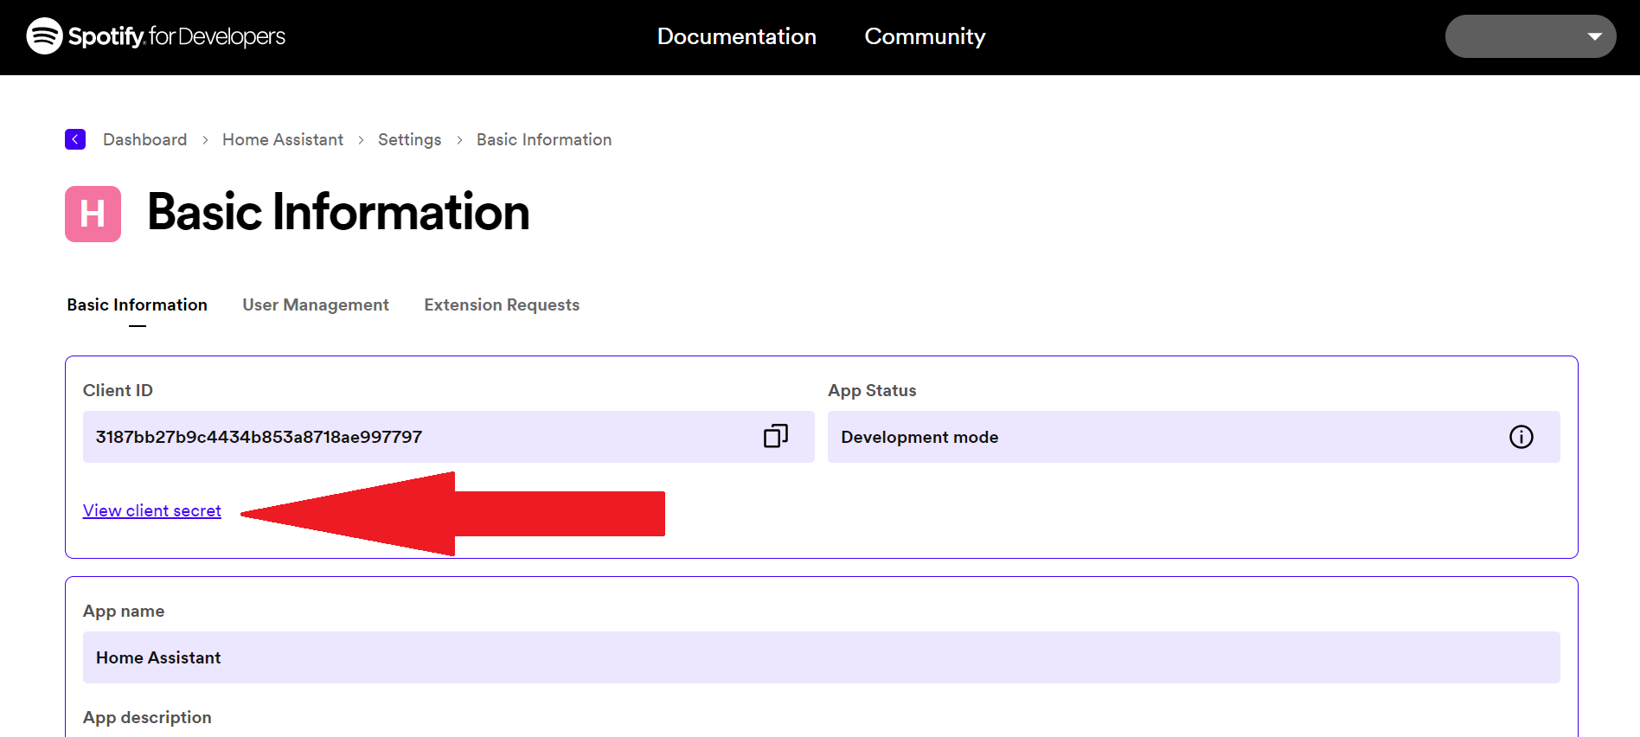

1. The *“Client ID”* and *“Client secret”* are the two pieces of information that Home Assistant needs to communicate with Spotify and is what we call: Application credentials.

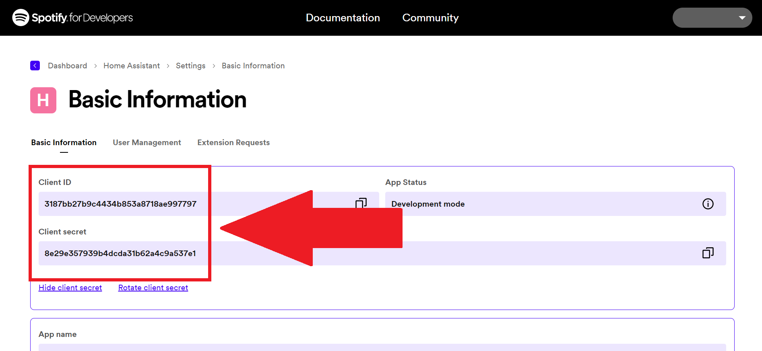

You will need the *“Client ID”* and *“Client secret”* during the Spotify integration setup process in Home Assistant.

You can now continue with the next chapter to configure the Spotify integration in Home Assistant.

I have manually disabled My Home Assistant

**Configuration**

To add the **Spotify** service to your Home Assistant instance, use this My button:

Spotify can be auto-discovered by Home Assistant. If an instance was found, it will be shown as **Discovered**. You can then set it up right away.

 Manual configuration steps

**Using multiple Spotify accounts**

This integration supports multiple Spotify accounts at once. You don’t need to create another Spotify application in the Spotify Developer Portal. Multiple Spotify accounts can be linked to a *single* Spotify application.

You will have to add those accounts into the **User Management** section of your application in the Spotify Developer Portal.

To add an additional Spotify account to Home Assistant, go to the Spotify website, log out, and then repeat *only* the steps in the [Configuration](https://www.home-assistant.io/integrations/spotify/" \l "configuration) section.

**Selecting output source**

To play media Spotify first needs a device selected for audio output known as the source.

# Example code to select an AV receiver as the output device

service: media\_player.select\_source

target:

entity\_id: media\_player.spotify

data:

source: "Denon AVR-X2000"

YAML

Copy

The Spotify API cannot initiate playback to a device not already known to the Spotify API. The source list of available devices can be found in the Details section of the Spotify Media Player Control and the source\_list attribute in the [Developer Tools States](https://my.home-assistant.io/redirect/developer_states" \t "_blank).

**Playing Spotify playlists**

You can send playlists to Spotify using the "media\_content\_type": "playlist", which is part of the [media\_player.play\_media](https://www.home-assistant.io/integrations/media_player/" \l "service-media_playerplay_media) service, for example:

# Example script to play playlist

script:

play\_jazz\_guitar:

sequence:

- service: media\_player.play\_media

target:

entity\_id: media\_player.spotify

data:

media\_content\_id: "<https://open.spotify.com/playlist/5xddIVAtLrZKtt4YGLM1SQ?si=YcvRqaKNTxOi043Qn4LYkg>"

media\_content\_type: playlist

YAML

Copy

The media\_content\_id value can be obtained from the Spotify desktop app by clicking on the more options (”…”) next to the album art picture, selecting “Share” and then “Copy Spotify URI” or “Copy Playlist Link” (also available in the Spotify phone and web app). Alternatively a Spotify URI string (e.g. spotify:playlist:5xddIVAtLrZKtt4YGLM1SQ) can be supplied for the media\_content\_id.

**Unsupported devices**

* **Sonos**: Although Sonos is a Spotify Connect device, it is not supported by the official Spotify API.