**[](https://reolink.com/)  
*Home Assistant Reolink addon***

[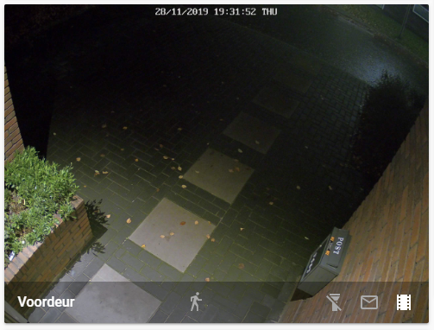](https://github.com/fwestenberg/reolink/blob/master/Lovelace%20Card.PNG?raw=true)

**Table of contents**

* [Installation](https://github.com/fwestenberg/reolink/blob/master/README.md#-installation)
* [Configuration](https://github.com/fwestenberg/reolink/blob/master/README.md#-configuration)
* [Usage](https://github.com/fwestenberg/reolink/blob/master/README.md#-usage)
* [Unsupported models](https://github.com/fwestenberg/reolink/blob/master/README.md#-unsupported-models)
* [Troubleshooting](https://github.com/fwestenberg/reolink/blob/master/README.md#-troubleshooting)

**Installation**

**Manual install**

# Download a copy of this repository

$ wget https://github.com/fwestenberg/reolink/archive/master.zip

# Unzip the archive

$ unzip master.zip

# Move the reolink_dev directory into your custom_components directory in your Home Assistant install

$ mv reolink-master/custom_components/reolink_dev <home-assistant-install-directory>/config/custom_components/

**HACS install**

1. Click on HACS in the Home Assistant menu
2. Click on Integrations
3. Click the top right menu (the three dots)
4. Select Custom repositories
5. Paste the repository URL (https://github.com/fwestenberg/reolink) in the dialog box
6. Select category Integration
7. Click Add
8. Click Install on the Reolink IP camera box that has now appeared

**Configuration**

1. Add the following to your configuration.yaml:

camera:

- platform: reolink_dev

host: IP_ADDRESS

username: admin

password: YOUR_PASSWORD

name: frontdoor (optional, default Reolink Camera)

stream: main or sub (optional, default main)

protocol: rtmp or rtsp (optional, default rtmp)

channel: NVR camera channel (optional, default 0)

scan_interval: 5 (optional, default 30s)

binary_sensor:

platform: template

sensors:

motion_frontdoor:

friendly_name: Camera frontdoor

device_class: motion

entity_id: camera.frontdoor

value_template: "{{ is_state('camera.frontdoor', 'motion') }}"

delay_off:

seconds: 30

switch:

- platform: template

switches:

camera_frontdoor_email:

value_template: "{{ is_state_attr('camera.frontdoor', 'email_enabled', true) }}"

turn_on:

service: camera.enable_email

data:

entity_id: camera.frontdoor

turn_off:

service: camera.disable_email

data:

entity_id: camera.frontdoor

icon_template: >-

{% if is_state_attr('camera.frontdoor', 'email_enabled', true) %}

mdi:email

{% else %}

mdi:email-outline

{% endif %}

camera_frontdoor_ftp:

value_template: "{{ is_state_attr('camera.frontdoor', 'ftp_enabled', true) }}"

turn_on:

service: camera.enable_ftp

data:

entity_id: camera.frontdoor

turn_off:

service: camera.disable_ftp

data:

entity_id: camera.frontdoor

icon_template: >-

{% if is_state_attr('camera.frontdoor', 'ftp_enabled', true) %}

mdi:filmstrip

{% else %}

mdi:filmstrip-off

{% endif %}

camera_frontdoor_ir_lights:

value_template: "{{ is_state_attr('camera.frontdoor', 'ir_lights_enabled', true) }}"

turn_on:

service: camera.enable_ir_lights

data:

entity_id: camera.frontdoor

turn_off:

service: camera.disable_ir_lights

data:

entity_id: camera.frontdoor

icon_template: >-

{% if is_state_attr('camera.frontdoor', 'ir_lights_enabled', true) %}

mdi:flashlight

{% else %}

mdi:flashlight-off

{% endif %}

camera_frontdoor_motion_detection:

value_template: "{{ is_state_attr('camera.frontdoor', 'motion_detection_enabled', true) }}"

turn_on:

service: camera.enable_motion_detection

data:

entity_id: camera.frontdoor

turn_off:

service: camera.disable_motion_detection

data:

entity_id: camera.frontdoor

icon_template: >-

{% if is_state_attr('camera.frontdoor', 'motion_detection_enabled', true) %}

mdi:motion-sensor

{% else %}

mdi:motion-sensor-off

{% endif %}

1. Restart Home Assistant.

**Usage**

In your Home Assistant Lovelace, add a new card with the following:

type: picture-glance

title: frontdoor

camera_image: camera.frontdoor

entities:

- switch.camera_frontdoor_ir_lights

- switch.camera_frontdoor_email

- switch.camera_frontdoor_ftp

- switch.camera_frontdoor_motion_detection

- binary_sensor.motion_frontdoor

Now you will have a card the looks like this (notice the buttons and motion icon):

[](https://github.com/fwestenberg/reolink/blob/master/Lovelace%20Card.PNG?raw=true)

**Unsupported models**

* B800
* B400
* D400
* E1
* E1 Pro
* Battery-powered camera's

**Troubleshooting**

* If the buttons are not working on the Lovelace card, make sure that the user that you configured in the Reolink camera is an **administrator**.