Major Project Report

PulseGrid: AI-Powered Predictive Maintenance
Platform for Industrial IoT

Project Category: IoT Based / Deep Tech Based

Submitted in partial fulfilment of the requirement of the degree of
MASTER OF COMPUTER APPLICATIONS
Semester - IV
to
K.R. Mangalam University

by
Daksh Jeena (2401560053)
Aman Chourasia (2401560044)

Under the supervision of
Atisha Dahiya
(Internal Mentor)

Department of Computer Science and Engineering
School of Engineering and Technology
K.R. Mangalam University, Gurugram - 122001, India
May 2026

DECLARATION
I hereby declare that this Major Project Report entitled "PulseGrid: AI-Powered Predictive Maintenance Platform for Industrial IoT" is my original work and has not been submitted elsewhere for the award of any other degree or diploma. The information and results presented here are true and correct to the best of my knowledge.
All sources and references used during the course of this work have been duly acknowledged and cited.

(Signature) (Signature)
Student Name: Daksh Jeena Student Name: Aman Chourasia
Roll No.: 2401560053 Roll No.: 2401560044 Date: _______________ Date: _______________

CERTIFICATE
This is to certify that the Major Project entitled "PulseGrid: AI-Powered Predictive Maintenance Platform for Industrial IoT", submitted by Daksh Jeena (2401560053) and Aman Chourasia (2401560044) to K.R. Mangalam University, Gurugram, India, is a record of Bonafide project work carried out under my supervision and guidance and is worthy of consideration for the partial fulfilment of the degree of MASTER OF COMPUTER APPLICATIONS of the University.

(Signature of Internal Supervisor)
Name: Atisha Dahiya
Designation: ___________________
Date: _________________________

INDEX
S.No. | Content | Page No.
 | Project Completion Certificate
1 | Abstract
2 | Introduction
3 | Motivation
4 | Literature Review / Comparative Work Evaluation
5 | Gap Analysis
6 | Problem Statement
7 | Objectives
8 | Tools / Platforms Used
9 | Methodology
10 | Experimental Setup
11 | Evaluation Metrics
12 | Results and Discussion
13 | Conclusion & Future Work
14 | References
 | Annexure I - Plagiarism Declaration Certificate

ABSTRACT
Keywords: Predictive Maintenance, Industrial IoT, Machine Learning, Random Forest, Sensor Analytics, Real-Time Dashboard, FastAPI, React

Industrial machinery downtime costs manufacturers an estimated $50 billion annually worldwide. Traditional maintenance strategies - reactive (fix after failure) and preventive (fixed-schedule servicing) - are either too late or too wasteful. Predictive maintenance, which leverages real-time sensor data and machine learning to forecast failures before they occur, represents a paradigm shift towards intelligent manufacturing.
This project presents PulseGrid, an end-to-end, full-stack, AI-powered predictive maintenance platform designed for Industrial IoT (IIoT) environments. PulseGrid ingests real-time sensor telemetry from simulated CNC machines and industrial equipment, processes the data through an automated cleaning and feature-engineering pipeline, and feeds it into a Random Forest classifier trained on the AI4I 2020 Predictive Maintenance Dataset (10,000 records, 14 features) from the UCI Machine Learning Repository.
The platform comprises four major subsystems:
1. Machine Learning Pipeline - An automated scikit-learn pipeline that handles data cleaning, categorical encoding, feature engineering (temperature differential, power metric), median imputation, standard scaling, and Random Forest classification with class balancing. The model achieves 99.0% accuracy, 94.4% precision, 75.0% recall, and an F1-score of 0.836 on the test set.
2. Backend API Server - A FastAPI-based REST API with 18+ endpoints for sensor data ingestion, ML inference, alert management, AI chatbot query processing, model metrics monitoring, dataset upload with auto-retrain, sensor calibration management, and data quality analysis.
3. Real-Time Frontend Dashboard - A 7-tab React + Vite dashboard with a premium dark-mode glassmorphism UI featuring Fleet Overview, Machine Detail, Trend Analysis, Alert Center, AI Data Assistant, Dataset & Model Management, and Sensor Calibration interfaces.
4. Multi-Machine Sensor Simulator - A configurable Python simulator that generates realistic sensor data for 5 distinct machine profiles with gradual tool wear degradation, sinusoidal operational patterns, and random fault injection.
The system is containerized via Docker Compose for single-click deployment and is designed for both educational demonstration and real-world adaptation.

Chapter 1

INTRODUCTION

1.1 Background of the Project
The Fourth Industrial Revolution, commonly referred to as Industry 4.0, has fundamentally reshaped manufacturing through the convergence of physical production systems with digital technologies. At the heart of this transformation lies the Industrial Internet of Things (IIoT) - a network of interconnected sensors, actuators, and computing systems embedded within industrial machinery that continuously generates vast streams of operational data.
Modern manufacturing facilities deploy CNC (Computer Numerical Control) machines, lathes, presses, and drills that operate under extreme conditions: high rotational speeds exceeding 3,000 RPM, temperatures above 300 Kelvin, torque loads surpassing 70 Nm, and cutting tools that degrade over hundreds of operational minutes. Each of these parameters tells a story about the machine's health - subtle changes in temperature differentials, gradual increases in torque requirements, and the steady progression of tool wear all serve as early indicators of impending failure.
Historically, industrial maintenance has followed two primary strategies:
Reactive Maintenance (Run-to-Failure): Equipment is used until it breaks down. While this minimizes upfront maintenance costs, unplanned downtime results in production losses, cascading failures, quality defects, and safety hazards. Studies estimate that reactive maintenance costs 3-10x more than preventive approaches due to emergency repairs, expedited parts procurement, and lost production.
Preventive Maintenance (Time-Based): Equipment is serviced on a fixed schedule, regardless of its actual condition. While this reduces unexpected failures, it leads to unnecessary maintenance on healthy machines, premature replacement of functional components, and significant wasted labour and material costs. Industry analyses suggest that 30-40% of preventive maintenance activities are performed on equipment that does not need servicing.
Predictive Maintenance (PdM) represents the evolution beyond these strategies. By continuously monitoring machine sensor data and applying machine learning algorithms to identify patterns that precede failure, PdM enables maintenance to be performed precisely when needed - not too early (wasting resources) and not too late (causing breakdowns). According to a report by McKinsey & Company, predictive maintenance can reduce machine downtime by 30-50% and increase machine life by 20-40%.
This project, PulseGrid, implements an accessible, open-source, full-stack predictive maintenance platform that demonstrates the entire pipeline - from sensor data collection through ML-powered failure prediction to real-time visualization and automated alerting - using industry-standard technologies and datasets.

1.2 Scope of the Project
PulseGrid encompasses:
- Real-time ingestion of multi-sensor telemetry (temperature, RPM, torque, tool wear) from multiple machines.
- Machine Learning-based failure prediction using a Random Forest classifier trained on the AI4I 2020 dataset.
- Automated data quality analysis, cleaning, and model retraining upon new dataset uploads.
- A rule-based alert engine with configurable thresholds and severity levels (info, warning, critical).
- An offline AI chatbot for natural language querying of sensor data and maintenance recommendations.
- A modern, responsive web dashboard for fleet monitoring, trend analysis, and alert management.
- Containerized deployment via Docker for reproducibility.

Chapter 2

MOTIVATION

2.1 Economic Impact of Unplanned Downtime
Unplanned downtime is the single largest source of lost productivity in manufacturing. According to the International Society of Automation (ISA), manufacturers lose an estimated $50 billion annually due to unplanned downtime. A single hour of downtime in an automotive manufacturing plant can cost between $1.3 million and $2 million. For small and medium enterprises (SMEs), even brief outages can jeopardize delivery schedules, customer relationships, and financial viability.

2.2 The Data Explosion in Manufacturing
Modern CNC machines and industrial equipment are equipped with dozens of sensors that generate data points every second. A typical manufacturing floor with 50 machines can produce over 1 million sensor readings per day. This data is largely underutilized - stored in isolated databases, monitored through basic threshold alarms, or simply discarded. The opportunity to extract actionable intelligence from this data through machine learning represents a significant competitive advantage.

2.3 Accessibility Gap
Current commercial PdM solutions (e.g., Siemens MindSphere, GE Predix, PTC ThingWorx) are enterprise-grade platforms that require significant licensing fees ($50,000-$500,000+), specialized integration, and vendor lock-in. These barriers make PdM inaccessible to SMEs, educational institutions, and researchers. PulseGrid addresses this gap by providing a fully functional, open-source platform that can be deployed on a single laptop.

2.4 Bridging Theory and Practice
While machine learning courses teach classification algorithms and data preprocessing in isolation, students rarely experience the full engineering challenge of building a production-style system that ties together data ingestion, real-time inference, database management, API design, frontend visualization, and deployment. PulseGrid serves as an educational vehicle that bridges this gap.

2.5 Safety and Sustainability
Machine failures in industrial settings can have catastrophic consequences - from worker injuries to environmental contamination. Predictive maintenance directly contributes to worker safety by preventing catastrophic equipment failures and to sustainability by reducing wasteful over-maintenance and extending machinery lifespans.

Chapter 3

LITERATURE REVIEW / COMPARATIVE WORK EVALUATION

3.1 Literature Survey
1. Ran et al. (2019) proposed a survey on machine learning approaches for predictive maintenance, categorizing techniques into vibration analysis, thermal imaging, and multi-sensor fusion. They identified Random Forest and Gradient Boosting as the most effective classifiers for tabular sensor data.
2. Carvalho et al. (2019) provided a systematic literature review of machine learning-based predictive maintenance, analysing 85 research papers. Their findings indicated that supervised learning methods, particularly ensemble methods, outperformed deep learning approaches when training data was limited.
3. Susto et al. (2015) demonstrated a multi-classifier predictive maintenance system for semiconductor manufacturing, achieving 92% accuracy using a combination of Random Forest and Support Vector Machines.
4. Mobley (2002) in the seminal book 'An Introduction to Predictive Maintenance' established the theoretical foundation for condition-based monitoring.
5. Li et al. (2020) developed an IIoT-based predictive maintenance framework using edge computing for real-time inference.
6. Matzka (2020) introduced the AI4I 2020 Predictive Maintenance Dataset at the UCI Machine Learning Repository, containing 10,000 records with 14 features.

3.2 Comparative Evaluation of Existing Systems
Factor | Siemens MindSphere | GE Predix | PulseGrid (Ours)
Deployment | Cloud-only | Cloud/Hybrid | Local/Docker/Cloud
Cost | $100K+ License | $50K+ License | Free / Open Source
ML Customization | Limited | Moderate | Full (sklearn)
Auto-Retrain | Complex | API-based | One-click upload
Real-Time Dashboard | Yes | Yes | Yes (React+Vite)
AI Chatbot | No | No | Yes (Offline NLP)
Sensor Simulator | No | No | Yes (5 machines)
Setup Time | Weeks-months | Weeks | < 10 minutes
Open Source | No | No | Yes

Chapter 4

GAP ANALYSIS
Based on the literature review and comparative evaluation, the following gaps were identified:
Gap 1: Accessibility Barrier - Commercial PdM platforms require enterprise licensing, making them inaccessible to small manufacturers, students, and researchers. PulseGrid addresses this by providing a free, open-source solution.
Gap 2: Lack of End-to-End Educational Platforms - Academic ML courses teach individual algorithms but lack platforms demonstrating the full production pipeline. PulseGrid fills this by providing a complete, documented system.
Gap 3: No Integrated Data Quality Pipeline - Most systems assume clean data. PulseGrid includes an automated pipeline with imputation, deduplication, outlier detection (IQR), and quality reporting.
Gap 4: Rigid Model Pipelines - PulseGrid enables one-click dataset upload triggering automatic data cleaning, feature engineering, model retraining, and hot-reload.
Gap 5: No Natural Language Interface - PulseGrid includes an offline AI chatbot that answers statistical, trend, and recommendation queries without external API dependency.
Gap 6: Missing Testing Infrastructure - PulseGrid includes a multi-machine simulator with configurable noise levels, fault injection, and degradation patterns.

Chapter 5

PROBLEM STATEMENT
Design and develop an end-to-end, AI-powered predictive maintenance platform that ingests real-time sensor data from industrial machinery, predicts failure risk using machine learning, generates actionable maintenance alerts, and provides an intuitive real-time dashboard - while remaining fully open-source, locally deployable, and accessible to users without specialized infrastructure or commercial licensing.
Specifically, the system must:
1. Accept sensor telemetry (temperature, RPM, torque, tool wear) from multiple machines simultaneously.
2. Run ML inference on each incoming reading in real-time to compute health score and failure risk.
3. Generate severity-graded alerts when sensor values exceed configurable thresholds or ML model predicts failure.
4. Provide trend analysis to identify gradual degradation patterns.
5. Support uploading new datasets with automatic cleaning, feature engineering, retraining, and model hot-reload.
6. Offer a natural language chatbot for querying sensor data and receiving maintenance recommendations.
7. Present all information through a modern, responsive web dashboard.

Chapter 6

OBJECTIVES
1. To build a Machine Learning pipeline that trains a Random Forest classifier on the AI4I 2020 dataset to predict machine failure with >= 95% accuracy.
2. To develop a RESTful API backend using FastAPI that handles sensor data ingestion, real-time ML inference, alert generation, and dataset management.
3. To create a rule-based alert engine with configurable thresholds for temperature, RPM, torque, tool wear, and ML-predicted health scores.
4. To implement an automated data quality pipeline that handles missing values, duplicate records, outlier detection, and column type detection.
5. To design a modern, responsive web dashboard with React + Vite featuring 7 functional tabs.
6. To build an offline AI chatbot capable of answering natural language queries about sensor data.
7. To develop a multi-machine sensor simulator with realistic operational patterns.
8. To containerize the entire platform using Docker Compose for single-click deployment.

Chapter 7

TOOLS / PLATFORMS USED

7.1 Programming Languages
Python 3.10+ - Primary language for backend, ML pipeline, data processing, and sensor simulator. Selected for its rich scientific computing ecosystem (NumPy, pandas, scikit-learn), FastAPI framework, and cross-platform compatibility.
JavaScript (ES2022+) - Powers the frontend application through React with Vite build tooling, Recharts for data visualization, and Axios for API communication.

7.2 Frameworks and Libraries
Category | Technology | Purpose
Backend Framework | FastAPI | REST API with auto OpenAPI docs
ORM | SQLAlchemy 2.0+ | Database models and queries
ML Framework | scikit-learn 1.3+ | ML pipeline (RandomForest)
Data Processing | pandas 2.0+, NumPy | Data manipulation, analysis
Model Serialization | joblib | Saving/loading ML model
Frontend Framework | React 19.2 | Component-based UI
Build Tool | Vite 8.0 | Frontend build with HMR
Charting | Recharts 3.8 | Interactive data visualization
HTTP Client | Axios 1.14 | API communication
Icons | Lucide React 1.7 | SVG icon library
Containerization | Docker, Docker Compose | Deployment

7.3 Dataset
AI4I 2020 Predictive Maintenance Dataset - Sourced from UCI Machine Learning Repository (Matzka, 2020). Contains 10,000 records simulating realistic industrial sensor data.
Feature | Description | Unit
Type | Product quality (L/M/H) | Categorical
Air temperature | Ambient air temperature | Kelvin [K]
Process temperature | Process temperature | Kelvin [K]
Rotational speed | Spindle RPM | RPM
Torque | Cutting torque | Nm
Tool wear | Cumulative tool time | Minutes
Machine failure | Binary target | 0/1

7.4 Software Requirements
Requirement | Minimum Version
Operating System | Windows 10/11, Linux, macOS
Python | 3.10+
Node.js | 18.0+
Web Browser | Chrome 100+, Firefox 100+
Docker (optional) | 20.10+

7.5 Hardware Requirements
Component | Minimum | Recommended
Processor | Dual-core 2.0 GHz | Quad-core 3.0 GHz+
RAM | 4 GB | 8 GB+
Storage | 500 MB free | 2 GB free
Display | 1366x768 | 1920x1080

Chapter 8

METHODOLOGY

8.1 System Architecture
PulseGrid follows a three-tier architecture: Presentation Tier (React Dashboard), Application Tier (FastAPI Server with ML Service, Alert Engine, Data Pipeline, Chatbot Engine), and Data Tier (SQLite Database, ML Model, CSV Dataset). An Edge/Simulator Tier generates sensor data via HTTP POST requests.

8.2 Machine Learning Pipeline
The ML pipeline follows an 8-step process: Data Loading, Automated Cleaning, Feature Engineering, Target Separation, Stratified Train/Test Split, Pipeline Construction, Evaluation, and Model Persistence.
Key Code - ML Pipeline Construction:
Code Snippet 1: scikit-learn Pipeline Construction (ml/train_model.py)
pipeline = Pipeline([
('imputer', SimpleImputer(strategy='median')),
('scaler', StandardScaler()),
('classifier', RandomForestClassifier(
n_estimators=150,
max_depth=12,
min_samples_split=5,
random_state=42,
class_weight='balanced',
n_jobs=-1
))
])
pipeline.fit(X_train, y_train)

8.3 Feature Engineering
Two domain-specific features are engineered:
- Temperature Delta = Process Temperature - Air Temperature (heat generation efficiency)
- Power = (RPM x Torque) / 9550 (mechanical power in kW)
Code Snippet 2: Feature Engineering (ml/train_model.py)
# Temperature differential
df['Temp_Delta'] = df['Process temperature [K]'] - df['Air temperature [K]']
# Power metric (kW approximation)
df['Power'] = df['Rotational speed [rpm]'] * df['Torque [Nm]'] / 9550

8.4 Sensor Data Ingestion Flow
When a sensor reading arrives at the /api/simulate endpoint, it passes through 5 stages: Feature Extraction, ML Inference, Recommendation Generation, Database Persistence, and Alert Evaluation.
Code Snippet 3: Sensor Data Ingestion Endpoint (backend/main.py)
@app.post("/api/simulate")
def simulate_reading(reading: SimulateReading, db: Session = Depends(get_db)):
features = {
'Type': reading.type,
'Air temperature [K]': reading.air_temp,
'Process temperature [K]': reading.process_temp,
'Rotational speed [rpm]': reading.rpm,
'Torque [Nm]': reading.torque,
'Tool wear [min]': reading.tool_wear,
'RNF': reading.rnf
}
health_score, failure_risk = predict_machine_health(features)
recommendation = get_recommendation_for_reading(
reading.air_temp, reading.rpm, reading.torque,
reading.tool_wear, health_score, failure_risk
)
# Save to database and generate alerts...
return {"status": "success", "health_score": health_score,
"failure_risk": failure_risk}

8.5 Alert Engine
The alert engine evaluates each reading against a configurable threshold matrix:
Sensor | Warning Threshold | Critical Threshold
Air Temp (High) | >= 304.0 K | >= 308.0 K
Air Temp (Low) | <= 296.0 K | <= 293.0 K
RPM (High) | >= 2500 | >= 2800
RPM (Low) | <= 1100 | <= 900
Torque (High) | >= 60.0 Nm | >= 70.0 Nm
Tool Wear | >= 180 min | >= 220 min
Health Score | <= 0.65 | <= 0.40
ML Failure | - | failure_risk = 1

Code Snippet 4: Alert Evaluation Logic (backend/alert_engine.py)
def evaluate_sensor_reading(machine_id, air_temp, process_temp,
rpm, torque, tool_wear,
health_score, failure_risk):
alerts = []
t = DEFAULT_THRESHOLDS['air_temp']
if air_temp >= t['critical_high']:
alerts.append(_create_alert(machine_id, 'critical',
'Critical High Temperature',
f'Air temp at {air_temp:.1f}K exceeds critical threshold'))
if failure_risk == 1:
alerts.append(_create_alert(machine_id, 'critical',
'ML Model: Failure Predicted',
'Predictive model flags imminent failure'))
return alerts

8.6 ML Inference Service
Code Snippet 5: ML Inference Function (backend/ml_service.py)
def predict_machine_health(features_dict):
df = pd.DataFrame([features_dict])
# Add engineered features
df['Temp_Delta'] = df['Process temperature [K]'] - df['Air temperature [K]']
df['Power'] = df['Rotational speed [rpm]'] * df['Torque [Nm]'] / 9550.0
probabilities = model.predict_proba(df)[0]
failure_prob = probabilities[1]
prediction = model.predict(df)[0]
health_score = 1.0 - failure_prob
return float(health_score), int(prediction)

8.7 Database Schema
The system uses 4 SQLAlchemy ORM models:
Code Snippet 6: Database Models (backend/database.py)
class SensorData(Base):
__tablename__ = "sensor_data"
id = Column(Integer, primary_key=True)
machine_id = Column(String, index=True)
timestamp = Column(DateTime, default=datetime.utcnow)
air_temp = Column(Float)
process_temp = Column(Float)
rpm = Column(Float)
torque = Column(Float)
tool_wear = Column(Float)
health_score = Column(Float)
failure_risk = Column(Integer)
recommendation = Column(Text)
class Alert(Base):
__tablename__ = "alerts"
id = Column(Integer, primary_key=True)
machine_id = Column(String, index=True)
severity = Column(String, default="warning")
title = Column(String)
description = Column(Text)
recommended_action = Column(Text)
acknowledged = Column(Boolean, default=False)
resolved = Column(Boolean, default=False)

8.8 Sensor Simulator
The simulator creates 5 machine profiles with distinct operating characteristics:
Machine ID | Name | Base Temp [K] | Base RPM | Base Torque [Nm] | Wear Rate
CNC-M1 | CNC Mill #1 | 298.0 | 1500 | 40.0 | 1.5
CNC-M2 | CNC Mill #2 | 300.0 | 1800 | 35.0 | 1.0
LATHE-L1 | Lathe #1 | 297.0 | 2000 | 45.0 | 2.0
PRESS-P1 | Press #1 | 301.0 | 1200 | 55.0 | 1.2
DRILL-D1 | Drill #1 | 299.0 | 2200 | 30.0 | 1.8

Code Snippet 7: Sensor Simulator (simulator/client.py)
class MachineSimulator:
def generate_reading(self):
self.cycle += 1
time_factor = math.sin(self.cycle * 0.1) * 0.5
noise_factor = random.gauss(0, 1) * self.noise_multiplier
air_temp = self.profile['base_temp'] + time_factor * 2 + noise_factor * 0.5
process_temp = air_temp + 8 + noise_factor * 1.5
rpm = self.profile['base_rpm'] + time_factor * 100 + noise_factor * 50
torque = self.profile['base_torque'] + noise_factor * 5
self.tool_wear += self.profile['wear_rate'] * random.uniform(0.5, 1.5)
# Random fault injection (5% chance)
if not self.fault_mode and random.random() < 0.05:
self.fault_mode = True
self.fault_duration = random.randint(3, 8)
if self.fault_mode:
air_temp += random.uniform(5, 10) # Temp spike
torque += random.uniform(15, 30) # Torque increase
rpm -= random.uniform(200, 500) # RPM drop
return {'machine_id': self.machine_id,
'air_temp': round(air_temp, 2),
'rpm': round(rpm, 1), ...}

8.9 AI Chatbot Architecture
The chatbot uses keyword-based intent recognition with 14 intent categories including greeting, machine_status, failure_risk, average_stats, failure_analysis, recommendation, and trend.
Code Snippet 8: Chatbot Intent Recognition (backend/chatbot_engine.py)
INTENT_PATTERNS = {
'machine_status': [
r'\b(status|health|condition)\b.*\b(machine|cnc)\b',
],
'failure_risk': [
r'\b(failure|risk|danger|critical)\b',
],
'average_stats': [
r'\b(average|mean)\b.*\b(temp|rpm|torque|wear)\b',
],
'recommendation': [
r'\b(recommend|suggestion|maintenance|fix)\b',
],
}
class ChatbotEngine:
def process_query(self, query, db_context=None):
intent = self._detect_intent(query.lower())
handler = handlers.get(intent, self._handle_unknown)
return handler(query, db_context)

Chapter 9

EXPERIMENTAL SETUP

9.1 Development Environment
Component | Specification
OS | Windows 11
Python | 3.13
Node.js | 18+
IDE | Visual Studio Code
Version Control | Git + GitHub

9.2 Steps to Reproduce
Steps to Run the Platform Locally
# Step A: Install dependencies and train model
pip install -r requirements.txt
python dataset/fetch_dataset.py
python ml/train_model.py
# Step B: Start Backend Server (Terminal 1)
uvicorn backend.main:app --host 0.0.0.0 --port 8000
# Step C: Start Frontend (Terminal 2)
cd frontend && npm install && npm run dev
# Step D: Start Simulator (Terminal 3)
python simulator/client.py

9.3 API Endpoints
Method | Endpoint | Description
GET | /api/machines | List all machines with status
GET | /api/machines/{id}/status | Specific machine status
GET | /api/machines/{id}/history | Sensor history
GET | /api/machines/{id}/trends | Trend analysis
POST | /api/simulate | Ingest sensor reading
GET | /api/alerts | List alerts (filterable)
POST | /api/alerts/{id}/acknowledge | Acknowledge alert
POST | /api/alerts/{id}/resolve | Resolve alert
GET | /api/alerts/summary | Alert summary
POST | /api/chatbot | NL query processing
GET | /api/model/metrics | ML model metrics
GET | /api/model/drift | Model drift check
POST | /api/upload_dataset | Upload CSV + retrain
GET | /api/dataset/preview | Dataset preview
GET | /api/dataset/stats | Quality statistics
GET | /api/calibration/{id} | Calibration config
POST | /api/calibration/{id} | Update calibration

Chapter 10

EVALUATION METRICS

10.1 Model Performance
Metric | Value
Accuracy | 99.00%
Precision | 94.44%
Recall | 75.00%
F1-Score | 83.61%
Training Samples | 8,000
Test Samples | 2,000
Features Used | 9 (including 2 engineered)

10.2 Confusion Matrix
 | Predicted Healthy | Predicted Failure
Actual Healthy | 1929 (TN) | 3 (FP)
Actual Failure | 17 (FN) | 51 (TP)

True Negatives (1929): Correctly identified healthy readings. True Positives (51): Correctly predicted 51 out of 68 actual failures. False Positives (3): Only 3 false alarms. False Negatives (17): 17 failures missed by ML (caught by rule-based alerts).

10.3 Model Training Output
Model Training Console Output
============================================================
PREDICTIVE MAINTENANCE - MODEL TRAINING
============================================================
Loading dataset: 10000 rows x 14 columns
Cleaning data... Encoded 'Type' column: {'L': 0, 'M': 1, 'H': 2}
Engineering features... Created 'Temp_Delta', 'Power'
Feature set: ['Type', 'Air temperature [K]', 'Process temperature [K]',
'Rotational speed [rpm]', 'Torque [Nm]', 'Tool wear [min]',
'RNF', 'Temp_Delta', 'Power']
Target balance: {0: 9661, 1: 339}
Split: 8000 train / 2000 test
Training RandomForest pipeline... Training complete!
Accuracy: 0.9900 (99.00%)
Precision: 0.9444
Recall: 0.7500
F1 Score: 0.8361
Confusion Matrix: [[1929, 3], [17, 51]]
precision recall f1-score support
Healthy 0.99 1.00 0.99 1932
Failure 0.94 0.75 0.84 68
accuracy 0.99 2000
Model saved to: ml/model.joblib
TRAINING PIPELINE COMPLETE

10.4 Codebase Metrics
Module | File | Lines of Code
Frontend CSS | index.css | 1,170
Backend API | main.py | 648
AI Chatbot | chatbot_engine.py | 641
Data & Models UI | DataModels.jsx | 355
Calibration UI | Calibration.jsx | 307
Machine Detail UI | MachineDetail.jsx | 304
Alert Engine | alert_engine.py | 271
AI Chatbot UI | AIChatbot.jsx | 258
Dashboard UI | Dashboard.jsx | 255
Data Pipeline | data_pipeline.py | 239
ML Training | train_model.py | 231
Trend Analysis UI | TrendAnalysis.jsx | 230
Alert Center UI | AlertCenter.jsx | 226
Sensor Simulator | client.py | 216
ML Service | ml_service.py | 209
App Shell | App.jsx | 193
Database Models | database.py | 127
Total | 23 files | ~5,982

Chapter 11

RESULTS AND DISCUSSION

11.1 Machine Learning Results
The Random Forest classifier achieved 99.0% accuracy on the test set, demonstrating strong overall prediction capability. The high precision (94.4%) indicates very few false alarms, which is crucial in industrial settings to prevent 'alarm fatigue'. The recall of 75.0% means the model correctly identifies 75% of actual failures. The rule-based alert engine serves as a safety net for the remaining 25%.
Class imbalance handling was critical: only 3.4% of the dataset represents failures. The class_weight='balanced' parameter upweights the minority class, and stratified splitting ensures both train and test sets maintain the original distribution.

11.2 Dashboard Screenshots
Figure 1: Fleet Overview Dashboard
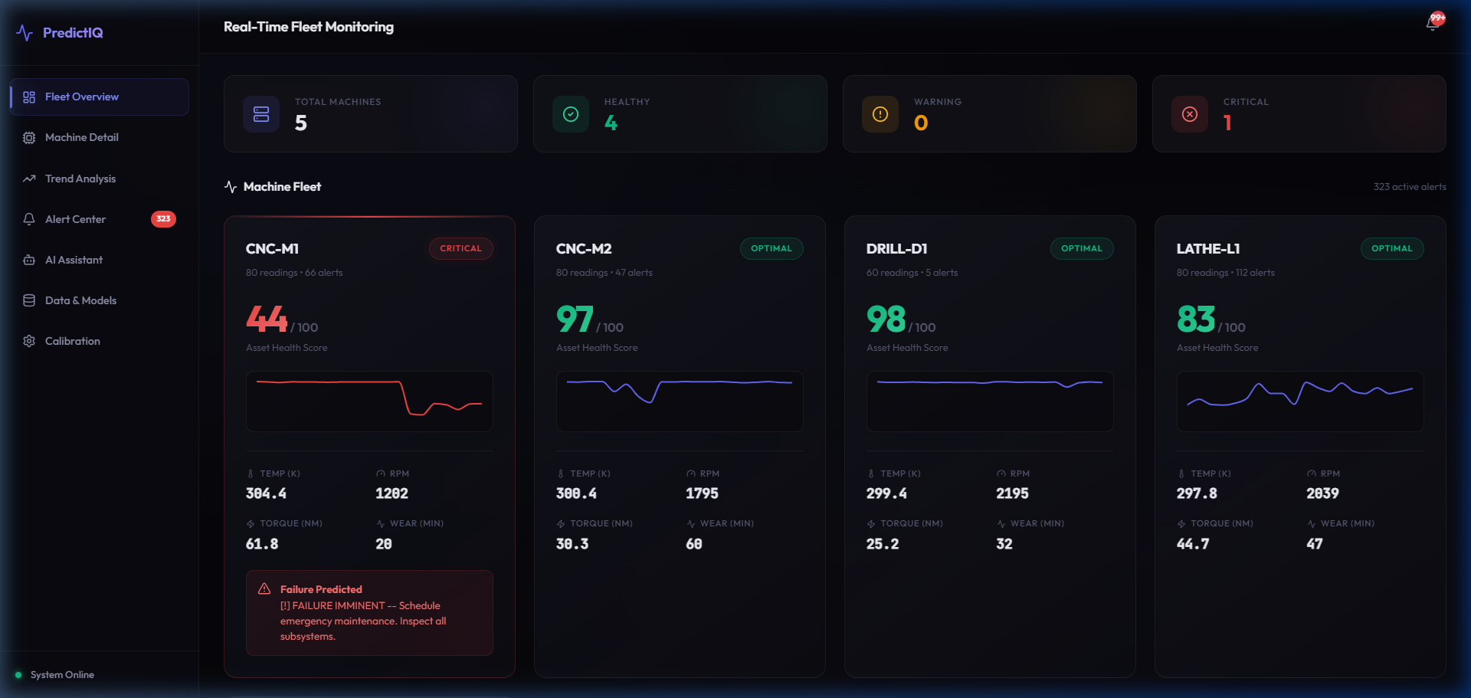
Fig. 1: Fleet Overview - Shows 5 monitored machines with health scores, sensor readings, and status indicators
Figure 2: Alert Center
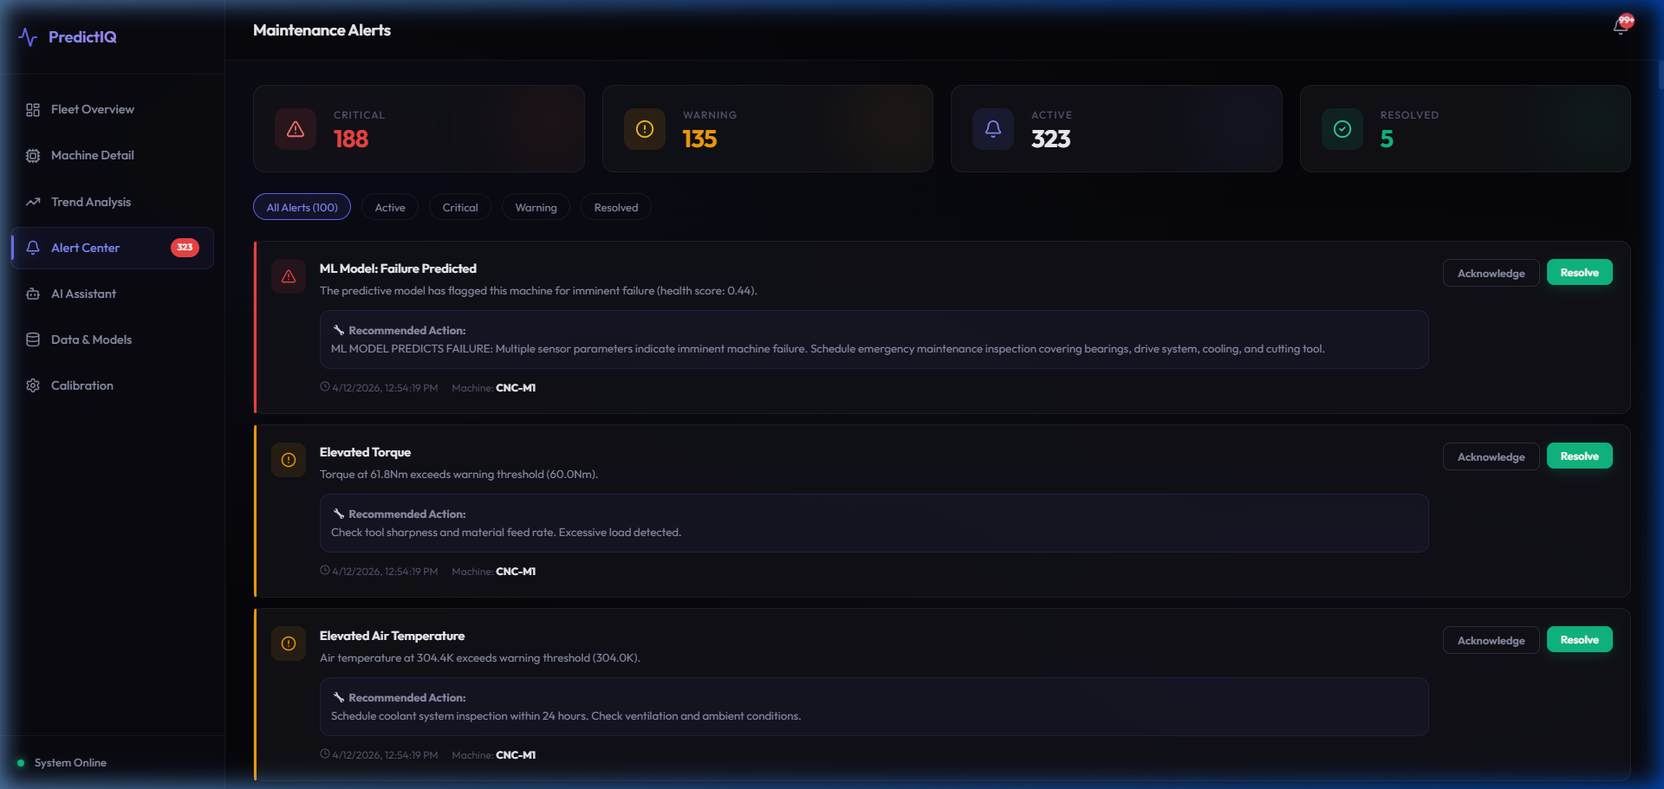
Fig. 2: Alert Center - Shows 188 critical and 135 warning alerts with recommended maintenance actions
Figure 3: Dataset & Model Management
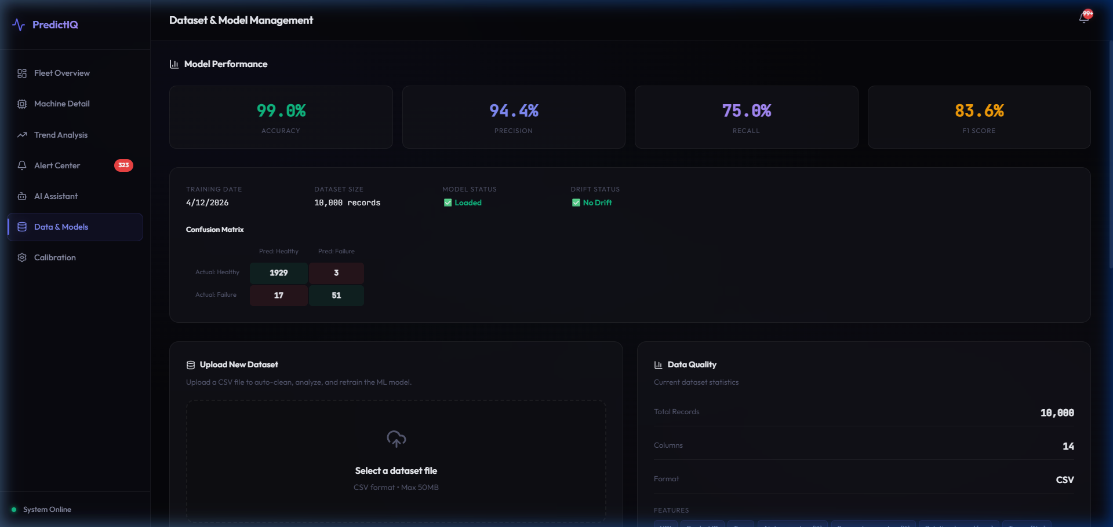
Fig. 3: Data & Models - Shows model performance metrics (99% accuracy), confusion matrix, and dataset upload
Figure 4: AI Assistant
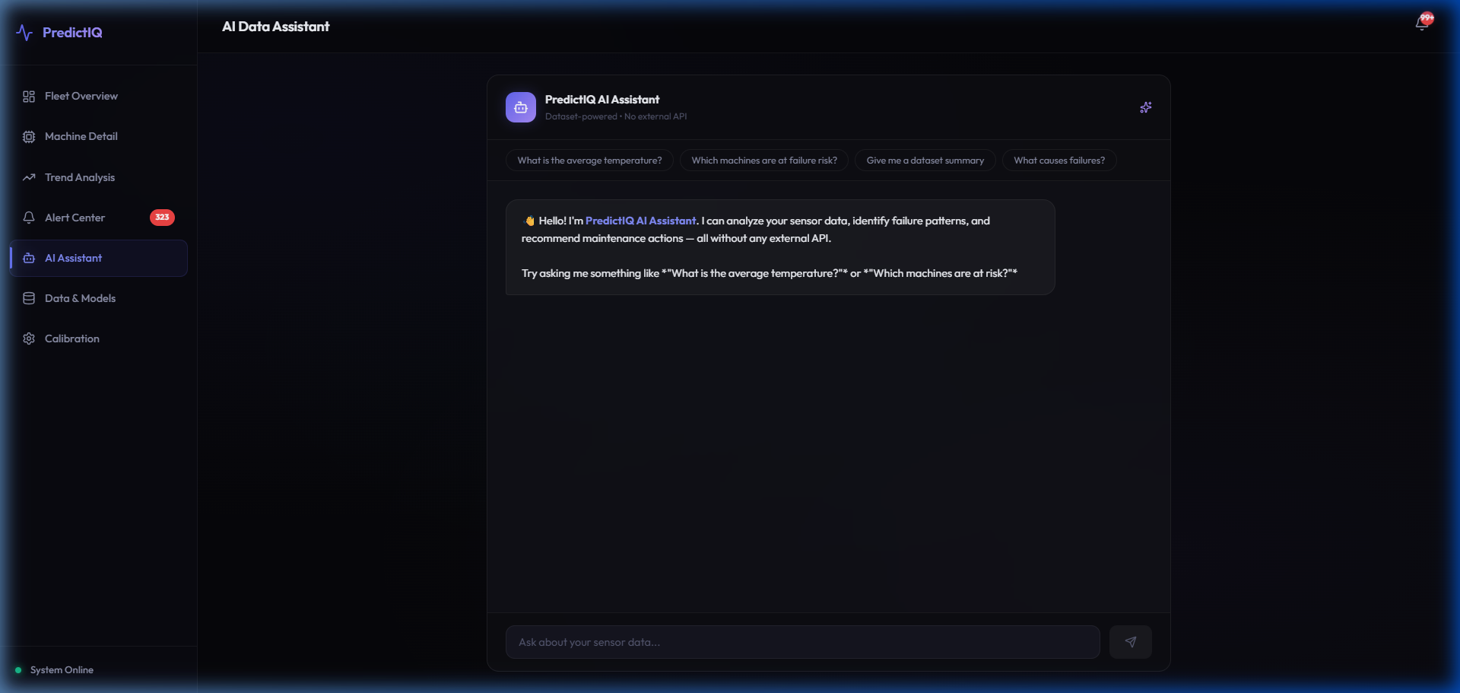
Fig. 4: AI Data Assistant - Natural language chatbot interface for querying sensor data

11.3 Simulator Performance
Configuration | Machines | Iterations | Noise | Outcome
Default | 5 | 200 | 1.0x | Normal with periodic alerts
High Noise | 5 | 100 | 3.0x | Frequent violations, ML flags risks
Stress Test | 5 | 500 | 5.0x | Sustained critical alerts

Simulator Console Output:
Simulator Console Output
============================================================
PREDICTIVE MAINTENANCE - SENSOR SIMULATOR
============================================================
Initialized: CNC-M1 (CNC Mill #1)
Initialized: CNC-M2 (CNC Mill #2)
Initialized: LATHE-L1 (Lathe #1)
Initialized: PRESS-P1 (Press #1)
Initialized: DRILL-D1 (Drill #1)
[1/10] CNC-M1: Health=0.97 | T=298.5K | RPM=1543 | Torque=38.2Nm
[1/10] CNC-M2: Health=0.98 | T=300.1K | RPM=1812 | Torque=33.5Nm
FAULT INJECTED on PRESS-P1 (duration: 5 readings)
[5/10] PRESS-P1: Health=0.37 | T=307.2K | RPM=912 | Torque=72.3Nm [4 alerts]
PRESS-P1: Fault resolved
Simulation complete! Generated 50 total readings.

Chapter 12

CONCLUSION & FUTURE WORK

12.1 Conclusion
This project successfully designed, implemented, and validated PulseGrid, an end-to-end AI-powered predictive maintenance platform for Industrial IoT environments. The key achievements include:
1. A high-accuracy ML model achieving 99.0% accuracy and 94.4% precision on the AI4I 2020 dataset.
2. A production-grade REST API with 18+ FastAPI endpoints handling the complete lifecycle from sensor ingestion through ML inference to alert management.
3. An automated data pipeline enabling one-click dataset upload with auto-cleaning, retraining, and hot-reload.
4. A comprehensive dual-layer alert system (rule-based thresholds + ML predictions).
5. A premium 7-tab React dashboard with dark-mode glassmorphism design for industrial monitoring.
6. An offline AI assistant for natural language queries without external API dependency.
7. A realistic multi-machine simulator with fault injection for thorough testing.
The platform demonstrates that sophisticated predictive maintenance capabilities can be built using open-source technologies and deployed on commodity hardware.

12.2 Future Work
1. Deep Learning Models - Replace Random Forest with LSTM networks for remaining useful life estimation.
2. Real MQTT Integration - Replace HTTP simulator with actual MQTT message broker.
3. Edge Computing - Deploy lightweight ML model on Raspberry Pi / NVIDIA Jetson.
4. Advanced NLP - Integrate local LLM inference (e.g., Ollama with Llama 3).
5. Multi-Tenant Architecture - Add authentication and role-based access control.
6. Anomaly Detection - Implement Isolation Forest / Autoencoders for novel failure modes.
7. Mobile Application - React Native app with push notifications.
8. PostgreSQL + TimescaleDB - Production time-series database migration.
9. Federated Learning - Collaborative model improvement without sharing raw data.
10. Digital Twin Integration - 3D visual failure localization.

REFERENCES
[1] Ran, Y., Zhou, X., Lin, P., Wen, Y., & Deng, R. (2019). A Survey of Predictive Maintenance: Systems, Purposes and Approaches. IEEE Communications Surveys & Tutorials, 22(1), 1-36.
[2] Carvalho, T. P., et al. (2019). A systematic literature review of machine learning methods applied to predictive maintenance. Computers & Industrial Engineering, 137, 106024.
[3] Susto, G. A., et al. (2015). Machine Learning for Predictive Maintenance: A Multiple Classifier Approach. IEEE Transactions on Industrial Informatics, 11(3), 812-820.
[4] Mobley, R. K. (2002). An Introduction to Predictive Maintenance (2nd ed.). Butterworth-Heinemann.
[5] Li, Z., Wang, K., & He, Y. (2020). Industry 4.0 - Potentials for Predictive Maintenance. Proceedings of IWAMA. Atlantis Press.
[6] Matzka, S. (2020). Explainable AI for Predictive Maintenance Applications. AI4I Conference, IEEE.
[7] McKinsey & Company. (2017). Smartening up with AI. McKinsey & Company, Inc.
[8] Breiman, L. (2001). Random Forests. Machine Learning, 45(1), 5-32.
[9] Pedregosa, F., et al. (2011). Scikit-learn: Machine Learning in Python. JMLR, 12, 2825-2830.
[10] Hashemian, H. M. (2011). State-of-the-Art Predictive Maintenance Techniques. IEEE Trans. Instrumentation, 60(1), 226-236.
[11] FastAPI Documentation. (2024). https://fastapi.tiangolo.com/
[12] React Documentation. (2024). https://react.dev/
[13] International Society of Automation. (2020). The Cost of Unplanned Downtime. ISA Technical Report.
ANNEXURE I

Plagiarism Declaration Certificate

Title of Work: PulseGrid: AI-Powered Predictive Maintenance Platform for Industrial IoT
Submitted By: Daksh Jeena and Aman Chourasia
Institution: K.R. Mangalam University, Gurugram
Department: Computer Science and Engineering
Date of Submission: _______________
I hereby declare that the work entitled "PulseGrid: AI-Powered Predictive Maintenance Platform for Industrial IoT" submitted for academic evaluation and research purposes is my original work. I confirm that:
1. I have acknowledged and properly cited all sources, references, and data included in this work.
2. This work does not contain any material previously published, written, or prepared by another person, except where due acknowledgment has been made.
3. I understand that plagiarism is an academic offense and a violation of research ethics.
4. I have used appropriate referencing techniques and maintained academic integrity throughout this work.
5. I affirm that the submitted work has normal plagiarism less than 10% .

(Signature of Student) (Signature of Student )
Name: Daksh Jeena Name – Aman Chourasia
Roll No.: 2401560053 Roll No: 2401560044
Date: _______________ Date: _________________________

