Lab5

# Problem 1

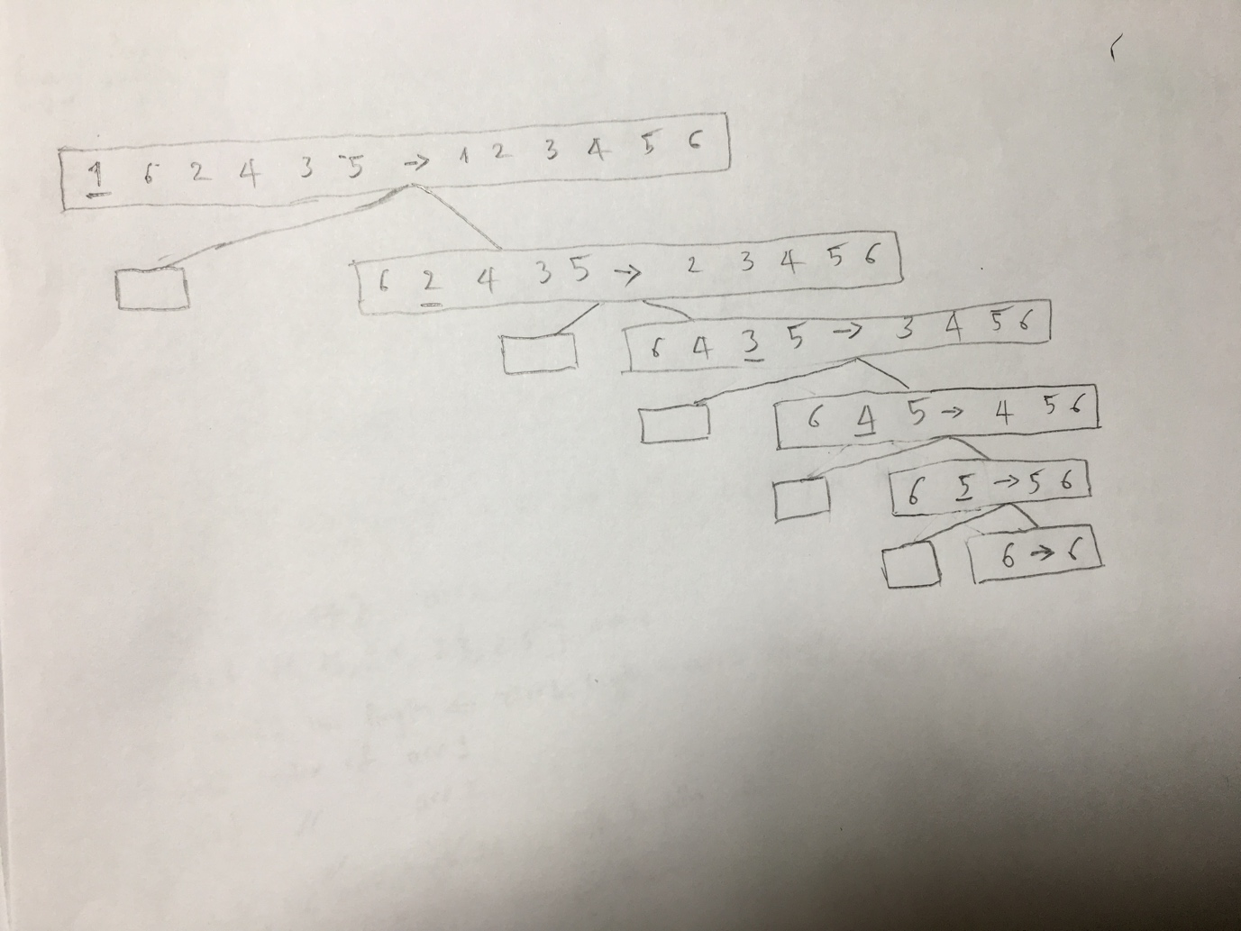

# Problem 2



# Problem 3

1. Good pivots are: 2, 3, 3, 4, 5
2. True because 5/9 > 1/2

# Problem 4

A

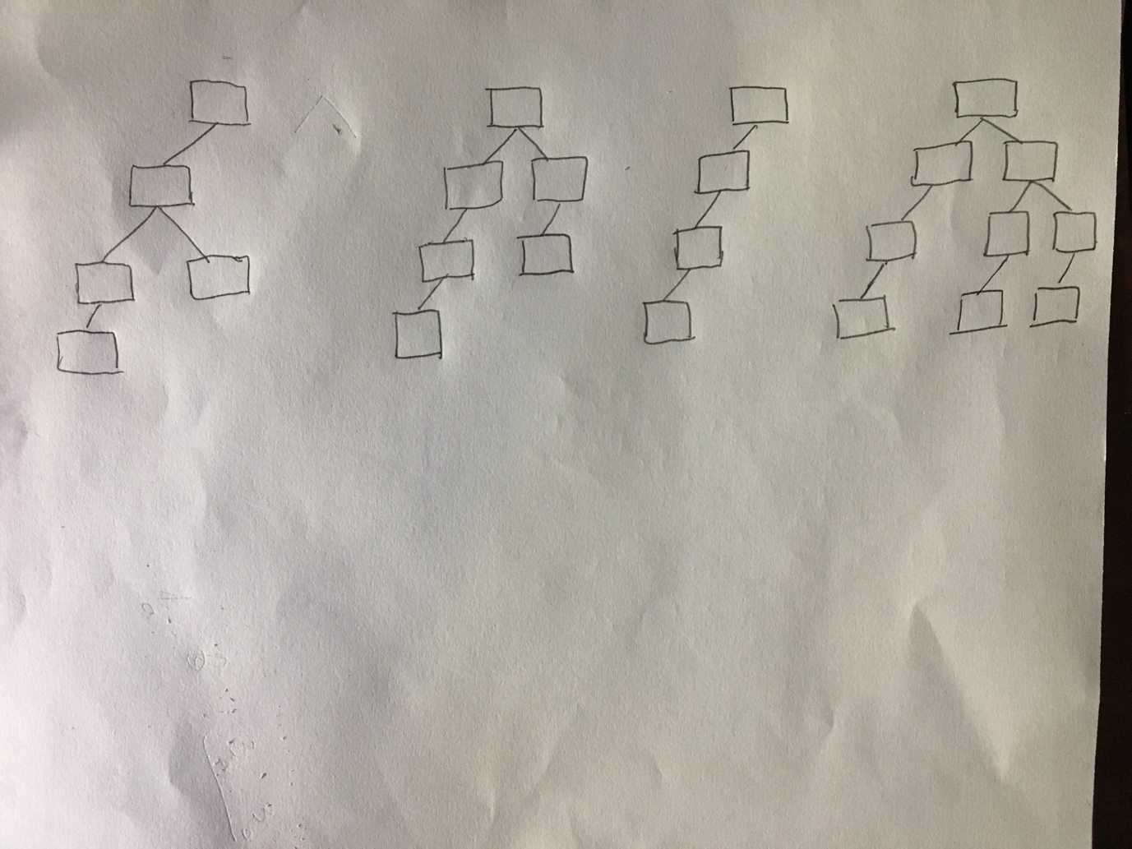

B. Every binary tree of height 3 has at most 23=8 leaves => True

C. Number of leaves = 2n , n = height of tree