Lab5

# Problem 1

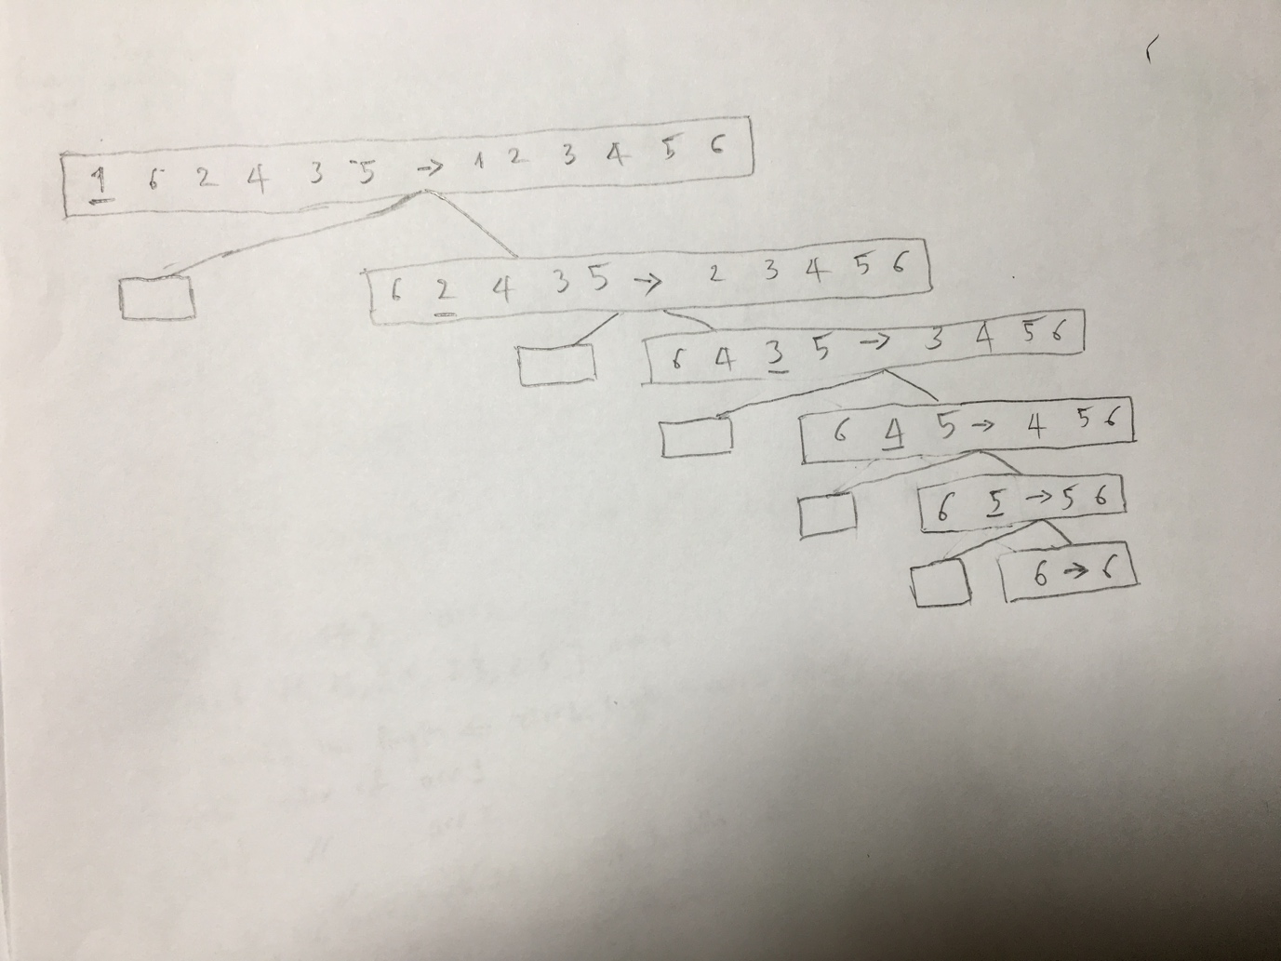

# Problem 2

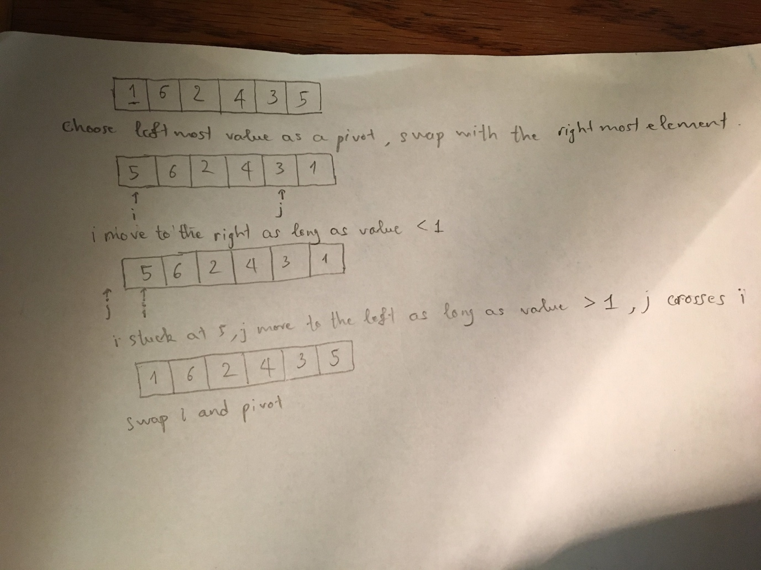

# Problem 3

1. Good pivots are: 2, 3, 3, 4, 5
2. True because 5/9 > 1/2

# Problem 4

Algorithm indexEqualToValue(A, b, t)  
 Input An sorted and distinct elements array A, lowest index of array b, highest index of array t  
 Output An integer m if A[m] = m  
   
 if (A[0] = 0) then   
 return 0  
 if ( b > t || A[0] > 0) then  
 return - 1  
   
 m = (b + t) / 2  
   
 if A[m] = m then  
 return m  
   
 if A[m] > m  
 return indexEqualToValue(A, b, m - 1)  
   
 return indexEqualToValue(A, m + 1, t)

We use Binary Search to solve this problem so the running time is O(log n)

# Problem 5

We use Median Finding algorithm (T(n) = O(n) ) to select the median element of the list as the pivot so you can make sure the size of L and the size of G is always less then 3n/4. So the running time in worst case is O(nlog n)

See more about Median Finding algorithm <http://www.cs.cornell.edu/courses/cs2110/2009su/Lectures/examples/MedianFinding.pdf>