**Lab 3**

1. In the code folder for this lab there is a package lesson3.labs.prob1 containing two classes, Person and PersonWithJob. In each class, the equals method has been overridden. Run the main method in the PersonWithJob class. In the main method, two instances of Person have been compared to determine if they are equal. The comparison is done in two different ways. One way leads to a “false”, the other to a “true.” Explain why this has happened. Then provide a solution by replacing inheritance with composition.

**Explain:** *p2.equals(p1) = true* but *p1.equals(p2) = false* because in the equals method of class PersonWithJob its check whether input object is **instance of** PersonWithJob or not. The input is a instance of class Person so it not an instance of class PersonWithJob so the function returns false.

1. Design a solution to the problem given below, and then implement in code. Hard-code a few buildings, apartments and their rental fees in the main method of a separate Main class to test your code. In your main method, calculate the income for your hardcoded values. (Note that the problem in this case is different from the one given in Lab 1.)

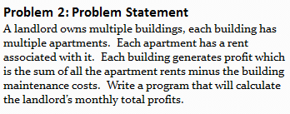

1. A. UML classes Circle and Cylinder are given below, pictured in an inheritance relationship. Write

the code for Circle and Cylinder in Java, making use of the inheritance relationship. Does it make

sense to use inheritance here? Explain.

**Explain:** It does not make sense to use inheritance here, because fragility of inheritance. Subclass Cylinder used the superclass Circle in unexpected way. When we print a cylinder object, it will use toString method which overrided in Circle class, so that the result will be area of Circle instead of volume of Cylinder. We can handle this problem by overriding toString method in Cylinder class or using composition.

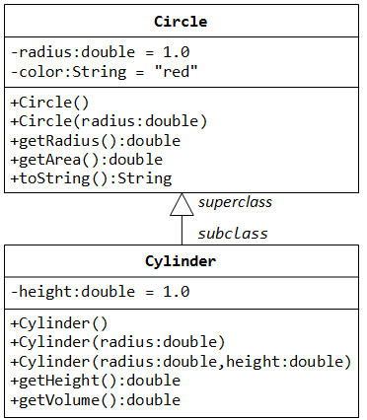

B. Redo the design using composition, and write the resulting code in Java.

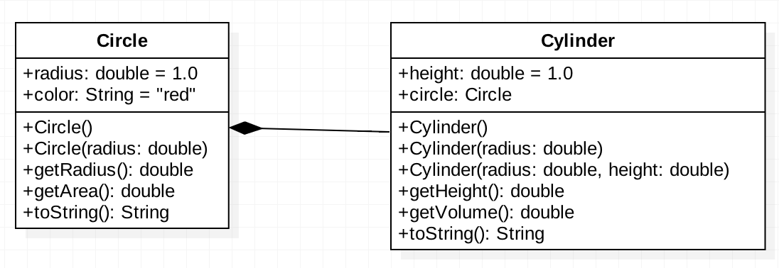

4. In Lab 1 a properties management system was introduced. In that lab, you specified classes and some attributes for those classes. In this exercise, think of a way to design further using inheritance and include associations (with multiplicities) and some operations for you classes. Then translate your diagram into Java code. Both an Admin and Driver class have been provided in your code folder. The Driver class creates some instances of the different properties and passes these into the Admin method computeTotalRent; this method performs a correct computation, but the implementation proceeds by checking the types of the different rental properties. Refactor the implementation of computeTotalRent so that the inheritance you have introduced is used, together with polymorphism. Below is provided the problem statement and a solution for the Lab 1 exercise.

***Problem Description:***

A landlord owns several types of properties: houses, condominiums, and trailers. A house has an address and a lot size. Rent for a house is computed by

rent = 0.1 * lot size

A condominium has an address and a certain number of floors (1 floor, 2 floors, or 3 floors). Rent for a condominium is computed by

rent = 400 * number of floors

A trailer belongs to a particular trailer park (specified by the trailer park address). The rent for a trailer is always $500.

The property managemet software is required to have an Admin module that supports various functions. One of these functions is to compute total rent for all the properties registered in the system. Another function is to list all properties in the system that are in a specified city.

