|  |
| --- |
| **Chemistry and Biology Project** |

|  |
| --- |
|  |

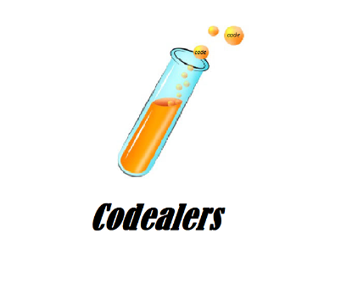

PROJECT

**TEAM MEMBERS** 2

**TOPIC** 2

SUMMARY 2

**STAGES OF REALIZATION** 2

LEVEL OF COMPLEXITY 3

**USED TECHNOLOGIES** 3

CONCLUSION 3

ALGORITHMIC SCHEME 4

# TEAM MEMBERS

|  |  |  |
| --- | --- | --- |
| NAME | CLASS | ROLE |
| Danail Todorov | 10G | Scrum Trainer |
| Zafir Stoyanov | 10G | Backend Developer |
| Daniel Vasilev | 10G | Backend Developer |
| Trani Tranev | 10G | Backend Developer |
| Anton Goreshtilov | 10G | Designer |

# 

# TOPIC

The topic of the project was to create a C++ game . The idea is to have fun with the game in your free time and understand that science is not boring.

# SUMMARY

## **STAGES OF REALIZATION**

* ​We obsessed and decided on the idea
* ​We wrote the C++ code
* ​A lot of modifications
* ​Make final changes

## 

## LEVEL OF COMPLEXITY

Teamwork can be very hard sometimes. Starting with scheduling a perfect time for everybody to begin working on the project. This was probably the hardest part.

In addition to that, working in a team can be very stressful. You should listen to everyone’s ideas and opinions before deciding anything.

## **USED TECHNOLOGIES**

* **Visual Studio** as our code editors
* **GitHub** for collaborative work
* **Microsoft Teams** and **Discord** for connection and communication
* **PowerPoint** for preparing a Presentation
* **Word** for preparing Documentation

## CONCLUSION

In conclusion, this project helped us improve our skills in working as a team. We learned how to stay calm and patient even through hard times. It also brought us closer together.

# ALGORITHMIC SCHEME

