**Important Files:**

* do.sh
* do_margin.sh
* run.sh
* runtwitter.sh

**Edited Files :**

* leveldb/benchmarks/db_bench.cc
  + 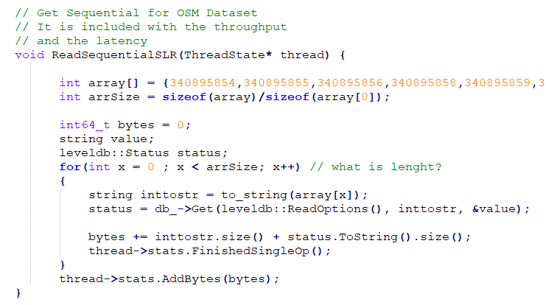
  + 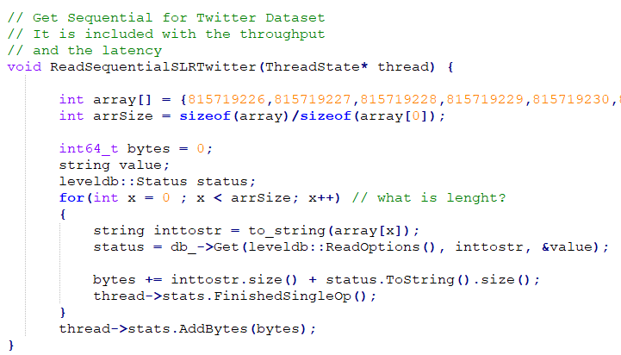
* leveldb/table/block.h
  + 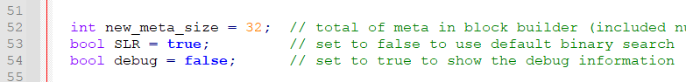
* leveldb/table/block.cc
  + 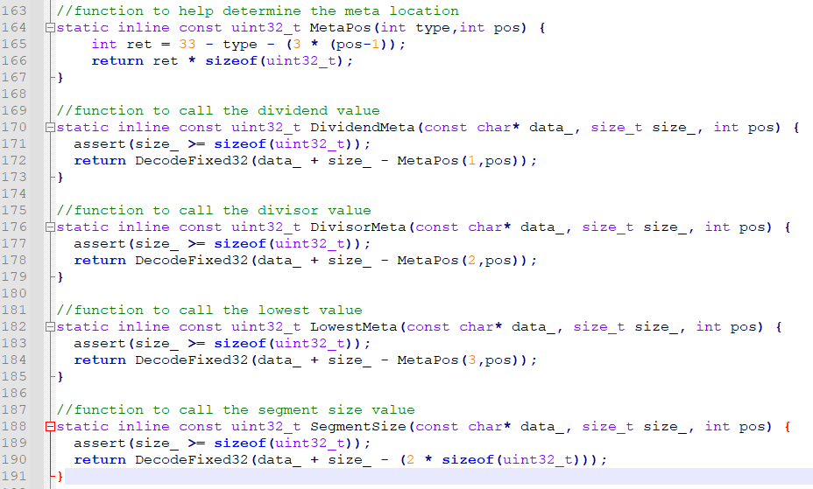
  + 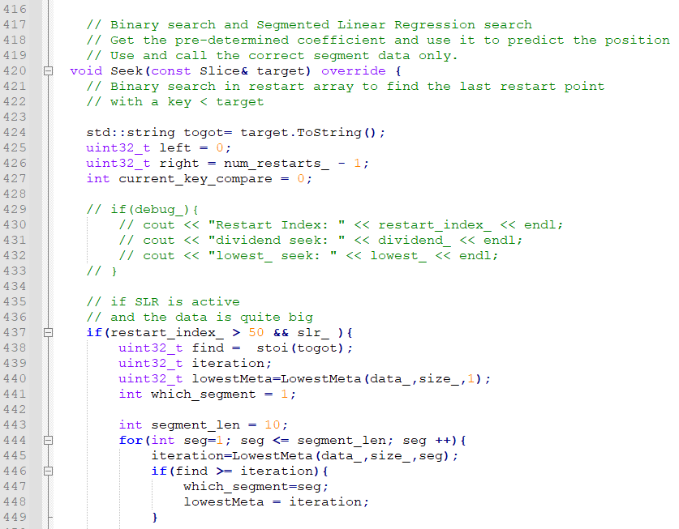
  + 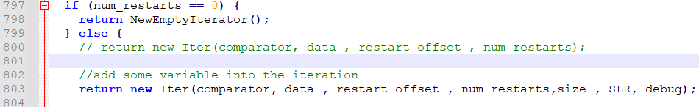
* leveldb/table/block_builder.h
  + 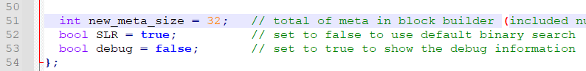
* leveldb/table/block_builder.cc
  + 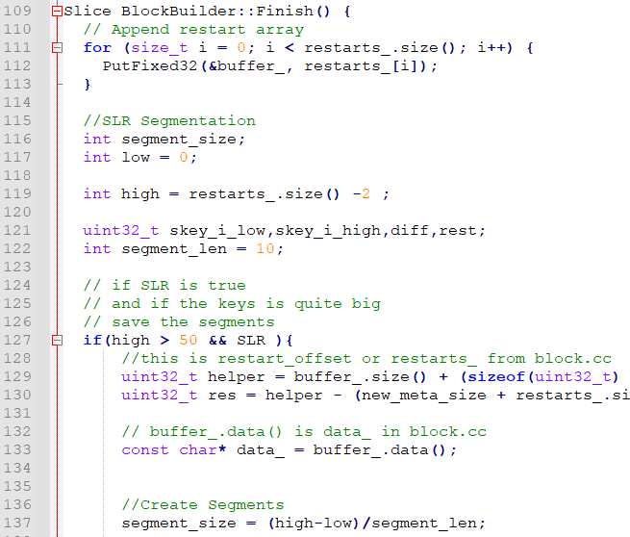
  + 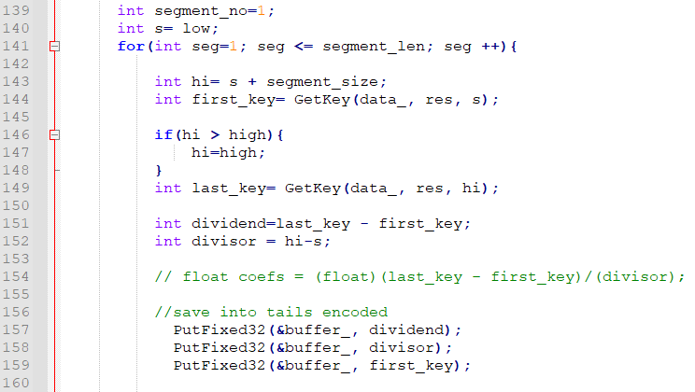

**How to run the db_bench:**

1. Single benchmark the OSM:

./db_bench --benchmarks="readseqslr" --histogram=1 --use_existing_db=1 --db=/home/leveldb/dbonly/test5

1. Multiple benchmarks the OSM:

./db_bench --benchmarks="readseqslr, readseqslr , readseqslr , readseqslr , readseqslr " --histogram=1 --use_existing_db=1 --db=/home/leveldb/dbonly/test5

1. Single benchmark the OSM:

./db_bench --benchmarks="readseqslrtwitter" --histogram=1 --use_existing_db=1 --db=/home/leveldb/dbonly/test5

1. Multiple benchmarks the OSM:

./db_bench --benchmarks=" readseqslrtwitter, readseqslrtwitter, readseqslrtwitter, readseqslrtwitter, readseqslrtwitter " --histogram=1 --use_existing_db=1 --db=/home/leveldb/dbonly/test5

1. Build, compile the scripts and run db_bench in one command:

./do.sh {dataset} {slr}

Example:

./do.sh osm true

./do.sh twitter false