Instructions – Exp 1
Chin Rest Positioning
Please begin by placing your chin on the chin rest provided. Take a moment to adjust yourself until you feel comfortable, ensuring that your face is directly aligned with the monitor in front of you. It’s important that you remain in this position for the duration of the experiment, but don’t worry—you will have opportunities to rest during the breaks between blocks.
Eye Tracker Calibration
In this study, we will be using an eye tracker to monitor where you are looking on the screen. Once you have read the study description displayed on the monitor, press any key to proceed to the calibration phase. A circle will appear on the screen to help guide you; please align your face within the circle. When you're ready, press the spacebar to continue.
A moving dot will appear on the screen, and you’ll be asked to follow it with your eyes. This calibration process will happen at the beginning of each block. If needed the eye-tracker can also be recalibrated during a experimental block.
Experiment Structure
The experiment is divided into four main parts:
- Part 1: A practice session where you will be shown 6 pictures to help familiarize you with the task.
- Parts 2-4: The main experiment, consisting of 3 blocks, each containing 100 pictures.
Practice Session
After completing the initial calibration, you will move into a brief practice session. Here, 6 images will be presented one at a time.
Before each image is displayed, you will see a fixation cross (+) in the center of the screen. It is important to focus your gaze on the center of this cross and then press the spacebar to proceed to the next image. The experiment only continues if the eye-tracker recognizes your fixation on the center. If pressing the spacebar doesn’t immediately move to the next image, try refocusing on the center of the cross, or close your eyes briefly and reopen them to refocus on the cross.
During each trial, you will see an image displayed for a short time. Please look at the image naturally—there is no right or wrong way to view it. Try to blink in between trials to avoid blinking while the images are shown.
Experiment Duration
The entire experiment, including the calibration and practice session, will take approximately 1 hour to complete.
Thank you for your time and participation in this study!

Instructions – Exp 2
Chin Rest Positioning
Please begin by placing your chin on the chin rest provided. Take a moment to adjust yourself until you feel comfortable, ensuring that your face is directly aligned with the monitor in front of you. It’s important that you remain in this position for the duration of the experiment, but don’t worry—you will have opportunities to rest during the breaks between blocks.
Eye Tracker Calibration
In this study, we will be using an eye tracker to monitor where you are looking on the screen. Once you have read the study description displayed on the monitor we proceed to the calibration phase. A circle will appear on the screen to help guide you; please align your face within the circle. A moving dot will appear on the screen, and you’ll be asked to follow it with your eyes. This calibration process will happen at the beginning of each block. If needed the eye-tracker can also be recalibrated during an experimental block.
Experiment Structure
The experiment is divided into three main parts: (1) A practice session to help familiarize you with the task, (2) the main experiment, consisting of 3 blocks, each containing 100 pictures, and (3) a memory task.
The eye-tracking experiment
In the experiment, there are 300 trials in which images will be displayed. Before each trial, you will see a fixation cross (+) in the center of the screen. It is important to focus your gaze on the center of this cross and then press the spacebar to proceed to the next image. The experiment only continues if the eye-tracker recognizes your fixation on the center. If pressing the spacebar doesn’t immediately move to the next image, try refocusing on the center of the cross, or close your eyes briefly and reopen them and try pressing the space bar again.
During each trial, you will see an image displayed for three seconds. The image will be blurred and desaturated except for a small circle around the center of your gaze. You should look around the image to explore the objects that you think will be the most diagnostic for a memory task you have to conduct later where you need to tell whether an image has been presented to you during the eye-tracking experiment. Try to blink in between trials to avoid blinking while the images are shown. The eye-tracking experiment, including the calibration and practice session, will take approximately 45 min. to complete.
The memory task
During the memory task, you will be presented with pairs of images of which one was presented to you during the eye-tracking experiment and one novel image. Your task is to indicate which image you think you have seen before. This will take around 15 min.
Thank you for your time and participation in this study!

Instructions Drawing - English

Thanks for participating in our experiment! During the experiment, you will complete two parts. In the first part, you will sketch two typical scenes: a bathroom and a kitchen. We will ask you to draw the most typical exemplar of these scenes, meaning that the scenes have a prototypical distribution of objects. Please do not simply draw an exact copy of a scene you know (e.g., a room from your own house) or a scene that you find particularly attractive. In the second part, we will ask you to draw copies of specific scene images.

When drawing your most typical scenes, you will have 30 seconds to think about the scene before you begin and 4 mins to complete each sketch.
During this period, please try and think about:
- Which objects you might find in that scene and how these should look like.
- The typical distribution of these objects across these scenes.
When drawing, please try to:
- Manage your time carefully. The experimenter will warn you when you’re halfway through and when you have 30s left.
- Do not draw unnecessary detail before finishing the most important aspects of the scene.

Here is an example drawing of a typical classroom.

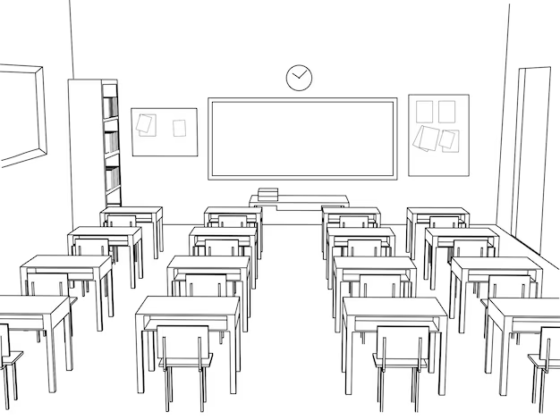

When copying scenes in session 2, you will have 4 minutes to copy the scene as accurately as possible.

