Vulkan Lab 2 - Procedural Geometry

and Model Loading (Vulkan 1.3)
| Next: Vulkan lab 3 →

SMART Objectives
- implement Procedural Geometry: Write C++ code to generate vertex and index data for common geometric shapes like grids and cylinders.
- Create Dynamic Meshes: Modify procedurally generated geometry to create more complex surfaces, such as a terrain.
- Encapsulate Geometry Creation: Structure your code to create a reusable utility for generating different types of meshes
- Integrate Third-Party Libraries: Add and configure a library like Assimp into a Vulkan project to handle asset loading.
- Load and Render External Models: Use Assimp to load vertex and index data from a 3D model file (e.g., .obj) and render it using your Vulkan application.

Completed Tasks

Exercise 1. Create a Flat Grid

Output

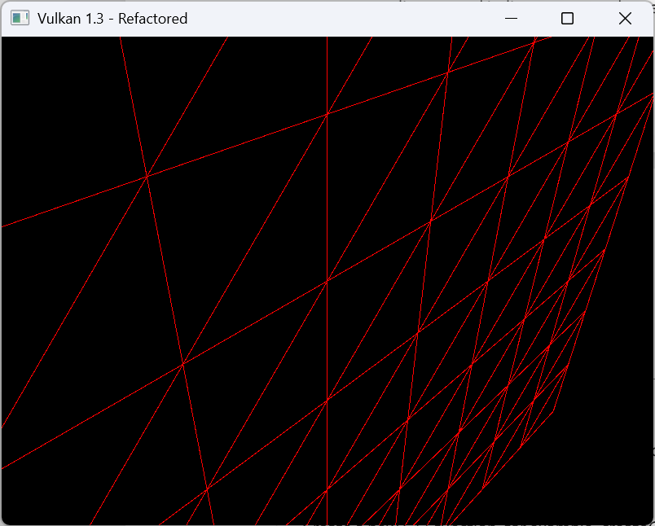

Correct camera coords

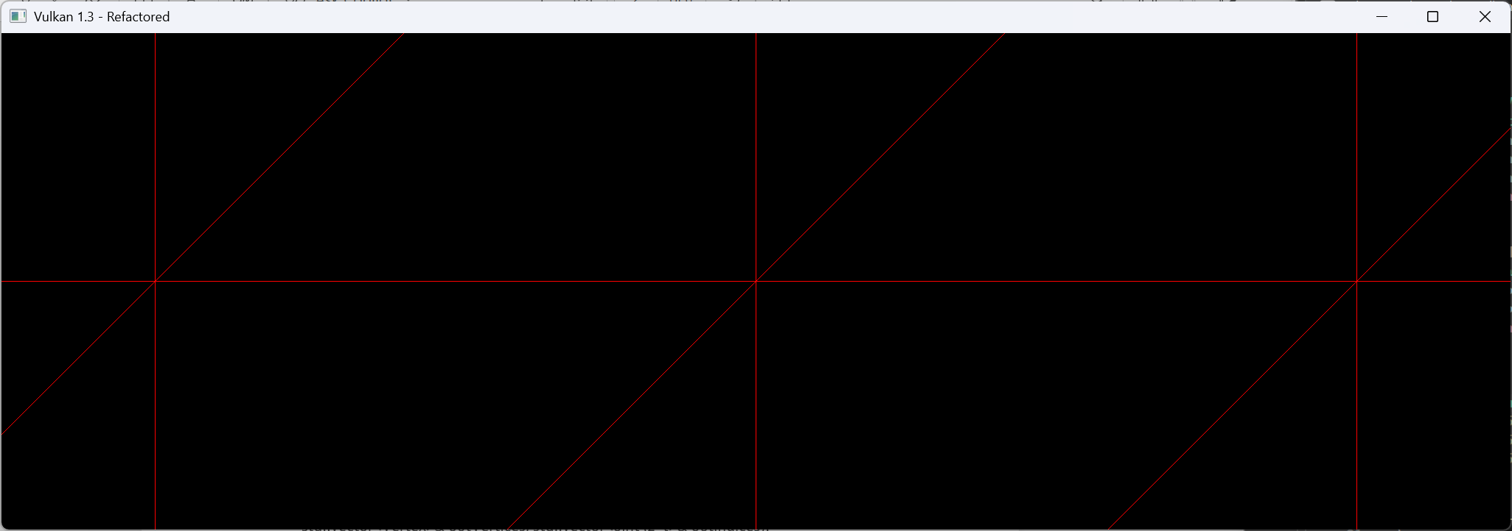

Code

Reflection

Exercise 2. Create a Wavy Terrai

OUTPUT Image

Code

Reflection

Exercise 3: Procedural Cylinder

Output

Code

Reflection

Exercise 4: Create a Reusable Geometry Utility

Output

Code

Reflection

Exercise 5: Loading External Models with Assimp

Output

Code

Reflection

Beyond the Lab (Optional)

Navigation:
- Vulkan lab 3

