Vulkan Lab 1 - Simple Shapes and Mesh Fundamentals (Vulkan 1.3)
| Next: Vulkan lab 2 →

SMART Objectives
- Understand how core Vulkan architecture works
- How GPU recourses like uniform buffers are managed
- Implementing 3D geometric primitives by using both vertex and index buffers
- Modifying the graphics pipeline (wireframe, transformations) and topology
- How to manage 3D transformations to render multiple objects in a scene

Completed Tasks

Exercise 1. Drawing Two Triangles without the use of vertex indices

Output

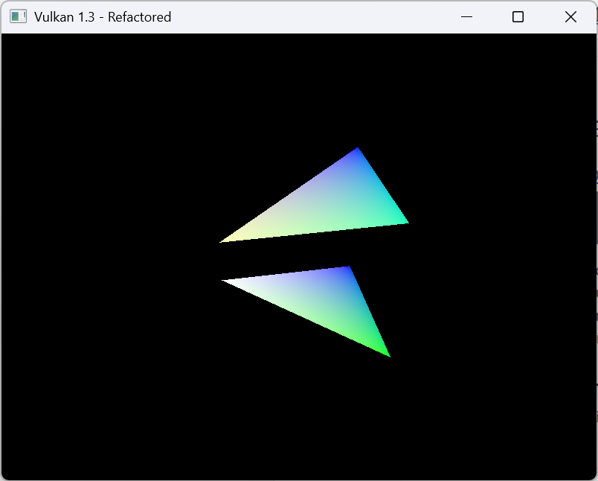

Code

Triangle code

//first triangle
//position //back //colour
{{-0.5f, -0.5f, -0.5f}, {1.0f, 0.0f, 0.0f}}, //0
{{0.5f, -0.5f, -0.5f}, {0.0f, 1.0f, 0.0f}}, //1
{{0.5f, 0.5f, -0.5f}, {0.0f, 0.0f, 1.0f}}, //2
{{-0.5f, 0.5f, -0.5f}, {1.0f, 1.0f, 1.0f}}, //3

//second triangle
//position //front //colour
{{-0.5f, -0.5f, 0.5f}, {1.0f, 1.0f, 0.5f} }, //4
{{0.5f, -0.5f, 0.5f}, {0.0f,1.0f,0.5f}}, //5
{{0.5f, 0.5f, 0.5f}, {0.0f,0.0f,1.0f}}, //6
{{-0.5f, 0.5f, 0.5f}, {1.0f,1.0f,1.0f}}, //7

const std::vector<uint16_t> Quad_indices = {
//front
0, 1, 2, 2, 3, 0,
};

Draw buffer code
vkCmdDraw(commandBuffer, 6, 1, 1, 1 ); //should now be able to draw two triangles aka 6 vertices

Reflection
In this exercise I had to draw two individual triangles by using vkCmdDraw().
The drawing of the triangles was easy enough since I just had to duplicate the first triangle and change the xyz coords. It feels a bit similar to OpenGL the main difference is that I need to use the vkCmdDraw() in order to draw 6 vertices that the triangle needs.

Exercise 2. Draw two squares using an index buffer

OUTPUT Image

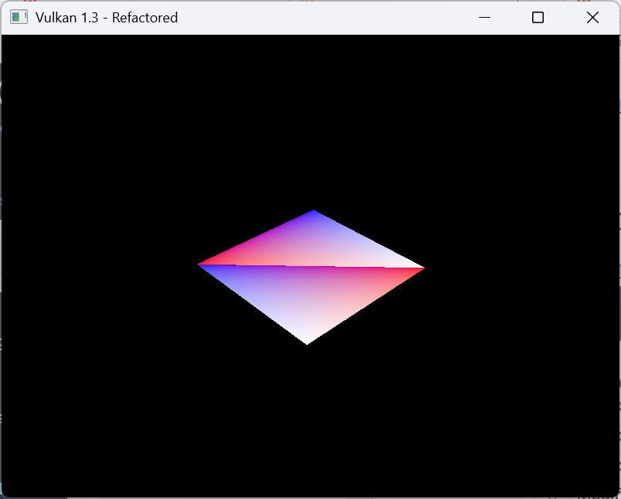

Code
Triangle
const std::vector<Vertex> Quad_vertices = {
//first triangle
//position //back //colour
{{-0.5f, -0.5f, -0.5f}, {1.0f, 0.0f, 0.0f}}, //0
{{0.5f, -0.5f, -0.5f}, {0.0f, 1.0f, 0.0f}}, //1
{{0.5f, 0.5f, -0.5f}, {0.0f, 0.0f, 1.0f}}, //2
{{-0.5f, 0.5f, -0.5f}, {1.0f, 1.0f, 1.0f}}, //3

//second triangle (square)
//position //front //colour
{{-0.5f, -0.5f, 0.5f}, {1.0f, 1.0f, 0.5f} }, //4
{{0.5f, -0.5f, 0.5f}, {0.0f,1.0f,0.5f}}, //5
{{0.5f, 0.5f, 0.5f}, {0.0f,0.0f,1.0f}}, //6
{{-0.5f, 0.5f, 0.5f}, {1.0f,1.0f,1.0f}}, //7

};
const std::vector<uint16_t> Quad_indices = {
//front
0, 1, 2, 2, 3, 0,
//back
4, 5, 6, 6, 7, 4,
};

vkCmdDrawIndexed(commandBuffer, static_cast<uint16_t>(indices.size()), 1, 0, 0, 0);

Reflection

Exercise two now uses the index buffer and as a result both triangles are now in the same position and use the same colour pallete. It’s interesting seeing the difference between vkCmdDrawIndex vs vkCmdDraw .

Exercise 3: Draw the four walls of a cube

Output
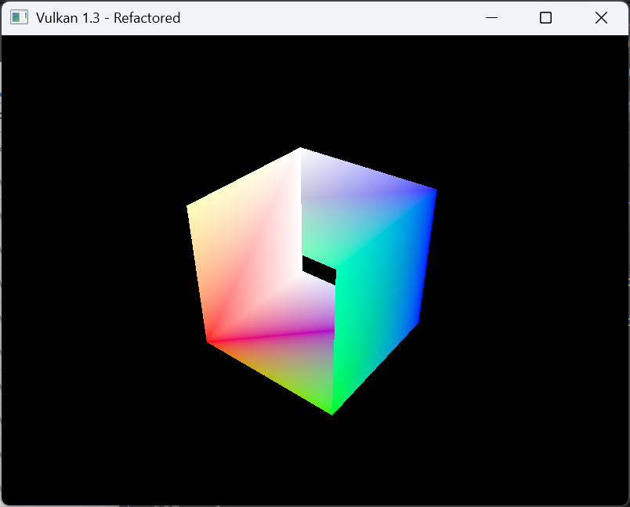

Code
Drawing Square
//square
const std::vector<Vertex> Quad_vertices = {
//first triangle
//position //back //colour
{{-0.5f, -0.5f, -0.5f}, {1.0f, 0.0f, 0.0f}}, //0
{{0.5f, -0.5f, -0.5f}, {0.0f, 1.0f, 0.0f}}, //1
{{0.5f, 0.5f, -0.5f}, {0.0f, 0.0f, 1.0f}}, //2
{{-0.5f, 0.5f, -0.5f}, {1.0f, 1.0f, 1.0f}}, //3

//second triangle
//position //front //colour
{{-0.5f, -0.5f, 0.5f}, {1.0f, 1.0f, 0.5f} }, //4
{{0.5f, -0.5f, 0.5f}, {0.0f,1.0f,0.5f}}, //5
{{0.5f, 0.5f, 0.5f}, {0.0f,0.0f,1.0f}}, //6
{{-0.5f, 0.5f, 0.5f}, {1.0f,1.0f,1.0f}}, //7

};

//first and second trianlge for square shape
//drawing cube now
const std::vector<uint16_t> Quad_indices = {
//front
0, 1, 2, 2, 3, 0,
//back
4, 5, 6, 6, 7, 4,
//left side
0,3,7,7,4,0,
//right
1,5,6,6,2,1

};

Enabling to draw cube
vkCmdDrawIndexed(commandBuffer, static_cast<uint32_t>(indices.size()), 1, 0, 0, 0); //should draw cube now

Reflection

In this section you needed to draw a 3D cube with its 4 walls. It was originally a bit hard to figure out this was mainly due to having to draw the points and vertices a bit differently compared to OpenGL, furthermore it would only load as a 2D square that was until I realized I had to make the draw index buffer larger.
Overall, it was quite interesting, but it will take a while to get used to how different Vulkan works compared to OpenGL.

Exercise 4: Wireframe Rendering

Output
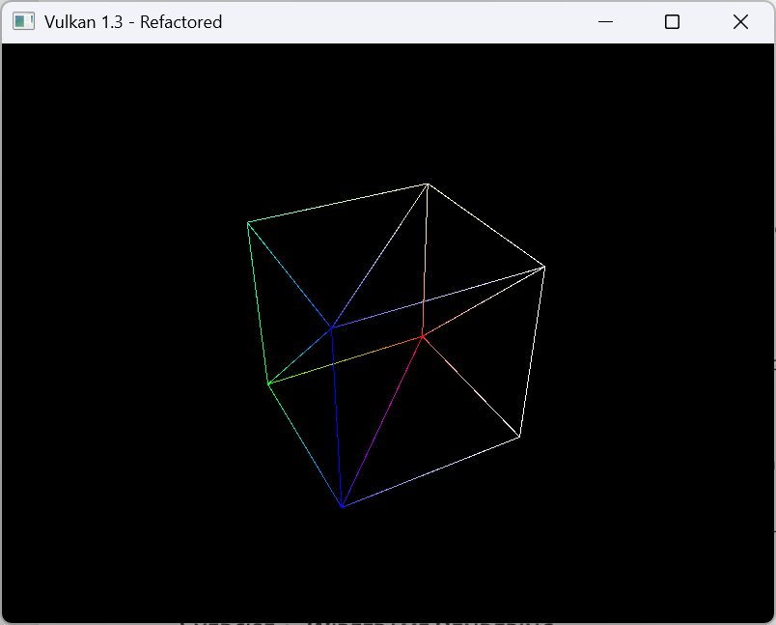

Code
rasterizer.polygonMode = VK_POLYGON_MODE_LINE;

Reflection
In this task I had to change VK_POLYGON_MODE_FILL to VK_POLYGON_MODE_LINE.
This results in the cube being rendered in wireframe (vertices and lines) instead of solid colours (faces, vertices and lines). It is quite similar to how it works in OpenGL as well with this line GL_FRONT_AND_BACK, GL_LINE to render wireframe and GL_FRONT_AND_BACK, GL_FILL to render solid shapes, meaning that there are some similarities between OpenGL and Vulkan at least in how to render a wireframe object.

However, there are some differences in that Vulkan also renders the triangles that make up the cube instead of just the lines of the cube like in OpenGL.

Exercise 5: Render the cube vertices as points

Output
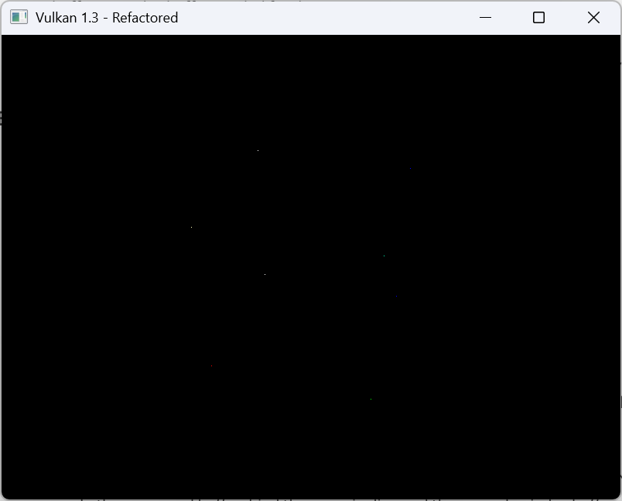

Code

inputAssembly.topology = VK_PRIMITIVE_TOPOLOGY_POINT_LIST; // render tris = triangle list, render points = point list

vkCmdDraw(commandBuffer, 8, 1, 0, 0 ); //should now be able to draw two triangles aka 6 vertices, to render cube draw 8 verticies

Reflection

In this task I have learned how to change the topology from VK_PRIMITIVE_TOPOLOGY_TRIANGLE_LIST to VK_PRIMITIVE_TOPOLOGY_POINT_LIST and by changing the draw method to be vkCmdDraw(commandBuffer, 8, 1, 0, 0) it enables to draw each separate point of the cube instead of the entire object like before. I don’t believe this could be done in OpenGL but I need to check again.

Exercise 6: Render the cube edges as lines

Output
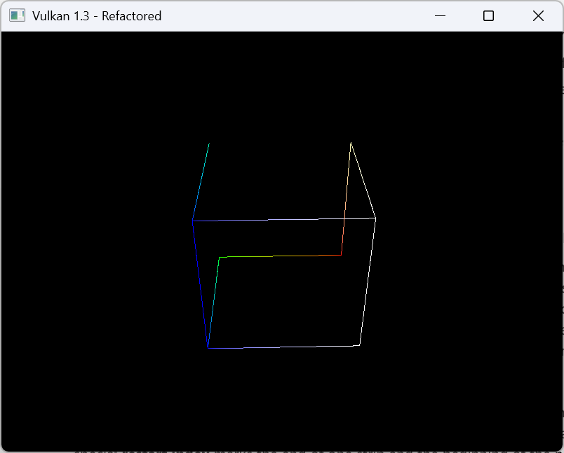

Code

inputAssembly.topology = VK_PRIMITIVE_TOPOLOGY_LINE_LIST;
vkCmdDrawIndexed(commandBuffer, static_cast<uint32_t>(indices.size()), 24, 1, 0, 0);

Reflection

In this exercise, the main goal was to draw the cube edges instead of the points/triangles. In order to do this inputAssembly.topology = VK_PRIMITIVE_TOPOLOGY_LINE_LIST was used and by using that and vkCmdDrawIndexed(commandBuffer, static_cast<uint32_t>(indices.size()), 24, 1, 0, 0) it should render 12 individual lines of the cube. However, some lines are missing and it’s only 9 lines in total. This isn’t due to them being culled out since I did disable culling and I am unsure what causes this.

Exercise 7: Triangle strips

Output

Code

Reflection

Exercise 8: Drawing multiple cubes using instanced drawing

Output

Code

Reflection

Exercise 9: Drawing two cubes using push constants

Output

Code

Reflection

Beyond the Lab (Optional)

Navigation:
- Vulkan lab 2

